PCR Detection of Bacteriocin Genes from LAB isolated from milk

Nwanekwu K.E, M.Sc., Federal University of Technology, Owerri
Nwabueze R.N. Ph.D, Federal University of Technology, Owerri
Orji, J.C. Ph.D, Federal University of Technology, Owerri

Abstract
The bacteriocin structural gene in six bacteriocinogenic Lactic acid bacteria(LAB) namely Lactobacillus acidophilus, Lactobacillus casei, Streptococcus thermophilus, Lactococcus lactis, Lactobacillus fermentum and Lactobacillus brevis isolated from raw and processed milk samples was studied. Four primers were designed to amplify bacteriocin genes of bacteriocin producing LAB. The primer sets were able to amplify the bacteriocin gene from all the six LAB isolates. Primer A(IcIA) amplified bacteriocin gene of L. casei, L. lactis and L. fermentum, Primer B(acdT) amplified bacteriocin genes of L. acidophilus, L. casei, L. lactis and L. brevis, Primer C(acdA) amplified bacteriocin genes of L. acidophilus, S. thermophilus and L. brevis, while Primer D(Iaf) amplified bacteriocin genes of L. casei and L. brevis. The bacteriocin genes of the organisms were between the ranges of 210-300 bp, which was determined based on the molecular weight marker in gel system. Hybridization analysis confirm the amplicon of these LAB are bacteriocins.

Image
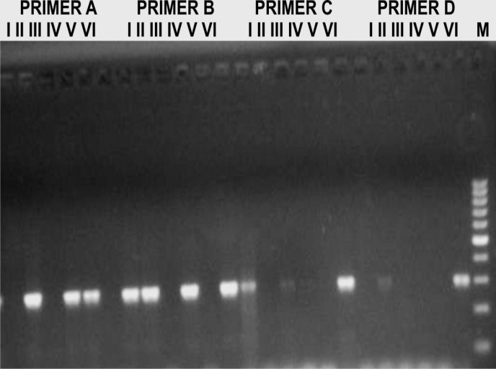
FIG. 1. Sample agarose gel of PCR products from amplification of bacteriocin genes.

Recent Publication
- Ammor, S., Tauveron, G., Dufour, E., & Chevallier, I. (2006). Antibacterial activity of lactic acid bacteria against spoilage and pathogenic bacteria isolated from the same meat small-scale facility: 1-screening and characterization of the antibacterial compounds. Food Control, 6, 454-461.
- Kos, B., Beganović, J., Jurašić, L., Švađumović, M., Pavunc, A.L., Uroić, K., & Šušković, J.(2011). Coculture-inducible bacteriocin biosynthesis of different probiotic strains by dairy starter culture Lactococcus lactis. Mljekarstvo, 61 (4), 273-282.

- Sieuwerts, S., de Bok, F.A.M., Hungenholtz, J., & van Hylckama-Vlieg, J.E.T. (2008). Unravelling Microbial Interactions in food fermentations: from Classical to Genomics approaches. Applied and Environmental Microbiology, 74, 4997-5007.

- Suskovic, J., Blazenka, K., Beganovic, J., Pavunc, A.L., Habjanic, K., & Matosic, S. (2010). Antimicrobial activity- the most important property of probiotic and starter Lactic acid bacteria. Food Technology and Biotechnology, 48 (3), 296 – 307.

- Yi, H., Lanwei, Z., Yanfeng, T., Xue, H. and Ming, D. (2010). A novel method for rapid detection of class IIa bacteriocin-producing lactic acid bacteria. Food Control, 21, 426-430.

______________________________________________________________________________

Biography
Nwanekwu is a PhD candidate at Federal University of Technology Owerri. He is a Lecturer of Microbiology at Imo State University, Owerri, Nigeria. He has published more than 15 papers in reputed journals.

