The threat of zoonotic diseases and Ebola Virus Disease specifically
Cdr Dr Stef Stienstra,
1-Civil-Military-Interaction-Command Royal Dutch Armed Forces

Abstract

Public health systems are not always prepared for outbreaks of infectious diseases. Although in the past several public health institutes, like the French ‘Institut Pasteur’ and the Dutch ‘Tropeninstituut‘, were prominent surveyors of infectious diseases, the investments in worldwide public health have decreased. Now more attention is given to curative healthcare compared to preventive healthcare. The recent Ebola Virus Disease outbreak in West Africa initiated a new wave of interest to invest in Worldwide Public Health to prevent outbreaks of highly contagious diseases.

Zoonotic diseases are threatening as the population does not have natural nor artificial (from vaccination) immune response to new diseases like in the Ebola Virus Disease outbreak in 2014. The new strain of the Ebola Virus in West Africa was slightly less lethal, compared to other Ebola Virus strains, but the threat of spreading was far bigger as it had a longer incubation time.

Most public health systems are not trained well enough to mitigate highly infectious and deadly disease outbreaks. NGO’s helping to fight the outbreak are often better trained in curative treatments and have less experience with biological (bioweapon) threats for which the military are trained for. The UNMEER mission was unique in this. It was a setting in which military and civilian actors cooperate in fighting a biological threat. Protection is essential for health workers. Smart systems have to be developed to prevent further spreading of the disease, but it is not only the biosafety, which has to be considered, but also the biosecurity, as misuse of extremely dangerous strains of microorganisms cannot be excluded.

Several zoonotic infectious diseases, like anthrax, smallpox and haemorrhagic fevers are listed as potential bioweapons. Therefor both biosafety and biosecurity have to be implemented in all measures to fight outbreaks of highly infectious diseases.
Image
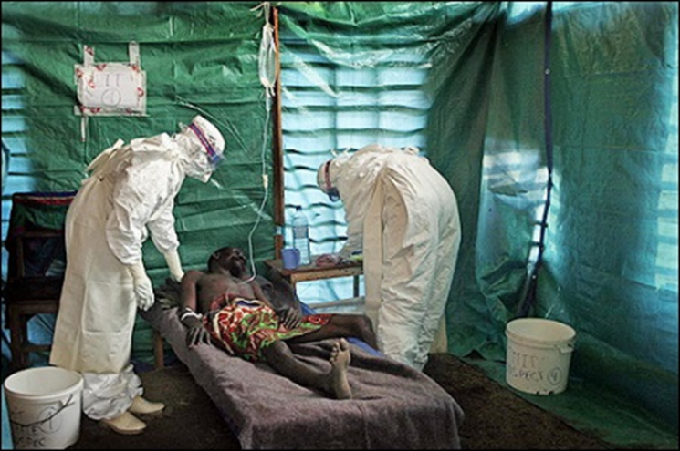
Recent publications
- Moon S et al (2015) Will Ebola change the game? Ten essential reforms before the next pandemic. The report of the Harvard-LSHTM Independent Panel on the Global Response to Ebola. Lancet; 386: 2204-21
- Kamradt-Scott A et al (2015) WHO must remain a strong global health leader post Ebola. Lancet 385:111.
- Kieny MP, Dovlo D (2015) Beyond Ebola: a new agenda for resilient health systems. Lancet 385: 92
- Cenciarelli O et al (2015) Viral bioterrorism: Learning the lesson of Ebola virus in West Africa 2013-2015. Virus Research 210: 318-326
- Abramowitz SA et al (2015) Social science intelligence in the global Ebola response. Lancet 385: 330

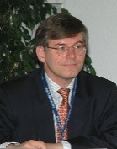 Biography
Works internationally for several medical and biotech companies as scientific advisory board member and is also an active reserve-officer of the Royal Dutch Navy in his rank as Commander (OF4). For the Dutch Armed Forces he is CBRNe specialist with focus on (micro)biological and chemical threats and medical- and environmental functional specialist within the 1st CMI (Civil Military Interaction) Battalion of the Dutch Armed Forces. For Expertise France he is now managing an EU CBRN CoE public health project in West Africa.
In his civilian position he is at this moment developing with MT-Derm in Berlin (Germany) a novel interdermal vaccination technology as well as a new therapy for cutaneous leishmaniasis for which he has won a Canadian ‘Grand Challenge’ grant. With Hemanua in Dublin (Ireland) he has developed an innovative blood separation unit, which is also suitable to produce convalescent plasma for Ebola Virus Disese therapy.
He has finished both his studies in Medicine and in Biochemistry in The Netherlands with a doctorate and has extensive practical experience in cell biology, immuno-haematology, infectous diseaases, biodefense and transfusion medicine. His natural business acumen and negotiation competence helps to initiate new successful businesses, often generated from unexpected combinations of technologies.
Email: Stef.Stienstra@inter.nl.net

Notes/Comments:

