Abstract: Azo dyes that are extensively used in textile industries are recalcitrant xenobiotic compounds causing a serious damage to the environment. Degradation of azo dyes being a necessity diverse dye dumped soils were screened for dye degrading yeasts. One efficient yeast isolate capable of decolorizing both mono-azo dyes and di-azo dyes was selected, immobilized by entrapment method and studied for decolorization efficiency. The isolate was morphologically, culturally and biochemically identified as Saccharomyces sp. Sodium alginate entrapped yeast cells were studied for decolorization of commercially available textile dyes having azo groups. The extent of colour removal in the culture medium was assessed through the decrease in dye absorbance of the supernatants. The immobilized yeast’s decolorization abilities were different and varied with inoculum size, incubation time and nutrients like carbon and nitrogen sources. The fermentation conditions like pH, temperature and aeration had no profound effect. The decolorization ranged from 70-100%. Complete decolorization was seen within 12 and 18 hrs depending on inoculum size. The immobilized beads with yeasts could be reused efficiently for three cycles. The dye degrading immobilized Saccharomyces isolate could be commercially significant as it is efficiently degrading both mono-azo and di-azo dyes, different dye waste waters in a semi-continuous manner and so could also be used for detoxification of industrial effluents.

1 INTRODUCTION:
Azo dyes represent the largest group of dyes used in the textile industry. They are characterized by the presence of one or more azo groups -N=N-, which are responsible for their coloration, recalcitrant nature and hence are less biodegradable [1]. Over 10% of the dye used in textile processing does not bind to the fibers and is therefore released to the environment. The percentage of unchanged dye after such treatments lost to waste waters more than 50%[2]2. Some of these compounds pose a serious threat because of their carcinogenic potential or cytotoxicity [3]. Currently the major methods of textile waste water treatment involve physical and chemical process [4]. These methods usually involve complicated procedures which are economically unfeasible. Microbial decolorization and degradation is an alternative approach which is both environment friendly and cost effective [3], [5]. Most studies on azo dye microbial biodegradation have focused on bacteria and fungi [6], [7]. Especially anaerobic bacterial species isolated from the intestinal micro flora [8]. Due to the inherent drawbacks of physical, chemical and photochemical approaches to dye removal, the use of biological methods for the treatment of textile waste waters has received attention as a more cost effective alternative [4], [9], [10]. Anaerobic microbial wastewater treatment can be very effective in removing color, primarily by the activity of azo reductases that cleave the azo bond yielding the corresponding amines, which are frequently toxic, mutagenic and carcinogenic and resist further degradation under anaerobic conditions [4], [11]. Bacteria, yeasts and molds are capable of aerobic decolorization and mineralization of dyes.The present study concentrated on degradation of Azo dyes by an efficient isolated yeast culture. Degrading yeast was immobilized by entrapment method and used for dye degradation studies, It showed nearly more than 90% decolorization ability for mono-azo dyes and nearly 50-60% for di-azo dyes. The co-metabolic role of carbon source was also studied along with effect of nitrogen source on decolorization. The isolate also responded well to dye waste water decolorization. Thus the present potential yeast isolate could be used efficiently for dye waste water treatment in semi-continuous manner.
2 RESULTS:
The yeast isolate, isolated from dye dumped soil by enrichment culture technique was immobilized by entrapment method in sodium alginate. This was identified by microscopic and biochemical studies as belonging to genus Sachharomyces sp, though it showed similarity to both cerevisiae species and italicus species it was not identified till species level (Table 1). The selected isolate showed good decolorization ability for both mono azo dyes like methyl red and di-azo dye like tryphan blue at different concentrations. The percentage decolorization ranged from 70-80% for methyl red and 65-75% for tryphan blue (Figure 1) of dyes. The isolate showed good response to immobilization as decolorization increased from 80% to 100% (Figure 2). A bead size of 0.02 cu.sq,mm and an inoculum size of 106 cells/ml showed 100% decolorization (Figure 2). The decolorization increased with incubation time and maximum decolorization was till 24 hours only for methyl red, red dye and red dye waste water (Figure 3). It produced alcohol which could enhance decolorization. The dye decolorized medium and dye waste waters did not show any presence of amine (Table 2). The beneficiary aspect of the immobilization is that the beads could be recycled. The beads were recycled four times comparatively the 1st cycle showed maximum decolorization within 24 hrs, the percentage decolourization of the dyes gradually decreased with the increase in the number of cycles ( Figure 4). The effect of simple carbon source (co-metabolite) like glucose and nitrogen source like yeast extract on decolorization of methyl red (Figure 5) and red dye waste water (Figure 6) was studied to ascertain the decolorization efficiency of the isolate under study. The response of the isolate was good with 100% decolorization even both in presence and absence of the cometabolites
Results :
 | Saccharo -myces italicus | Saccharo-myces cerevisiae | Isolate
  Character
 | Flat, cream to tannish cream in color | Pale cream & smooth with regular edge | Flat cream colony with regular edge
  Colony Morphology
 | Absent | Absent | Absent
  Microscopic- Presence of Pseudomycelium
 | Oval | Spherical | Oval
  Shape of the cell
 | + | + | +
  Fermentation of Glucose |  |  | +
 | + | + | +
  Galactose
 | + | + | +
  Sucrose | + | + | +
 | + | + | +
  Maltose | + | + | +
 | - | - | -
  Lactose
 | - | - | -
  Nitrate utilization
Urease production | + | + | +
Alcohol production | + | + | +

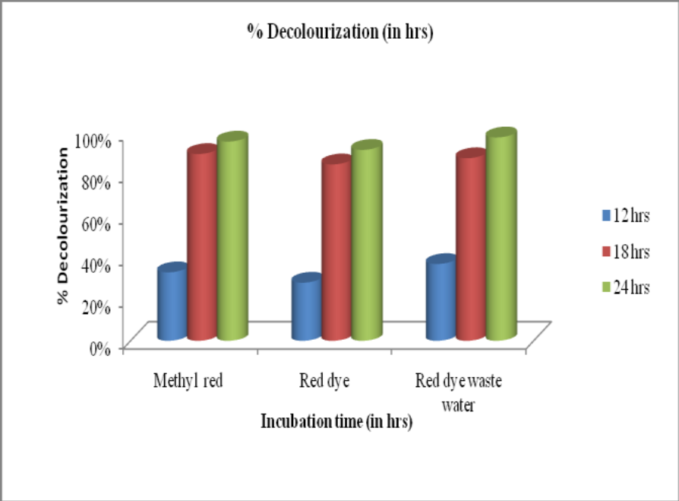
Figure 1: Effect of incubation time on Dye decolorization by immobilized yeast .
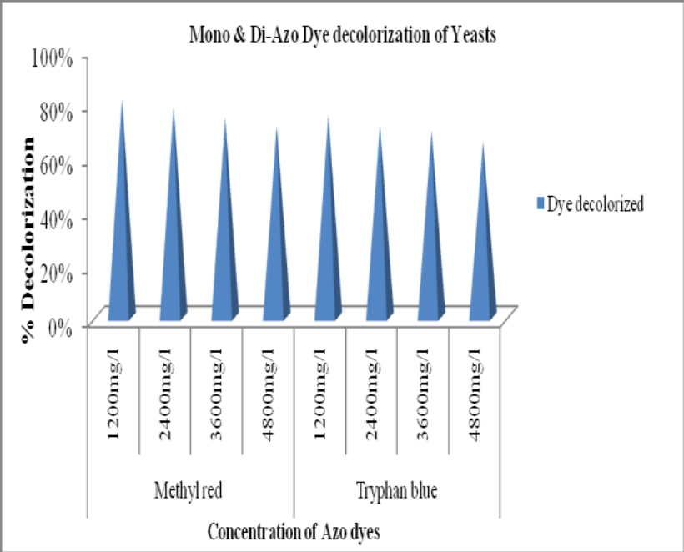
Figure 2: Decolorization of different concentrations of mono azo and di azo dyes by yeast isolate.

REFERENCES:
[1]. H.J .Knackmuss,‖Basic Knowledge and Perspectives of Bioelimination of Xenobiotic Compounds‖, Journal of biotechnology, 51, 287-295, 1996.

[2]. C.I. Pearce, J.R. Lloyd & J.T. Guthrie, ―The Removal of Color from Textile Waste Water Using Whole Bacterial Cells : A Review‖, Dyes and pigments, 58, 179-196, 2003.

[3]. I.M. Banat, P. Nigam, D. Singh & R. Marchant,‖ Microbial Decolorization of Textile Dye- Containing Effluents: A Review‖, Bioresour Technol, 58, 217-227, 1996.

[4]. T. Robinson, G. McMullan, R. Marchant & P. Nigam , ‖Remediation of Dyes in Textile Effluent: A Critical Review on Current Treatment Technologies with a Proposed Alternative‖, Bioresour. Technol. 77, 247-255, 2001.

[5]. A. Stolz, ―Basic and Applied Aspects in the Microbial Degradation of Azo Dyes‖, Appl. Microbiol. Biotechnol, 56, 69-80, 2001.

[6]. T. Zimmermann, F. Gasser, H.G. Kulla & T. Leisinger, ―Comparison of Two Bacterial Azo-Reductases Accquired During Adaptation to Growth on Azo Dyes‖, Arch Microbiol. 138, 37-43, 1984.

[7]. M.A.M. Martins, M.H. Cardoso, M.J. Queiroz & M.T. Ramalho, ―Biodegradation of Azo Dyes by the Yeast Candida zeylanoides in Batch Aerated Cultures, Chemosphere‖, 38, 2455–2460, 1999.

[8]. C. O’Neill, A. Lopez, S. Esteves, F.R. Hawkes, D.L. Hawkes & S. Wilcox, ―Azo-Dye Degradation in an Anaerobic Treatment System Operating on Simulated Textile Effluent‖, Appl. Microbiol. Biotechnol, 53, 249-254, 2000.

