Prevalence of Pseudomonas aeruginosa in burn infection and comparative study of antibiotics and some medicinal plants against isolated species

Dr. Muhammad Naziruddin, PhD, AP, University of Swat, PK
Dr Wajid Khan, PhD, AP, University of Swat, PK
Mr.Taj Ud Din, BS Microbiology, University of Swat, PK
Mr.Ayaz Ud Din, BS Microbiology, University of Swat, PK

Abstract

The aims of our study were association of Pseudomonas aeruginosa with burn infection and comparative study of antibiotics sensitivity of available antibiotics and traditional herbs medicine against isolated Pseudomonas aeruginosa isolates from different ecological zones of District swat. A total of 90 swab samples were collected from burn infected patients. Out of these 80.68 % were positive for Pseudomonas aeruginosa. Study the effect of environmental conditions Mingora region have high (52 %) prevalence when compare with Islampur region (14 %). Age group of 1 to 15 years have high prevalence with 89. 18 percent. In gender wise distribution female have more (61.97 %) infection than male (38.02 %). Antibiotics Piperacilin /Tazobactum recorded high growth inhibition with average inhibition zone of 28 mm among the 9 examined antibiotics. Ciprofloxacin and Cefoperazone/Sulbactum have intermediate response with 21 mm and 19 mm average zones of inhibition respectively. While Polymixin showed no response against Pseudomonas aeruginosa. Among herbs, Berberis lyceum and Polygonum aviculare have remarkable activities with 27.33 mm and 23.33 mm growth inhibition zones respectively. Similarly, Trachyspermum ammi (19.88 mm), Mentha longifolia (17.88 mm) and Sapindus mukrossi (17.88 mm) have intermediate response against isolates of the given pathogen from different ecological zones while Feoniculum vulgaris and Ocimum basilicum have no effect on growth of isolates.

KEY WORDS: Pseudomonas aeruginosa, burn infection, prevalence, ecological zones, antibiotic sensitivity, traditional herbs, growth inhibition.

Image

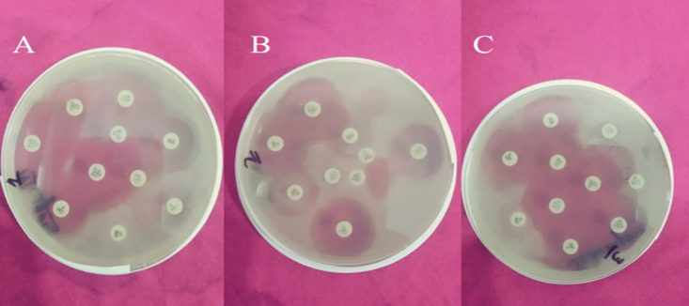
Figure A, B and C show antibiotics sensitivity of isolated P.aeruginosa from Mingora region, Matta region and Islampur region respectively.
Recent Publications
- AL-Aali, K. Y. (2016). Microbial Profile of Burn Wound Infections in Burn Patients, Taif, Saudi Arabia. Archives of Clinical Microbiology.Heilig M, Egli M (2006) Pharmacological treatment of alcohol dependence: Target symptoms and target mechanisms. Pharmacology and therapeutics 111:855-876.
- Chahal, K. K., Dhaiwal, K., Kumar, A., Kataria, D., & Singla, N. (2017). Chemical composition of Trachyspermum ammi L. and its biological properties: A review. Journal of Pharmacognosy and Phytochemistry, 6(3), 131-140.Room R, BaborT, Rehm J (2005) Alcohol and public health. Lancet 365: 519-530.
- Davies, J. C. (2002). Pseudomonas aeruginosa in cystic fibrosis: pathogenesis and persistence. Paediatric respiratory reviews, 3(2), 128-134.
- Kadir, A. R. (2007). Paediatric burns in Sulaimani, Iraq. Annals of burns and fire disasters, 20(3), 121.
- Mousa, H. A. L. (2016). Fungal Burn Wound Infection. Fungal Genom Biol, 6, e121.
- Pollack, M. (2000). Pseudomonas aeruginosa. Principles and practice of infectious disease, 2310-2334.

Biography
Dr. Muhammad naziruddin
Email:nazirkhattak@yahoo.com

Notes/Comments:

