The Unexpected Discovery of Orally Efficacious β-carboline Antimalarials
Jopaul Mathew¹, Sha Ding¹, Kevin Künz¹, Joshua H. Butler², Emilio F. Merino², Zaira Rizopoulos⁴, Maxim M. Totrov³, Maria B. Cassera² and Paul R. Carlier¹*
¹Department of Chemistry, Virginia Tech, Blacksburg, VA, 24061 (U.S.A)
²Department of Biochemistry and Molecular Biology and Center for Tropical and Emerging Global Diseases
(CTEGD), University of Georgia, Athens, GA 30602
³Molsoft, San Diego, CA, 92121
⁴Medicines for Malaria Venture(MMV)

Abstract
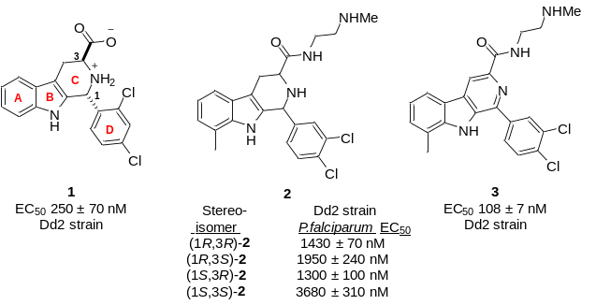Malaria, caused by the parasite Plasmodium, remains one of the deadliest infectious diseases worldwide. The development of resistance to all current antimalarials mandates the discovery of new drug candidates. Our previous work identified 1 as inhibitor of the MEP pathway, which produces essential isoprenoid precursors (IPP and DMAPP) in the malaria parasite P. falciparum. To search for new antimalarial structures, we constructed a generalized 3D pharmacophore based on 1 and 92 of its analogs and used it for a virtual ligand screen of a publicly available database of antimalarial hits. This exercise identified 2 (undefined stereochemistry), which was reported to have nearly the same potency of 1. All four stereoisomers of 2 were synthesized, but none were potent antimalarials. Serendipitously, the β-carboline byproduct 3 (formed in the synthesis of 2) proved to be more potent in vitro than 1 and cleared malaria infection in mice following oral administration. In this talk I will discuss the emerging structure-activity relationship within this scaffold, the animal efficacy model used, ADME-Tox and PK of 3, and outline remaining challenges to improve drug-like properties.

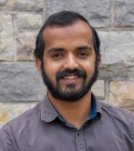
Image

Recent Publications
- “Antimalarial Compounds and Uses Thereof”, PCT/US2021/024542, publication date 09/30/2021
- Mathew J, Ding S, Kunz K, Stacy ES, Butler JH, Haney R, Merino EF, Rizopoulos Z, Totrov M, Cassera MB, Carlier PR (2022) Malaria Box-inspired Discovery of N-aminoalkyl-β-carboline-3-carboxamides, a Novel Orally-active Class of Antimalarials.Submitted to ACS Med. Chem. Lett.
- Bankar SK, Mathew J, Ramasastry SSV (2016) Synthesis of Benzofurans via Acid Catalyzed Transacetaliztion/Fries-Type O→C Rearrangement/Michael Addition/Ring-Opening Aromatization Cascade of β-Pyrones. Chem. Comm. 52:5569.
- Manisha, Dhiman S, Mathew J, Ramasastry SSV (2016) One-pot Relay Catalysis: Divergent Synthesis of Furo[3,4-b]indoles and Cyclopenta[b]indoles from 3-(2-aminophenyl)-1,4-enynols. Org. Biomol. Chem. 14, 5563

Jopaul Mathew
Jopaul Mathew is currently(2017-present) doing his PhD in discovering and developing orally efficacious Betacarboline antimalarials under the guidance of Dr. Paul R Carlier, Department of chemistry Virginia Tech University, USA. This research group was able to develop a drug lead which can be optimized to a drug candidate for treating malaria in near future. He was graduated with an integrated dual BS-MS degree (2011-2016) in Chemistry from Indian Institute of Science Education and Research, Mohali, India.
Email: jopaulm6@vt.edu

Notes/Comments:

