Title: Computational and in-vivo GABA-ergic screening of some newly designed and synthesized molecules of 1,3,4-oxadiazole and 2(3H)furanone moiety.
¹Arvind Kumar, ¹Vaishali
¹Department of Pharmaceutical Chemistry, S D College of Pharmacy & Vocational Studies, Muzaffarnagar, Uttar Pradesh, India
Keywords: GABA, oxadiazole, furanone, PTZ, anti-convulsant.
- Abstract Body
A number of new chemical structures have been design and screened through 3D structure catalytic site of Gamma-Amino-Butanoic-Acid receptor (pdb code: 3IP9). The Lamarckian genetic algorithm was implemented in Auto Dock 4.0 on Fedora Linux WS 3.0 and carried out comparative computational experiments of all design structures with the known Atu2422-GABA receptor in complex with GABA. Best 10 structures have been selected on the basis of least mean binding energies and docking positioning. Selected structures were synthesized through convenient synthetic methods. The core moiety of all synthesized compounds belongs to 2(3H)-furanone and 1,3,4-oxadiazole. All synthesized compound were characterized by H¹NMR, FTIR spectrometry and C,H,N elemental analysis. In-vivo evaluation of all synthesized compounds was carried out on male albino mice using PTZ model for anticonvulsant activity. The test drug C-46, C-52 and C-55 was found to be comparable to that of Diazepam as standard drug as they reduce the convulsion rate and percentage of mortality protection.
- Image
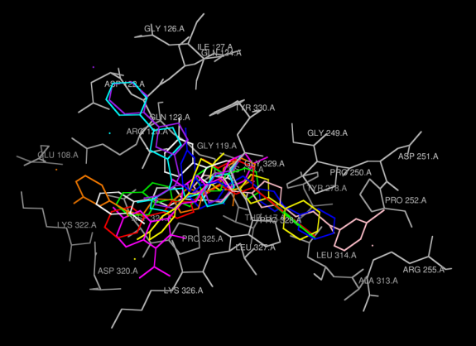
- Reference:
- Yi-chen, C.; Fang-Rong, C.; Yang-chang,W., Tetrahedron Lett., 1999, 40, 7513-7514; C.A., 132, 2037 K (2000).
- Doherty, J.D.; Hattox, S.E.; Snead, O.C.; Roth, R.H., J. Pharmacol. Exp. Ther., 1978, 207, 130.
- Pattan, S. R.; Rabra, P. A.; Pattan, J. S.; Bukittagar, A. A.; Wakale, V. S.; Musmade, D. S., Ind. J. Chem., 2009, 48(B), 1453-1456.
- Omar, A.; Mohsen, M. E.; Abdul, W. O. M., J. Heterocycl. Chem., 1984, 21, 1415
- Biography:
Dr. Arvind Kumar has completed Master of Pharmacy from Hamdard University, New Delhi, India and Ph.D in 2011 from Jaipur National University, Jaipur, India. He is the Director of S D College of Pharmacy & Vocational Studies in India. He published more than 27 papers in reputed journals. He guided more than 40 PG students of pharmacy field. His research area includes new drug discovery from synthetic medicinal chemistry and natural product.
- Presenting author details
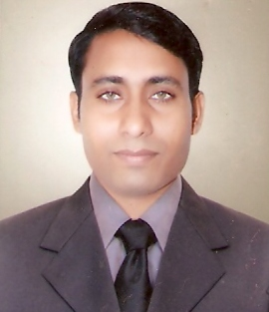
Full Name: Dr. Arvind Kumar
Contact Number: +919837294299, +918937095010
Twitter account: @DrArvin28077319
Linked In account: Arvind Kumar
Session name/ Number: Global Medicinal Chemistry and GPCL Summit
Category: Oral presentation
Passport number: Applied

