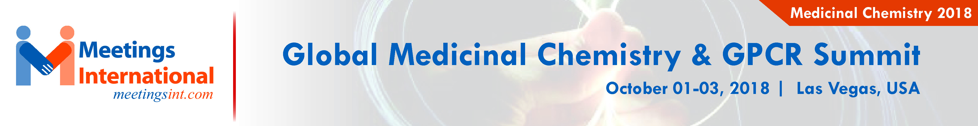

Abstract Template

New Extraction Methods of Natural compound from Iranian Herbal and their application in Modern Medicine
Mohammadbagher Rezaee
Department of Medicinal plants & By-products,
Research Institute of Forest and Ranglands, Tehran, Iran
mb.rezaee@gmail.com.

Keywords: Phytochemistry, Herbal, Curcues sativa, Taxsus bacata, alkaloid,Tanen, terpenoids and antioxidant

- Abstract

Today renewable natural resources in different aspects play an important role. Iran by great physicians e.g. Zakariyyā-ye Rāzī, (854–925 CE), was a chemist, philosopher, and Avicenna, as the father of early modern medicine. Iran is located in Middle East; our botanical scientists are identified more than 10.000 plants species, out of these abut 2500 species are medicinal plants e.g. Curcues sativa, Taxsus bacata, hypericum perferatum and Carum carvi. Phyto-chemistry studying of medicinal plants could provide healthy nutrition and components to make drug out of it for the society. So in this research the plant samples were collected from natural lands and identified their components and pharmaceutical uses. The parts of plants as leaf, root, steam, seed and flower contain different amounts of components like phenol, alkaloid,Tanen, terpenoids and antioxidant or antibacterial activity. So after solvents extraction, next step is purifying them. Naturally in the formulation stage selected active compound are using. As the use of herbal medicines has increased, so too have the reports of suspected toxicity and adverse events. So we most tack care of using much of them. In this presentation also I am going to tell about Phyto-chemical screening of some medicinal and Aromatic plants, and traditionally patients consuming these plants as herbal remedies. Finally Pharmacological studies on therapeutic effects of the indigenous plants mentioned in this study are necessary.

Image:
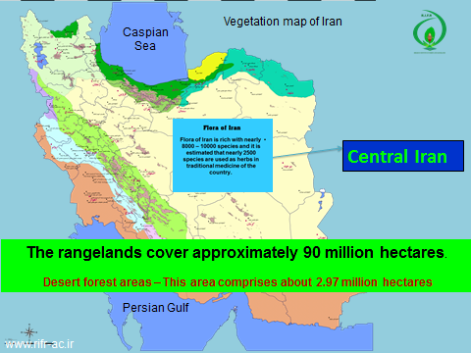
- Reference:

- K. M. Wu, H. Ghantous, and D. B. Birnkrant, “Current regulatory toxicology perspectives on the development of herbal medicines to prescription drug products in the United States,” Food and Chemical Toxicology, vol. 46, no. 8, pp. 2606–2610, 2008.
- W. Lam, S. Bussom, F. Guan et al., “Chemotherapy: the four-herb Chinese medicine PHY906 reduces chemotherapyinduced gastrointestinal toxicity,” Science Translational Medicine, vol. 2, no. 45, Article ID45ra59, 2010.
- Introduction to Toxicology, 3rd ed. John Timbrell, Informa Healthcare. 2001
- Council of Scientific and Industrial Research, National Institute of Science Communication and Information Resources. The useful plants of India. New Delhi: National Institute of Science Communication, 2000.

Biography:

I am Iranian scientist. I did my PhD. and Research work on Photochemistry or chemistry (Ag). And up to now my personal life for doing research with our co-worker on cultivation, extraction, formulation and produce natural products out of medicinal and Aromatic plants. So we designed research apparatuses and pilot of essential oil distillation and herbal extraction. Published 6 Books on my subjects in Persian language and add international of two chapters of bio-activity of herbal extracts or essential oil on bacteria's. Finish it 65 projects with MSc. and PhD thesis students on medicinal plants. Publish more than 200 papers on this topic and related on this, in national and international (ISI) journals. Know my position are as scientist in Research Institute Forests and Rangelands (RIFR) -Tehran-IRAN, Chairman of "Union Medicinal plants of Iran" (UMPI) and chair member of "Iranian medicinal plants society" (IMPS). I got three national award abut selected and important medicinal plant as natural product or instead of synthetic medicine and bio-logical uses. And so on…
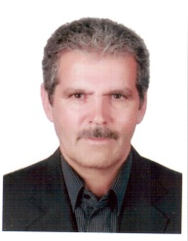
Mohammadbagher Rezaee
+98 9121932565
Research Institute of Forests and Rangelands Category: Oral presentation
Passport Number: k30866111

Copyright © 2016-2018 Meetings Int PTE Ltd, All Rights Reserved.
Meetings Int.Pte Ltd

28 MAXWELL ROAD, #03-05 RED DOT TRAFFIC, SINGAPORE (069120)
Contact Number: +6531080483
Web: https://www.meetingsint.com/conferences/medicinalchemistry |
E-mail: medicinalchemistryconference@meetingseries.org |
Email: medicinalchemistry@annualmeetings.net

