Abstract

Title: Multicomponent reaction to synthesize 3,5-dicyano-6-sulfanylpyridine and its derivatives

Mayasim Almotairi, Naga Srilekha Somu¹, Nwal Alruwaili ¹, Jin Jin¹, Shaozhong Zhang¹
¹Department of chemistry, Western Illinois University, Macomb, IL 61455, USA

Keywords: Multicomponent reactions (MCR), scaffolds, 4-aryl-6-sulfanylpyridine, malononitrile, alkylation

- Abstract Body
Multicomponent reactions (MCR) have gained popularity over the past few decades in the world of chemistry. (MCR) is a chemical reaction where 3 or more compounds react together to produce a one product. The concept of privileged medicinal scaffolds was originally introduced by Merck researchers, during the course of their work on benzodiazepines, recently acting as a guiding principle in modern drug discovery. Privileged scaffolds generally consist of a rigid ring structure such as a heterocyclic ring. 3,5-Dicyanopyridines are an important privileged heterocyclic scaffold.
In our research, we explored the methodology to synthesize 4-aryl-6-sulfanylpyridine derivatives by MCR. The derivatives of 4-phenylpyridine are reported to show excellent biological activities. A three-component reaction of 4-anisaldehyde, malonitrile, and NaSH produced a very important intermediate-2-amino-3,5-dicyano-6-mercapto-4-(4-methoxyphenyl)-pyridine. Alkylation reaction on sulfur of this intermediate will result in various 3,5-dicyano-6-sulfanyl pyridine products as desired. All products were characterized by ¹H NMR and ¹³C NMR spectroscopy.

Image:

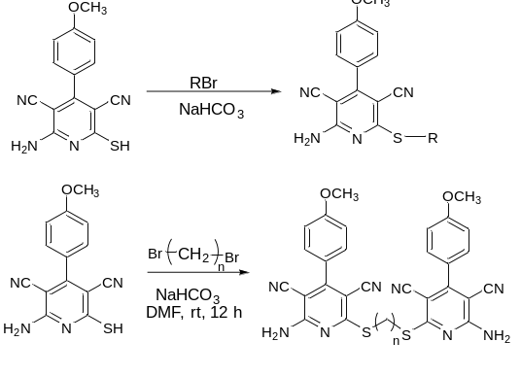
- Reference:

- Chang, L. C., Jacobien K. Von Frijtag Drabbe Künzel, Mulder-Krieger, T., Spanjersberg, R. F., Roerink, S. F., Hout, G. V., . . . Ijzerman, A. P. 2005. A Series of Ligands Displaying a Remarkable Agonistic−Antagonistic Profile at the Adenosine A1Receptor. Journal of Medicinal Chemistry, 48(6), 2045-2053.
- Evdokimov, N. M., Magedov, I. V., Kireev, A. S., & Kornienko, A. 2006. One-Step, Three-Component Synthesis of Pyridines and 1,4-Dihydropyridines with Manifold Medicinal Utility. ChemInform, 37(29).
- Evdokimov, N. M., Kireev, A. S., Yakovenko, A. A., Antipin, M. Y., Magedov, I. V., & Kornienko, A. 2007. One-Step Synthesis of Heterocyclic Privileged Medicinal Scaffolds by a Multicomponent Reaction of Malononitrile with Aldehydes and Thiols. ChemInform, 38(36).
- Ganem, B. (2009). ChemInform Abstract: Strategies for Innovation in Multicomponent Reaction Design. ChemInform, 40(23).

Biography:
I am Mayasim Almotairi. I am from Saudi Arabia. I am 27 years old. I did my bachelor degree of general chemistry from King Abdulaziz University. I have been trained at Eye hospital laboratory and Al-mostaqbal hospital. Now, I am on my final semester of master since chemistry.

Presenting author details

Full name: Mayasim Amer Almotairi
Contact number: +1 309-361-8461
Category: Synthetic Organic Chemistry

