Title: Synthesis and Antimicrobial Activity of Novel Adamantylthiourea, Isothiourea and Related Derivatives

Lamees S. Al-Rasheed 1, Fatmah A. Al-Omary 1, and Ali A. El-Emam, 2
1Department of Pharmaceutical Chemistry, College of Pharmacy, King Saud University, Riyadh 11451, Saudi Arabia
2Department of Medicinal Chemistry, Faculty of Pharmacy, University of Mansoura, Mansoura 35516, Egypt

Keywords: Adamantane, Thiourea, Isothiourea, Protein analysis, Antimicrobial

- Abstract Body (up to 250 words)
The incorporation of an adamantyl moiety into several molecules results in compounds with relatively high lipophilicity, which in turn can modify the biological availability of these molecules. Beyond increasing partition coefficients, the adamantyl group positively modulates the therapeutic index of many experimental compounds, through a variety of mechanisms. Several adamantane derivatives have long been known for their diverse biological properties, mainly as antiviral, antibacterial and antifungal. In addition, thiourea and isothiourea nucleus were reported to constitute the pharmacologically active moiety of several compounds. On these bases, new series of 1-adamantyl derivatives, in which the adamantyl moiety was covalently conjugated to arylthiourea or 4-Thiazolidinone moieties have been synthesized as potential bioactive agents.

The reaction of 1-adamantylamine with various aryl isothiocyanates yielded the corresponding 1-(adamantan-1-yl)-3-arylthiourea derivatives (A). The reaction of the thioureas (A) with various arylmethyl bromides and ethyl bromoacetate, in acetone, in the presence of potassium carbonate yielded the corresponding (Z)-3-(adamantan-1-yl)-1-aryl-S-(benzyl or substituted benzyl)-isothioureas (B) and ethyl 2-[(Z)-1-(adamantan-1-yl)-3-arylisothioureido]acetates (C). The 3-(adamantan-1-yl)-2-aryliminothiazolidin-4-ones (D) were obtained by cyclization of the ethyl 2-[(Z)-1-(adamantan-1-yl)-3-arylisothioureido]acetates (C) via prolonged heating with sodium acetate in ethanol. The structures of the compounds (A-D) were confirmed by analytical and spectral data and single crystal X-ray diffraction. Compounds (A-D) were tested for in vitro activities against a panel of Gram-positive and Gram-negative bacteria and the yeast-like pathogenic fungus Candida albicans, several derivatives produced good or moderate activities particularly against tested Gram-positive bacteria.
In this investigation, 27 new target compounds were prepared, 15 of them displayed potent antibacterial activity.

Image:
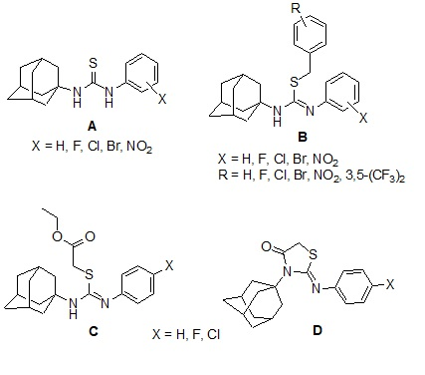

Biography:
Lamees Alrasheed has her expertise working as outpatient, intravenous and in patient pharmacist at Prince Mohammed bin Abdulaziz Hospital, Riyadh, Saudi Arabia while obtaining her master’s degree in medicinal chemistry.

Presenting author details

Full Name: Lamees Alrasheed Contact number: 00966555792772
Category: (Poster presentation)
Passport Number:T695141

