Title: The search for potential isoform-selective histone deacetylase inhibitors via Structure-based virtual screening

ABDULLAHI IBRAHIM UBA1,2, KEMAL YELEKCI1
1Department of Bioinformatics and Genetics, Faculty of Engineering and Natural Sciences, Kadir Has University, 34083 Fatih, Istanbul Turkey
²Center for Biotechnology Research, Bayero University, Kano, P.M.B 3011, B.U.K road, Kano, Nigeria

Keywords: Structure-based virtual screening, Molecular docking, Molecular dynamics simulation, ADMET prediction, Isoform-selective HDAC inhibitors

- Abstract Body (up to 250 words)
Histone deacetylases (HDACs) have gained increased attention as targets for anticancer drug design and development. HDAC inhibitors have proven to be effective for reversing the malignant phenotype in HDAC-dependent cancer cases. However, lack of selectivity of the many HDAC inhibitors in clinical use and trials is causes adverse effect. It is believed that, the continued identification of isoform-selective inhibitors will eliminate these undesirable adverse effects — a task that remains a major challenge due to high structural similarity around the HDACs active site. The present work attempted to identify isoform-selective inhibitors of individual members of class I HDACs by screening a large compound library containing ~ 200,000 compounds retrieved from Otava database. We identified a total of 40 compounds with high isoform selectivity and these compounds passed drug-likeness and absorption, distribution, metabolism, elimination and toxicity prediction tests. Furthermore, to study the stability of ligand binding modes, 10 ns-molecular dynamics (MD) simulations of the free HDAC isoforms and their complexes with respective best-ranked ligands were performed using nanoscale molecular dynamics (NAMD) software. The inhibitors remained bound to their respective targets over time of the simulation and the overall potential energy, root-mean-square deviation, root-mean-square fluctuation profiles suggested that the predicted inhibitors may be potential isoform-selective inhibitors or serve as promising lead compounds for further optimization.

Image:
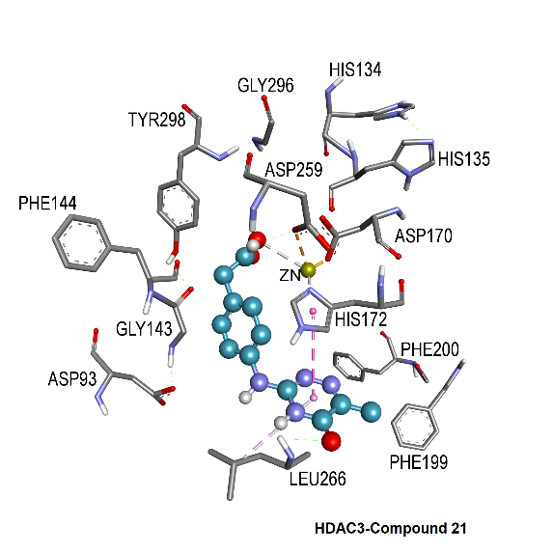
- Reference:

- Bolden, J. E., Peart, M. J. and R. W. Johnstone, 2006. Anticancer activities of histone deacetylase inhibitors. Nat Rev Drug Discov, 5:769–84.
- Negmeldin, A. T., Padige, G., Bieliauskas, A. V. and M. K. H. Pflum, 2017. Structural Requirements of HDAC Inhibitors: SAHA Analogues Modified at the C2 Position Display HDAC6/8 Selectivity. ACS Med Chem Lett, 8: 281–286.
- Park, H., Kim, S., Kim, Y. E. and S. J. Lim, 2010. A structure-based virtual screening approach toward the discovery of histone deacetylase inhibitors: Identification of promising zinc-chelating groups. ChemMedChem, 5: 591–597.

Biography:
ABDULLAHI IBRAHIM UBA has completed his PhD at the age of 31 years from KADIR HAS University Istanbul. He is a lecturer II at Center for Biotechnology Research, Bayero University Kano, Nigeria. He has published more than 17 papers in reputed journals and has been a reviewer for several scholarly journals.

Presenting author details


Full Name: ABDULLAHI IBRAHIM UBA Contact number: +905397743581 Twitter account: Linked In account:
https://www.linkedin.com/in/abdullahi-ibrahim-uba-06a6b684/
Session name/ number:
Category: Oral presentation
Passport Number: A08005981

Copyright © 2016-2018 Meetings Int PTE Ltd, All Rights Reserved.
Meetings Int.Pte Ltd

Company Registration No: 201524282R,28 MAXWELL ROAD, #03-05 RED DOT TRAFFIC, SINGAPORE (069120)
Tel: +1-302-231-6756 ; +6531080483| Toll Free no. +800-852-6126
Web: https://www.meetingsint.com/conferences/medicinalchemistry |
E-mail-medicinalchemistry@meetingseries.org

