The Effect of Different Variables on Indocyanine Green (ICG) in Imaging Guided Treatments
Ain Kim¹, Chad Yang³, Seung-Hee Han^{1,2}
¹University of Toronto, Ontario, Canada
²University Health Network, Ontario, Canada
³York University, Ontario, Canada

Keywords: Indocyanine Green (ICG), Fluorescence Imaging, Imaging-guided, Surgery
- Abstract Body
Fluorescence Imaging (FI) has become a major tool diagnostic tool in the surgical field where Indocyanine Green (ICG) is mainly used as contrast agents, as it is currently the most widely compatible, FDA-approved contrast agent. ICG stained particles emit fluorescent light when irritated by pulses of laser. For in vivo surgical imaging, however, ICG is used in either different concentrations or mixed with various viscous solutions to avoid dispersion to unnecessary areas. Depending on the mixture and the concentration, absorption levels will fluctuate and wavelengths may even shift from what is determined to be the norm. Similarly, ICG has limited capabilities in detection under certain depths. This can lead to inconsistent decisions among surgeons, further leading to reoccurring problems both during and post-surgery as detection may become faint or inaccurate. Due to its high contrast, high sensitivity and affordability, much research has been done on the properties of ICG but there currently is a lack of sufficient data on the varying shifts and absorption levels caused by different conditions. By determining and solidifying a spectrum of wavelengths that different ICG solutions emit depending on its concentration, mixture and depth, ICG detection can greatly be enhanced through better calibration. Ultimately, it will increase the effectiveness of non-invasive imaging-guided treatments and diagnostics.
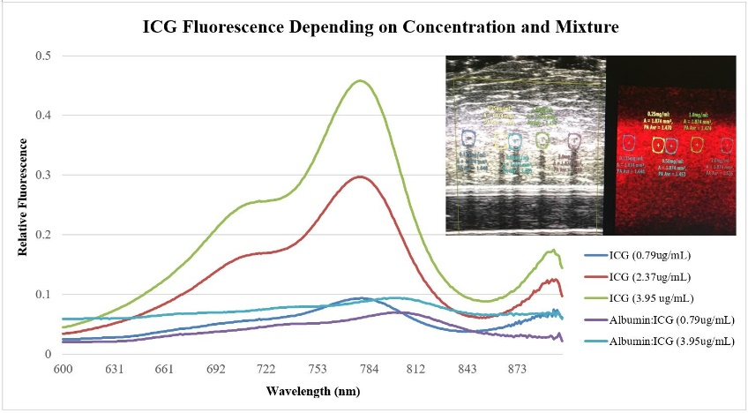
- Image

- Reference
1. Ankersmit M, Dam DAV, Rijswijk A-SV, Heuvel BVD, Tuynman JB, Meijerink WJHJ. Fluorescent Imaging with Indocyanine Green During Laparoscopic Cholecystectomy in Patients at Increased Risk of Bile Duct Injury. Surgical Innovation. 2017;24(3):245–252.
2. Boni L, David G, Mangano A, Dionigi G, Rausei S, Spampatti S, Cassinotti E, Fingerhut A. Clinical Applications of Indocyanine Green (ICG) Enhanced Fluorescence in Laparoscopic Surgery. Surgical Endoscopy. 2015;29:2046-2055.

- Biography
Ain Kim is a Life Science student in Neuroscience and Cell & Molecular Biology Double Major at University of Toronto. Her research projects at University Health Network are focused on non-invasive oncolytic gene delivery using High Intensity Focused Ultrasound (HIFU) and surgical diagnostics enhancement using ICG. She has received the 2017 Young Generation Poster Research Competition Award at the Association of Korean Canadian Scientists and Engineers Conference. Ain is also working as a research assistant at Princess Margaret Cancer Research Centre, focusing on the effects of Photodynamic Therapy (PDT) on pigmented and non-pigmented melanoma with varying delivery methods.
- Presenting Author Details
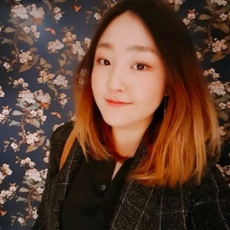

Full Name: Ain Kim
Contact number: 416-809-1349
Session name/ number: Optical Imaging
Category: Oral presentation
Passport number: HP637477

