Abstract Template

Title: Anatomical variants of the Circle of Willis: A Computed Tomography Angiography based study

Komal Priya¹, Prabath Sharma², Dr. Samir M P³, Arathy Mary John⁴
^{1&2}Interns,BSc MIT, Department of Medical Imaging Technology, SOAHS, Manipal Academy of Higher Education, Karnataka, India
²Assistant professor, Department of Radio diagnosis and Imaging, KMC, Manipal Academy of Higher Education, Karnataka, India
³Assistant professor, Department of Medical Imaging Technology, SOAHS, Manipal Academy of Higher Education, Karnataka, India

Keywords: Computed Tomography Angiography, Circle of Willis, Anterior circulation, Posterior circulation, Variants in COW, Multi planar reconstruction images, Maximum intensity projection images, Volume rendering images.

- Abstract Body
Knowledge of the presence of normal variants of Circle of Willis (COW) plays a crucial role in the diagnosis and management of cerebro vascular disorders¹. Based on radiological and anatomical studies, no more than 50% of the general population have a complete Circle of Willis (COW)². It is proven that Lack of knowledge of the anatomical variants of COW is the cause of approximately 10% of medical errors³. Sensitivity (81%–90%) and specificity (93%) of multi-detector CT angiography (CTA) are reported to be high in identifying the anatomical variants in Circle of Willis (COW)⁴. Aim of this study is to identify the frequency of anatomical variants in Circle of Willis by using Computed Tomography Angiography (CTA) and to determine the gender association of COW anatomical variants.
In this retrospective study COW CTA images of 400 patients are reading by a radiologist to identify the variants by using Multi Planar Reconstruction (MPR) mages, Maximum Intensity projection (MIP) images and Volume Rendering (VR) images.. Variants present in anterior circulation (A1 segment, Anterior Communicating artery (AComA) and A2 segment), posterior circulation (P1 segment, Posterior Communicating artery (PComA) and P2 segment), Middle cerebral artery (MCA), Basilar and vertebral artery, internal carotid artery (ICA), and others will be studied. Data will be analyzed by using SPSS and frequency of variants will be identified. Chi-Square test will be used to find out the association of variants among gender.

- Image:
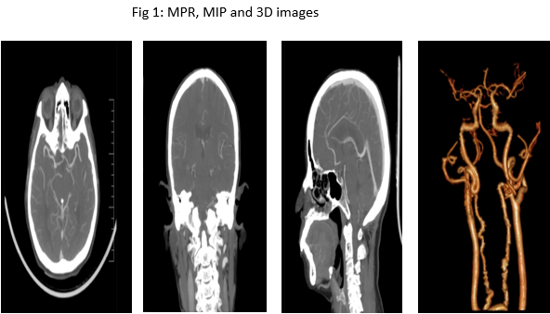

- Reference:
- Dimmick SJ, Faulder KC. Normal Variants of the Cerebral Circulation at Multidetector CT Angiography. 2009;29(4):1027–43
- Ren Y, Chen Q, Li Z-Y. A 3D numerical study of the collateral capacity of the Circle of Willis with anatomical variation in the posterior circulation. 2015;14 Suppl 1(Suppl 1):S11.
- KJiménez-Sosa MS, Cantu-Gonzalez JR, Morales-Avalos R, de la Garza-Castro O, Quiroga-Garza A, Pinales-Razo R, et al. Anatomical Variants of Anterior Cerebral Arterial Circle: A Study by Multidetector Computerized 3D Tomographic Angiography. 2017;35(3):1121–8.
- Klimek-Piotrowska W, Kopeć M, Kochana M, Krzyżewski RM, Tomaszewski KA, Brzegowy P, et al. Configurations of the circle of Willis: a computed tomography angiography based study on a Polish population. 2013;72(4):293–9

- Presenting author details


Full Name: Arathy Mary John
Contact number: +91 9742561199
Linked In account:
Session name/ number:
Category: Oral presentation
Passport Number: M1052241

