ASSESSMENT OF RV FUNCTION IN ASD BY USING TISSUE DOPPLER IMAGING AND STRAIN RATE IMAGING
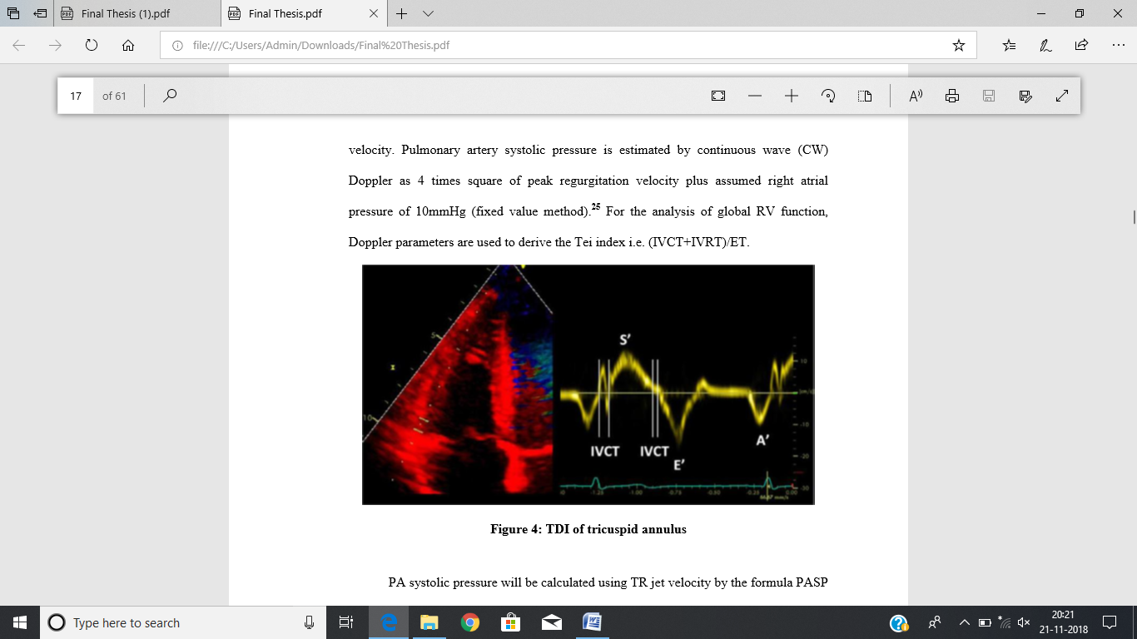
Keerthana Wilson

Abstract
Assessment of Right ventricular function plays a major role in the Evaluation of Atrial Septal Defect.The introduction of Doppler measurement of myocardial wall velocities (tissue Doppler imaging; TDI) and the recent development of strain rate imaging (SRI) technique have made a more adequate assessment of global and regional systolic and diastolic RV function possible. This study was conducted to evaluate the RV function by using newer echocardiographic indices such as Tissue Doppler Imaging & Strain Rate Imaging.

A prospective study was conducted among 64 adult patients admitted for ASD device closure in the department of cardiology at Narayana Institute of Cardiac Sciences (NICS) Bangalore. A basic apical 4chamber (A4CH) view was taken during echocardiography in which the tissue motion velocity is superimposed for real time colour display. TDI annular velocities during systole, early relaxation (Ea), and atrial systole (Aa) were possessed from RV free wall (FW) and inter ventricular septum at basal site in the A4CH view. Deceleration time (DT), isovolumic relaxation time (IVRT), isovolumic contraction time (IVCT) and ejection time (ET) were measured.For the analysis of global RV function, Doppler parameters are used to derive the Tei index i.e. (IVCT+IVRT)/ET. The stain and strain rate was estimated from the RV focused AP4CH view from tissue Doppler data, by calculating the velocity gradient. All these measurements were taken pre and post ASD closure.

Data was analysed by descriptive statistics and Wilcoxon sign rank test was used to find out pre and post procedural comparison. The study showed significant decrease in tissue Doppler parameters including annular velocity, strain and strain rate during immediate post device closure and increase after 1 month of closure. The RV function improved significantly post 1 month of closure compared with post 24 hours.

Figure No I: Lateral RV tricuspid annular waves
and duration

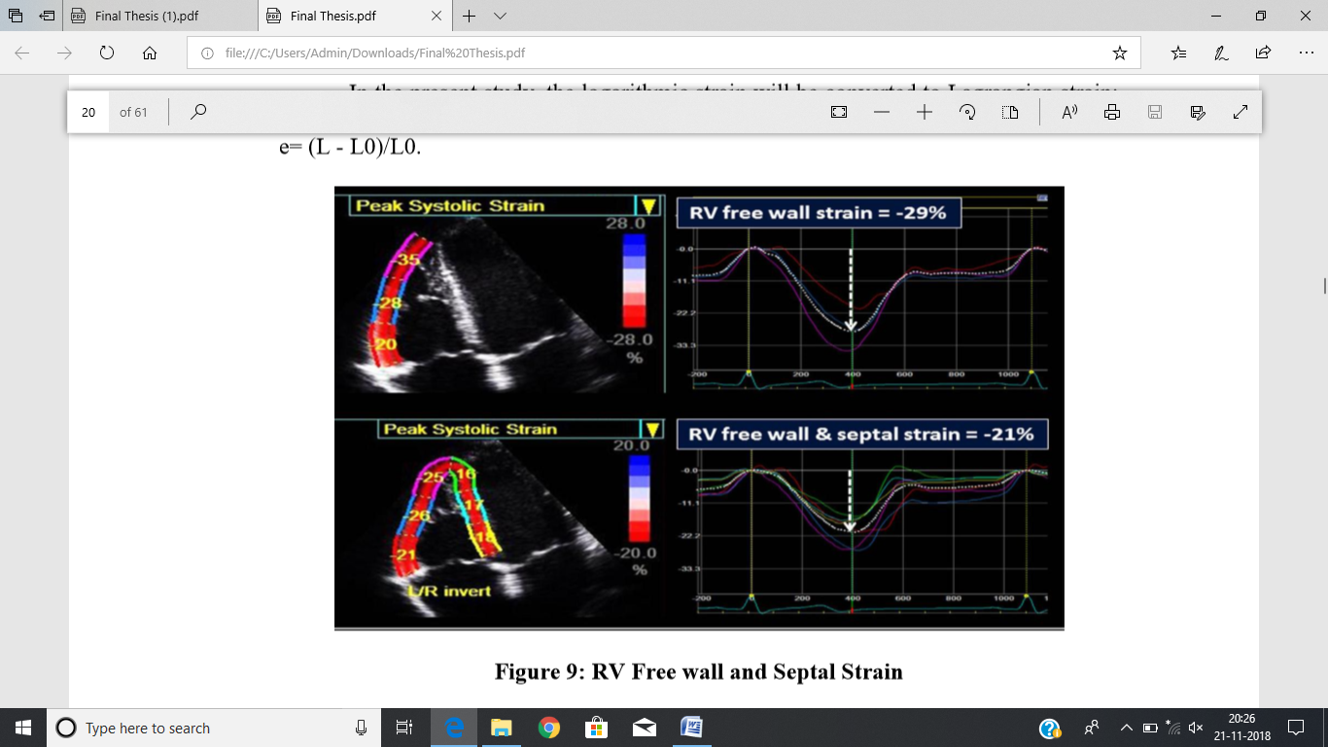
Figure NoII: RV Free wall and Septal Strain

 Ms.Keerthana Wilson
Assistant Professor and Echocardiographer in Yenepoya Medical College has completed my Masters in Echocardiography and Bachler in CardioVascular Technology from an excellent development team of a progressive hospital where knowledge and skills of an individual are counted , shared and encouraged. Am an expertise in echoardiographic evaluation and has passion in improving the health and wellbeing of the patients. I am having experience in, evaluation and teaching both in hospital and education institutions. I Intend to build a career in a challenging environment by adding value to the organization with my subject matter expertise, quick grasp of new facts, patience and skills, and work to be a model with a perfect blend of professionalism and human values.
Email: keerthanawilson@gmail.com

