

Title: A case of Kaposi's varicelliform eruption in adults

He lisha, Lu yonghong

Department of Dermatovenereology Chengdu Second People’s Hospital, Chengdu, 610017,China

Keywords: Adults; Kaposi's varicelliform eruption

- Abstract Body
A 24 - year-old woman, with facial papules, vesicles , itching for 1 week. Skin section circumstance: involving the entire face, Skin lesions in the left chin is the most serious.Grain to green bean size blisters on the basis of erythema,with clarified blister fliud ,and isolated umbilicus can be seen in part of blisters. The distribution of the lesions on the left chin is intensive and unmixing.The lesions can also be seen on the double eyelid and oral lip . Diagnosis: Kaposi's varicelliform eruption¹.

Image:

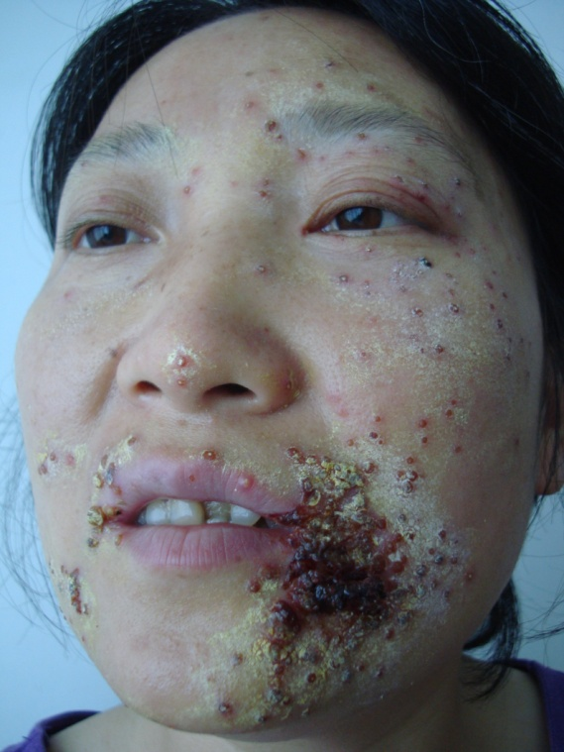
Reference:

1.Kramer S C , Thomas C J , Tyler W B , et al. Kaposi's
varicelliform eruption: A case report and review of the literature[J]. Cutis, 2004, 73(2):115-122.

Biography:
Yonghong Lu has completed her Master's degree at the age of 39 years from department of dermatology and venereology, Sichuan University. She is the Director of Chengdu Second People's Hospital, a premier Bio-Soft service organization.She has published 143 academic papers, edited 1 monograph on dermatology.

Presenting author details
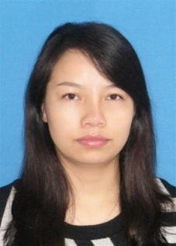
Full Name:
He lisha
Contact number:
15198037943
Twitter account: Linked In account:
Session name/ number:
Category: (Oral presentation/ Poster presentation) Oral presentation
Passport Number:



