

Title: Nevus Lipomatosus Superficialis coexisting with Fibrofolliculoma on the Knee：A rare case secondly discribed in the world

Yonghong Lu¹, Mengsha Ma^{1,2},Bin Yin¹,Min Lin^{1,2}
1Department of Dermatovenereology Chengdu Second People’s Hospital, Chengdu, 610017,China
2.Zunyi Medical College,Zunyi 563003,China

Keywords: Nevus Lipomatosus Superficialis, Fibrofolliculoma

- Abstract Body
A 50-year-old women had presented with nodules and plaques on the knee for 35 years(a).Histologic examination revealed abnormal position adipocytes distributed in the whole dermis(b),radiating follicular epithelium cords which is surrounded by loose connective anastomosed to form a scaffold-like appearance(c). A diagnosis of nevus lipomatosus superficialis coexisting with fibrofolliculoma was established. In our rare case,the hypothetical origin of dermal fat may be vascular endothelial cells or perivascular mesenchymal cells,which differed from the case first reported by a korean scholar¹. Surgical excision was implemented,and no recurrence was seen after three months’treatment(d)

Image:
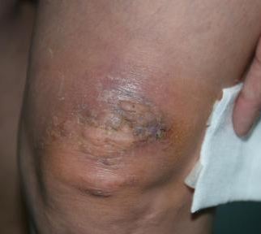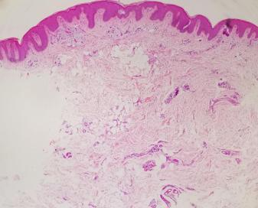
b
a
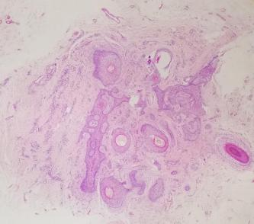 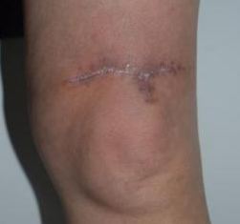
Reference:
c
d

1..Yun SJ,Kim EJ,Kim SJ et al.The association of naevus lipomatosus with pilosebaceous abnormalities including fibrofolliculoma.Br J Dermatol 2005;153: 209-10.

Biography:
Yonghong Lu has completed her Master's degree at the age of 39 years from department of dermatology and venereology, Sichuan University. She is the Director of Chengdu Second People's Hospital, a premier Bio-Soft service organization.She has published 143 academic papers, edited 1 monograph on dermatology.

Presenting author details

Full Name: Yonghong Lu
Contact number: 18908178072
Twitter account: Linked In account:
Session name/ number:
Category: (Oral presentation/ Poster presentation) Oral presentation
Passport Number:



