A World Without GPS- Can You Navigate Your Car with AI?
Barak Or, Founder and CEO
ALMA Technologies Ltd., Haifa, Israel

Abstract

Imagen you wake up in the morning and check your navigation app, only to discover that “it is searching for a network”. Imagen that while you are driving the navigation app is suddenly stops working. Can you still navigate?

The GPS’s positioning services is one of the important things we have access to every day, hour, and moment. You want to know where you are at all times, so you probably use a GPS. The system was originally limited to use by the United States military, where civilian use was allowed from the 80s.

Let’s focus only on car positioning. Today many drivers use Google Maps, Apple Maps, Waze, and other navigation apps to determine the best route to their destination. All these navigation apps rely on GPS availability to calculate the car position anytime, anywhere, and for that, you most probably use the and derive the best route, ETA, etc.

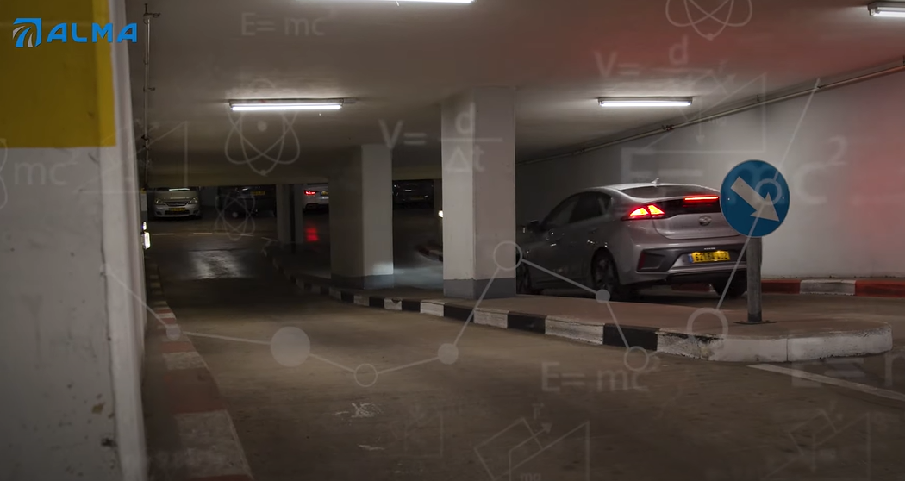

ALMA Technologies Ltd. was established to find a robust alternative for car positioning without relying on GPS. ALMA develops a unique positioning system based on low-cost inertial sensors and revolutionary AI algorithms that can operate without GPS. The system is mainly based on learning the road terrain and cutting-edge map-matching technique only by processing the inertial sensors in a real-time fashion. The relationship between the driver, road, car, and the map is consistently processed through the unique AI algorithm, allowing ALMA to feed many features to their deep learning models.

The company is led by ex-Google, ex-Qualcomm, and ex-Elbit employees who tackled various sensors-based positioning problems. The key perspective is to allow any driver and car to know their position with a low-cost accelerometer and gyroscope that can be found in any smartphone at a low-grade level. ALMA doesn’t require any regulation standards, high-cost sensors, and installation. It is just a simple “plug and play” SDK, allowing car drivers to keep on track.

Today there are two main R&D projects for the company: indoor and outdoor positioning. Many automotive OEM and Tier 1 companies have been dealing with indoor parking lot positioning for almost a decade. They are trying to make a huge sensor fusion to allow autonomous driving in this tough environment eventually. There, not only is GPS is unavailable, but also cameras, V2X communications, LiDAR, and other sensors have trouble operating indoor.

ALMA learns the geometric of the surface, matches the trajectory of the car to the parking lot map. ALMA unique AI-based engine provides a very accurate car speed allowing keeping the positioning with a relatively small error in a complicated parking lot with more than five floors, leading the driver to a specified spot, storing the parking position on the driver’s smartphone, and guiding the car to the right exit. Today, ALMA performs adjustments to enable indoor positioning and navigation for over 3M drivers in Israel.

ALMA also develops an outdoor positing solution for GPS-denied environments such as urban canyons and tunnels. There, the car driver can still have the positing parameters and keep navigating without connecting the GPS. Moreover, a hybrid mode in the developed SDK allows the use of the inertial sensors together with the GPS if available. This mode takes care of the quality of the GPS measurement in these environments, as it is insufficient for car drivers. Today ALMA makes the last adjustments to allow more than 100M users all over Europe, with improved positioning services, which are much more accurate, continuous, and cost-effective.

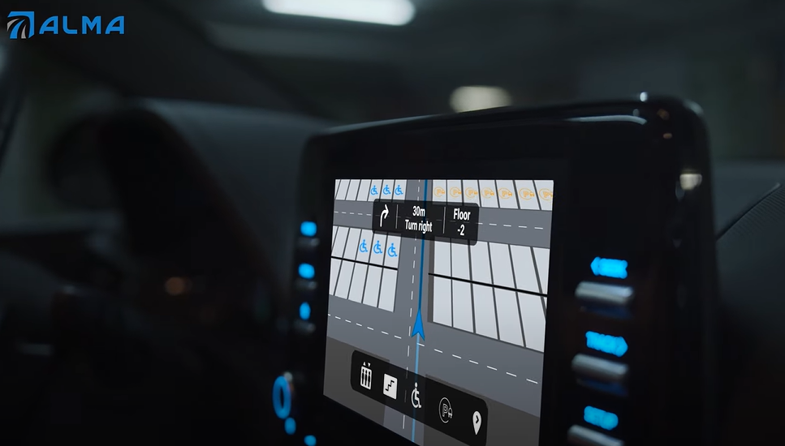

Recent Publications
- Freydin, Maxim and Or, Barak. "Learning Car Speed Using Inertial Sensors." arXiv preprint arXiv:2205.07883 (2022).
- Barak Or, Barak and Amos, Ido. “LengthNet: Length Learning for Planar Euclidean Curves” Smart Tools and Apps for Graphics - Eurographics Italian Chapter Conference (2021)
- Or, Barak. "Deep Learning for Inertial Navigation - A short review of cutting-edge deep learning-based solutions for inertial navigation." Towards Data Science (2020).
- Or, Barak. "What is IMU?" Towards Data Science (2021).
- Or, Barak. " Dead Reckoning is Still Alive!" Towards Data Science (2022).




Biography
Barak is a researcher in the fields of artificial intelligence and sensor fusion. Barak has authored several patents and articles that have been published in professional journals. He is the founder of ALMA Tech. LTD, an AI & advanced navigation company. He was with Qualcomm 2019-2020, where he mainly dealt with DSP and machine learning algorithms. Prior to that, he led the localization project at Autotalks. He received the M.Sc. (2018) and B.Sc. (2016) degrees in Aerospace Engineering, as also a B.A. in Economics and Management (2016, Cum Laude) from the Technion, Israel Institute of Technology. Barak is currently completing his Ph.D. at the University of Haifa, Israel.

Email: barak@almatechnologies.com

Presenting author details
Full name: Barak Or
Contact number: +972-544-880143
Linked In account: https://www.linkedin.com/in/barakor/
Session name/ number:
Category: Oral presentation

