Application of a probabilistic algorithm for automated identification of car loads in mines
Ilshat Khasanshin, PhD, Financial University under the Government of the Russian Federation, Russia

Abstract
Statement of the Problem: Many mines use wagon delivery of ore to the device for lifting the ore to the surface. To control the flow of ore, it is necessary to take into account each wagon loaded on the ore pass and unloaded on the wagon dumper. However, accurately determining the number of loaded wagons is a difficult task. The first factor is the large number of massive metal objects that lead to complex re-reflections of electromagnetic waves. The second factor is the difficult conditions of the mine. Mine conditions are technologically very complex, for example, if too large a piece of ore gets into the wagon from the ore pass, then it is simply blown up. This often leads to the failure of RFID tags or antennas. All these factors lead to the fact that it is often impossible to unambiguously judge which wagon was loaded. Methodology & Theoretical Orientation: The study was aimed to develop an effective method for automated accounting of each wagon at the railway transportation level. The general scheme of the algorithm: first, you need to build the cars in the order in which the train was formed, then knowing the sequence of cars and getting the data that was received before and after the activation of the ore pass, the most likely cars that were loaded are determined. Conclusion & Significance: Studies have shown that the developed probabilistic algorithm shows a higher percentage of coincidence with real loads compared to the deterministic one in the conditions of mines, where there are frequent cases of equipment failures. Verification of the algorithm was carried out by comparing it with the data of loading operations at the mines.

Image
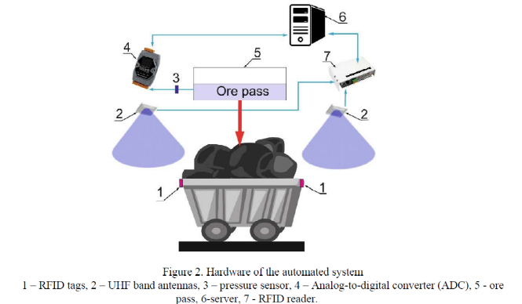
Recent Publications
- Mei-yu LI, Ke-qi HAN, Xiao-yong ZHANG, Xiao-lin LI, Yong-jun ZHAI, Wei-hu YU (2008) A management information system for mine railway transportation equipment, Journal of China University of Mining and Technology, Volume 18, Issue 3.
- Lars Barnewold, Bernd G. Lottermoser (2020) Identification of digital technologies and digitalisation trends in the mining industry, International Journal of Mining Science and Technology, Volume 30, Issue 6.
- Yu A Gerber et al 2018 IOP Conf. Ser.: Mater. Sci. Eng. 456 012042.
- Chaowasakoo, P. et al (2017) Digitalization of mine operations: Scenarios to benefit in real-time truck dispatching. International Journal of Mining Science and Technology.
5. Qing-hua GU, Cai-wu LU, Fa-ben LI, Chang-yong WAN (2008) Monitoring dispatch information system of trucks and shovels in an open pit based on GIS/GPS/GPRS, Journal of China University of Mining and Technology, Volume 18, Issue 2.

 Biography
Ilshat Khasanshin received a doctorate in aviation and space thermophysics. For a long time, he was engaged in process automation in various industries. Currently, he works as an associate professor in the Department of Data Analysis and Machine Learning, and is also the head of the Laboratory of Robotics, Embedded Systems and the Internet of Things.
Email: iykhasanshin@fa.ru

Notes/Comments:

