Autonomous Robot Evolution
Wei Li, PhD, University of York, York, UK

Abstract
This research will investigate the long-term vision of a technology enabling the evolution of entire autonomous robotic ecosystems that live and work for long periods in challenging and dynamic environments without the need for direct human oversight. Based on state-of-the-art 3D printing techniques with novel materials and a hybridised hardware-software evolutionary architecture - the research will address current weaknesses in robot design methodology by establishing self-reproducing robots that evolve their morphologies and controllers in real-time. Imagine an environment where autonomous systems (robots) are not designed by humans (or indeed designed at all) but are created through a series of steps that follow evolutionary processes. These robots will be “born” through the use of 3D manufacturing, with novel materials and a hybridised hardware-software evolutionary architecture. “Child” robots will learn in a safe and controlled environment where success will be rewarded. The most successful individuals will make available their genetic code for reproduction and for the improvement of future generations. Such a process will ultimately lead to a change in the way things are designed and manufactured. This research focuses on a disruptive robotic technology where robots are created, reproduce and evolve in real-time and real space. The long-term vision is a technology enabling the evolution of entire autonomous robotic ecosystems that live and work for long periods in challenging and dynamic environments without the need for direct human oversight. This means radically new autonomous systems are needed, where robots are conceived and born, rather than designed and manufactured. Such robots will fundamentally change the concept of machines, showcasing a new breed that can change their form and behavior, not in error but on purpose.
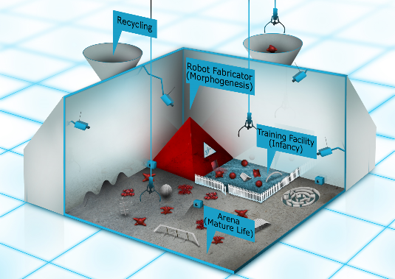

Recent Publications
- Buchanan, Edgar, Léni K. Le Goff, Wei Li, Emma Hart, Agoston E. Eiben, Matteo De Carlo, Alan F. Winfield et al. (2020) Bootstrapping Artificial Evolution to Design Robots for Autonomous Fabrication. Robotics, 4: 106.
- Buchanan, Edgar, Léni K. Le Goff, Emma Hart, Agoston E. Eiben, Matteo De Carlo, Wei Li, Matthew F. Hale et al. (2020) Evolution of diverse, manufacturable robot body plans. The 2020 IEEE Symposium Series on Computational Intelligence (SSCI), 2132-2139.
- Le Goff, Léni K., Edgar Buchanan, Emma Hart, Agoston E. Eiben, Wei Li, Matteo de Carlo, Matthew F. Hale et al. (2020) Sample and time efficient policy learning with cma-es and bayesian optimisation. In Artificial Life Conference Proceedings, 432-440.
- Hale, Matthew F., Mike Angus, Edgar Buchanan, Wei Li, Robert Woolley, Léni K. Le Goff, Matteo De Carlo et al. "Hardware design for autonomous robot evolution." In 2020 IEEE Symposium Series on Computational Intelligence (SSCI), 2140-2147.
- Hale, Matthew F., Edgar Buchanan, Alan F. Winfield, Jon Timmis, Emma Hart, Agoston E. Eiben, Mike Angus et al. (2019) The are robot fabricator: How to (re) produce robots that can evolve in the real world." In Artificial Life Conference Proceedings, 95-102.

 Biography
Wei Li received the B.Eng. degree in automation and the M.Eng. degree in control science and engineering from the Harbin Institute of Technology, China, in 2009 and 2011, respectively, and the Ph.D. degree from the University of Sheffield, U.K., in 2016. He is currently an Associate Professor with the Institute of AI and Robotics, Fudan University. He has published more than 30 academic articles in peer-reviewed journals and conferences, such as the IEEE Transactions on Robotics and NeurIPS. His research interests include robotics and computational intelligence, and especially self-organized systems, and evolutionary machine learning.
Email: liwei0502101@gmail.com

