Continuous Video Surveillance to predict danger of drowning using Computational Neural Network
Serigne Mansour DIOP, CS-Researcher MSc, ISIMS Sfax, Tunisia

Abstract (300 word limit)

Increasingly, computer vision is being used in automated swimming pool monitoring systems. Several studies have been proposed to overcome timeless surveillance drowning incidents based on the use of video footage to track the movement and position of humans.

Our project consists to build a system that automates the task of pool monitoring. We will analyze the video stream in real time and identify any behavior that characterizes a drowning danger for each swimmer in the pool.

This system is based on an extension of deep neural networks which consists of 3D to learn the spatio-temporal characteristics of the video stream.

We will use a spatio-temporal autoencoder, based on a 3D convolution network. The encoder part extracts the spatial and temporal information, then the decoder reconstructs the frames. Abnormal postures and behaviors are identified by calculating reconstruction loss.
Image
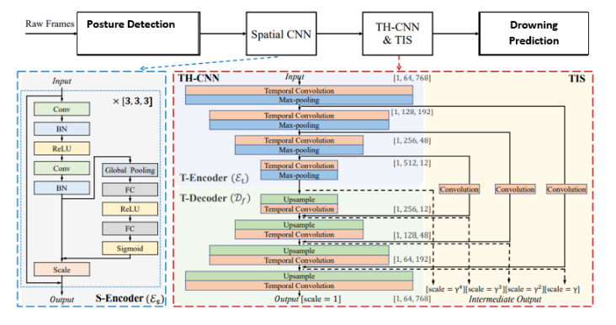
Recent Publications (minimum 5)
- Z. Du, S. Wu, D. Huang, W. Li and Y. Wang Spatio-Temporal Encoder-Decoder Fully Convolutional Network for Video-based Dimensional Emotion Recognition DOI 10.1109/TAFFC.2019.2940224, IEEE
- W. Rahmaniar and A. Hernawan Real-Time Human Detection Using Deep Learning on Embedded Platforms: A Review Journal of Robotics and Control (JRC) Volume 2, Issue 6, November 2021 ISSN: 2715-5072 DOI: 10.18196/jrc.26123
- J. Yang, J.P. Wilson and S.Gupta DARE: AI-based Diver Action Recognition System using Multi-Channel CNNs for AUV Supervision arXiv: 2011.07713v1 [cs.CV] 16 Nov 2020
- B. Esmaeili, A. AkhavanPour and A. Bosaghzadeh An Ensemble Model For Human Posture Recognition 2020 International Conference on Machine Vision and Image Processing (MVIP) Faculty of Engineering, College of Farabi, University of Tehran, Iran, 19 & 20 Feb. 2020
5. A.G.Howard, M. Zhu, B.Chen, D. Kalenichenko, W. Wong, T. Weyand, M. Andretto and H. Adam MobileNets: Efficient Convolutional Neural Networks for Mobile Vision Applications arXiv: 1704.04861v1 [cs.CV] 17 apr 2017.

Biography (150 word limit)
Serigne Mansour Diop is a computer scientist and inventor at the master's degree in the field of systems engineering. He has contributed to a lot of research in Artificial Intelligence, notably in Deep learning with his team based in Senegal and Tunisia. He also took part in international fairs for invention and innovation. He was delegated in Senegal by the French Federation of Inventors under the tutelage of Gerard Roquillon in 2018 and is delegated in Senegal to the Intarg International Exhibition in Poland.
Email: serignemansour.diop@isimsf.u-sfax.tn

Notes/Comments:

