Evaluation, Forecasting and Seasonal Analysis of an Extrusion Plastic Production Variables
By
¹Ejikeme, Ifeanyi Romanus and ²Ezeliora Chukwuemeka Daniel
¹² Department of Mechanical Engineering, Federal Polytechnic, Oko, Anambra State, Nigeria; email: rojykengrg@gmail.com +2348068947718¹ and cezeliora@gmail.com +2348060480087²
Abstract
The study forecast and expresses the seasonal analysis of the extrusion plastic production variables in Innoson Plastic Manufacturing Company, Nnewi, Anambra State, Nigeria. The research method adopted is the application of statistical tools to forecast and to express the seasonal influence of the variables. It statistically reveals the extrusion plastic production variable to understand what the data portrays and its influence on the variables. Time series decomposition analysis and winter’s forecasting methods used show that the appropriate quantity of the product that is necessary to be produced in January 2019 is 9416.11 and 10521.2units respectively. However, the seasonal analysis expressed that the seasonal index is high at the month of October and low at the month of November. The results shows that the industry should be conscious of highly influence of input variables and seasonal influence during production
Keywords: Forecast, winter method, Time series, Decomposition Analysis, Regression, Plastic, Production
- Introduction
In industrialization, the need to understand the trend of production and industrial growth with its development is of paramount importance to the industrial sectors. This is the key element to keep the industry alive, to remain competitive, to enhance its profitability and to grow industrialization with its economy of the nation. This gave rise to the applications of some selected forecasting methods that will help to understand the appropriate production variables in the case study.
Forecasting is the process of making statements about events whose actual outcomes (typically) have not yet been observed. A commonplace example might be estimation of some variable of interest at some specified future date. Prediction is a similar, but more general term. Both might refer to formal statistical methods employing time series, cross-sectional or longitudinal data, or alternatively to less formal judgmental methods. Usage can differ between areas of application: for example, in hydrology, the terms "forecast" and "forecasting" are sometimes reserved for estimates of values at certain specific future times, while the term "prediction" is used for more general estimates, such as the number of times floods will occur over a long period.
Risk and uncertainty are central to forecasting and prediction; it is generally considered good practice to indicate the degree of uncertainty attaching to forecasts. In any case, the data must be up to date in order for the forecast to be as accurate as possible.[1]

Categories of Forecasting Methods: Qualitative forecasting techniques are subjective, based on the opinion and judgment of consumers, experts; they are appropriate when past data are not available. They are usually applied to intermediate- or long-range decisions. Examples of qualitative forecasting methods are informed opinion and judgment, the Delphi method, market research, and historical life-cycle analogy.
Quantitative forecasting models are used to forecast future data as a function of past data; they are appropriate when past data are available. These methods are usually applied to short- or intermediate-range decisions. Examples of quantitative forecasting methods are last period demand, simple and weighted N-Period moving averages, simple exponential smoothing, and multiplicative seasonal indexes.
Naïve approach: Naïve forecasts are the most cost-effective objective forecasting model, and provide a benchmark against which more sophisticated models can be compared. For stationary time series data, this approach says that the forecast for any period equals the historical average. For time series data that are stationary in terms of first differences, the naïve forecast equals the previous period's actual value.
Time series methods: Time series methods use historical data as the basis of estimating future outcomes.

Causal / Econometric Forecasting Methods: Some forecasting methods use the assumption that it is possible to identify the underlying factors that might influence the variable that is being forecast. For example, including information about climate patterns might improve the ability of a model to predict umbrella sales. This is a model of seasonality which shows a regular pattern of up and down fluctuations. In addition to climate, seasonality can also be due to holidays and customs; for example, one might predict that sales of college football apparel will be higher during the football season than during the off season.[2]
Causal forecasting methods are also subject to the discretion of the forecaster. There are several informal methods which do not have strict algorithms, but rather modest and unstructured guidance. Alternatively, one can forecast based on, for example, linear relationships. If one variable is linearly related to the other for a long enough period of time, it may be beneficial to extrapolate such a relationship into the future.
Causal methods include:
- Regression analysis includes a large group of methods that can be used to predict future values of variable using information about other variables. These methods include both parametric (linear or non-linear) and non-parametric techniques.
- Autoregressive moving average with exogenous inputs (ARMAX)[3]
Quantitative forecasting models are often judged against each other by comparison of their in-sample or out-of-sample mean square error, although some researchers have advised against its use.[4]

Judgmental Methods: Judgmental forecasting methods incorporate intuitive judgments, opinions and subjective probability estimates.
Demand Forecasting: demand forecasting is the activity of estimating the quantity of a product or service that consumers will purchase. Demand forecasting involves techniques including both informal methods, such as educated guesses, and quantitative methods, such as the use of historical sales data or current data from test markets. Demand forecasting may be used in making pricing decisions, in assessing future capacity requirements, or in making decisions on whether to enter a new market.
Importance of Demand Forecasting: Production Planning and product scheduling a business firm cannot function in wilderness. It has to take crucial decisions about what to produce and how much to produce. This in return depends upon its estimate of future demand for the product. If the forecasted demand is likely to rise, the firm can plan expansion of its production capabilities to meet the growing demand at the right point of time. In the eventuality of declining demand.
Inventory planning Demand forecasting is useful for the firm to acquire the right quantum of inventory at the right point of time, to meet the needs of the production same time without unnecessarily locking up the finances of the firm in inventory accumulation.
Capital planning: Increased production requires increased capital resources fixed as well as working capital. Availability of demand forecasts helps the firm to mobilize the capital resources in time.
Marketing strategy: Demand forecasting will be useful in devising appropriate sales promotion or marketing strategies. If the demand forecasts indicate a declining trend in sales, it should resort to intensive sales promotion campaign to sustain its sales.
Manpower planning: A firm has to recruit and train the appropriate level of work force. This calls for forecasting the demand well in advance so that the required contingent of the labor resources could be obtained.
Pricing strategies: Devising and setting the optimum pricing depends upon the forecasted demand. If the forecasts indicate a declining share in the market demand then it has to slash the prices to sustain demand. Conversely, if the forecasts indicate increased demand for the prod act over a longer period it can charge higher prices subject to the other considerations. [15]
Components of Demand Forecasting: There are two main factors that help determine the type of forecasting method that will be used. They are: Time Frame and Behavior.
Time Frame: The length of the forecast depends on product market changes and susceptibility to technological changes. The classifications are generalizations. Short to Mid and Long range is all relative to the business and what is being forecast.
Short to Mid-Range forecasts are usually anywhere from daily to up to two years in length. They are commonly used to determine production and delivery schedules and to establish inventory levels.
Long-Range forecasts are generally over two years into the future. They are usually used for strategic planning. Strategic planning determines where the company is headed in the future. It is used to establish long-term goals, plan new products, enter new markets and develop new facilities & technology.
Behavior: Demand sometimes behaves in random and irregular ways. Other times it exhibits predictable behavior. The 3 main types of predictable behavior are trends, cycles, and seasonal patterns.
A trend is a gradual, long-term, upward or downward movement in demand. A current trend is the steady increase in sales of personal computers over the past few years.
A cycle is an up-and-down movement in demand that repeats itself over a longer time span. Automotive sales often behave in a cyclical pattern.
Application of Forecasting: The process of climate change and increasing energy prices has led to the usage of Egain Forecasting of buildings. The method uses forecasting to reduce the energy needed to heat the building, thus reducing the emission of greenhouse gases. Forecasting is used in the practice of Customer Demand Planning in everyday business forecasting for manufacturing companies. Forecasting has also been used to predict the development of conflict situations. Experts in forecasting perform research that use empirical results to gauge the effectiveness of certain forecasting models.[5] Research has shown that there is little difference between the accuracy of forecasts performed by experts knowledgeable of the conflict situation of interest and that performed by individuals who knew much less.[6]
Similarly, experts in some studies argue that role thinking does not contribute to the accuracy of the forecast.[7] The discipline of demand planning, also sometimes referred to as supply chain forecasting, embraces both statistical forecasting and a consensus process. An important, albeit often ignored aspect of forecasting, is the relationship it holds with planning. Forecasting can be described as predicting what the future will look like, whereas planning predicts what the future should look like.[8][9] There is no single right forecasting method to use. Selection of a method should be based on your objectives and your conditions (data etc.).[10] A good place to find a method, is by visiting a selection tree. An example of a selection tree can be found here.[11] Forecasting has application in many situations:
- Supply chain management - Forecasting can be used in Supply Chain Management to make sure that the right product is at the right place at the right time. Accurate forecasting will help retailers reduce excess inventory and therefore increase profit margin. Studies have shown that extrapolations are the least accurate, while company earnings forecasts are the most reliable.[12] Accurate forecasting will also help them meet consumer demand.
Limitations Forecasting Methods: Limitations pose barriers beyond which forecasting methods cannot reliably predict.

Performance limits of fluid dynamics equations: As proposed by Edward Lorenz in 1963, long range weather forecasts, those made at a range of two weeks or more, are impossible to definitively predict the state of the atmosphere, owing to the chaotic nature of the fluid dynamics equations involved. Extremely small errors in the initial input, such as temperatures and winds, within numerical models double every five days.[13]

Complexity introduced by the technological singularity: The technological singularity is the theoretical emergence of super intelligence through technological means.[14] Since the capabilities of such intelligence would be difficult for an unaided human mind to comprehend, the technological singularity is seen as an occurrence beyond which events cannot be predicted.
However, several researchers have undergone its research on forecasting but have not researched on the particular product selected on the case study company, to understand its future production variations in its output. This interests the research to venture into the forecasting of the product, in other to foreseen its future production output.
2 Research Method
The research method used for data analysis is the application of some forecasting models which are used to study the production variables. Data was analyzed by using forecasting model to predict the actual quantity needed to be produce in the plastic under production using the appropriate variables over the month in the manufacturing industry. The seasonal analysis tool will review the seasonal influence of the production variables in the system. The use of Minitab tool was made to evaluate and to test for the fitness variables.
Table 1: Presentation of Monthly Data for Extrusion Plastic Production
year | month | time | PVC(kg) | Stabilizer(kg) | Calcium(kg) | Steric(g) | Titanium(g) | Pigment(g) | P6(kg) | P6(units)
2018 | Jan | 1 | 3468 | 116 | 694 | 12 | 1 | 0.5 | 4290 | 2860
 | Feb | 2 | 2837 | 95 | 567 | 9 | 1 | 0.4 | 3510 | 2340
 | Mar | 3 | 9215 | 307 | 1843 | 31 | 2 | 1 | 11400 | 7600
 | April | 4 | 5529 | 184 | 1106 | 18 | 1 | 1 | 6840 | 4560
 | May | 5 | 9773 | 326 | 1955 | 33 | 3 | 1 | 12090 | 8060
 | June | 6 | 9337 | 313 | 1879 | 31 | 3 | 1 | 11625 | 7750
 | July | 7 | 13122 | 437 | 2624 | 44 | 3 | 2 | 16233 | 10822
 | Aug | 8 | 7300 | 243 | 1460 | 24 | 2 | 1 | 9030 | 6020
 | Sept | 9 | 8270 | 276 | 1654 | 28 | 2 | 1 | 10230 | 6820
 | Oct | 10 | 17352 | 578 | 3470 | 58 | 5 | 2 | 21465 | 14310
 | Nov | 11 | 1552 | 52 | 310 | 5 | 0.4 | 0.2 | 1920 | 1280
 | Dec | 12 | 7894 | 263 | 1579 | 26 | 2 | 1 | 9765 | 6510

3. Time Series Decomposition Analysis for the Product
Table 2: Seasonal Indices
Period Index
1 2838.44
2 -2211.06
3 -742.72
4 -1464.22
5 1065.61
6 513.94
Table 3: Time Series Decomposition Analysis
Time Output Trend Seasonal Detrend Deseason Predict Error
Jan 2860 6577.67 2838.44 -3717.67 21.6 9416.11 -6556.11
Feb 2340 6577.67 -2211.06 -4237.67 4551.1 4366.61 -2026.61
Mar 7600 6577.67 -742.72 1022.33 8342.7 5834.94 1765.06
Apr 4560 6577.67 -1464.22 -2017.67 6024.2 5113.44 -553.44
May 8060 6577.67 1065.61 1482.33 6994.4 7643.28 416.72
Jun 7750 6577.67 513.94 1172.33 7236.1 7091.61 658.39
Jul 10822 6577.67 2838.44 4244.33 7983.6 9416.11 1405.89
Aug 6020 6577.67 -2211.06 -557.67 8231.1 4366.61 1653.39
Sep 6820 6577.67 -742.72 242.33 7562.7 5834.94 985.06
Oct 14310 6577.67 -1464.22 7732.33 15774.2 5113.44 9196.56
Nov 1280 6577.67 1065.61 -5297.67 214.4 7643.28 -6363.28
Dec 6510 6577.67 513.94 -67.67 5996.1 7091.61 -581.61

Table 4: Forecasting result of time series decomposition
Period Forecast
Jan 9416.11

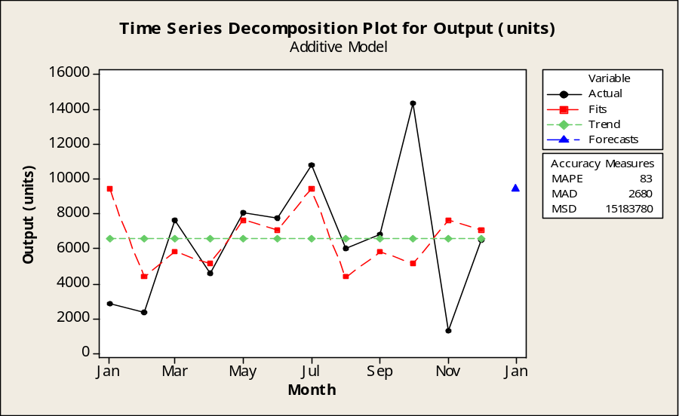
Fig 1: Time Series Decomposition Plot for Output (units)

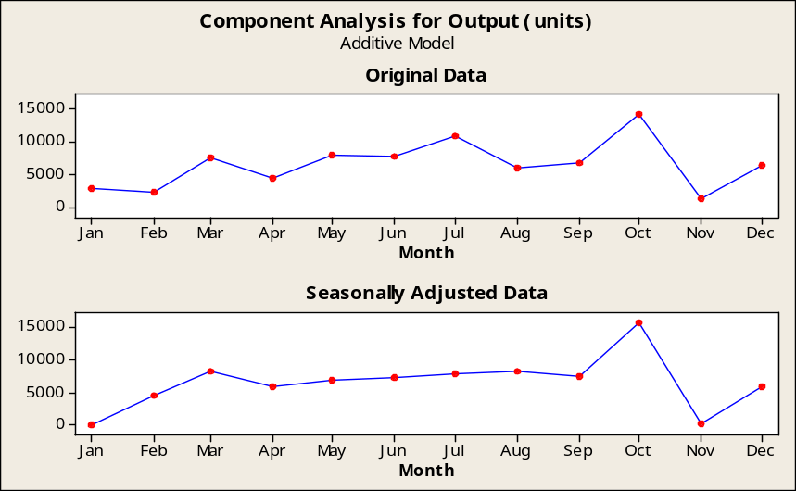
Fig 2: Decomposition - Component Analysis for Output (units)
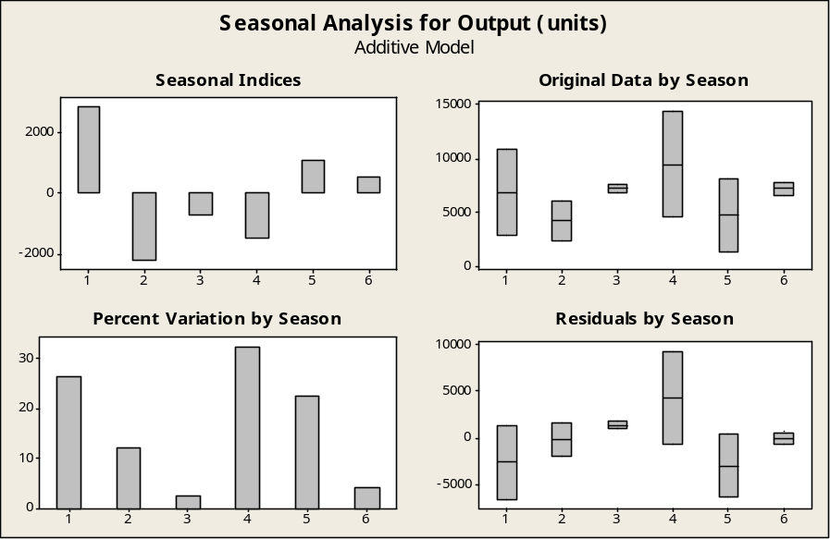
Fig 3: Decomposition - Seasonal Analysis for Output (units)

Table 4: Winters' Method for Output
Time Output Smooth Predict Error
Jan 2860 1752.9 2908.7 -48.67
Feb 2340 1764.7 2467.1 -127.12
Mar 7600 4225.3 5432.0 2168.00
Apr 4560 7540.3 9203.0 -4642.96
May 8060 4168.6 4912.7 3147.26
Jun 7750 8303.8 9607.3 -1857.31
Jul 10822 9011.0 10210.2 611.78
Aug 6020 6254.4 6995.1 -975.10
Sep 6820 12568.0 13865.0 -7044.98
Oct 14310 13760.9 14882.4 -572.41
Nov 1280 8916.7 9580.0 -8299.98
Dec 6510 10528.1 10968.5 -4458.48
Table 5: Forecasting result of Winter’s Method
Period Forecast Lower Upper
Jan 10521.2 3589.06 17453.4
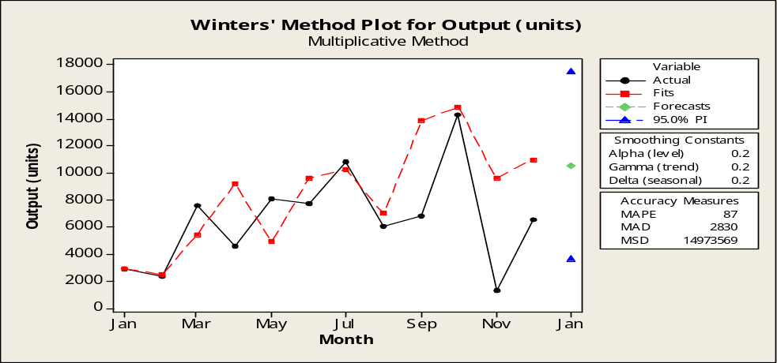
Fig 4: Winters' Method Plot for Output

4. ARIMA Method of Forecasting
Model Summary Chart
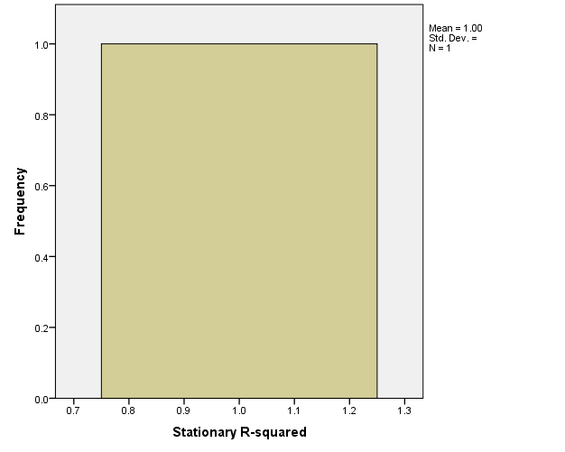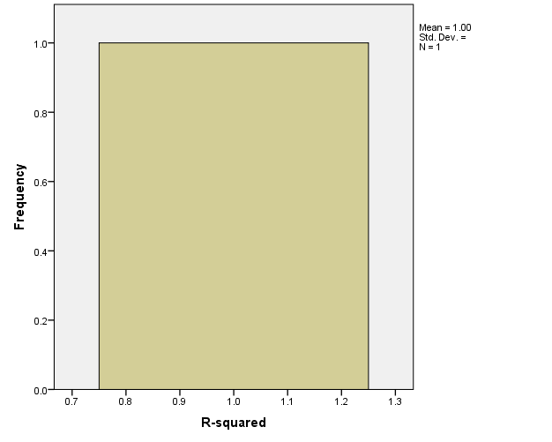
Fig 5: Stationary R-squared Chart Fig 6: Normal R-squared Chart

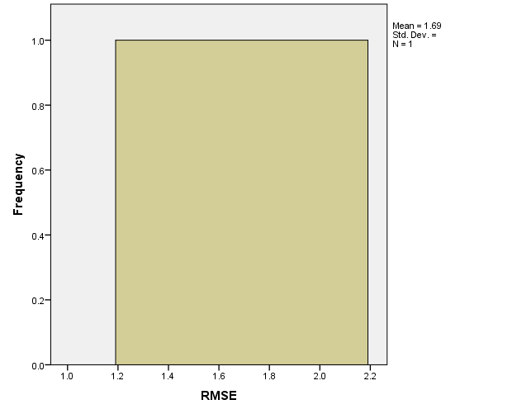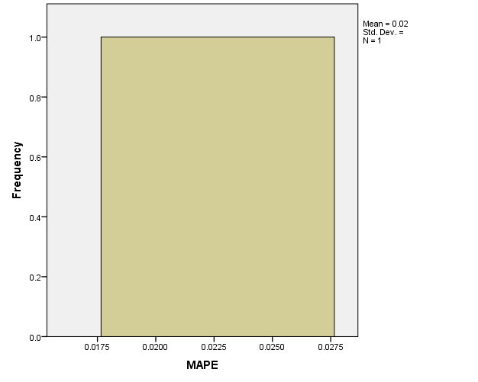
Fig 7: RMSE Model Summary Chart Fig 8: MAPE Model Summary Chart

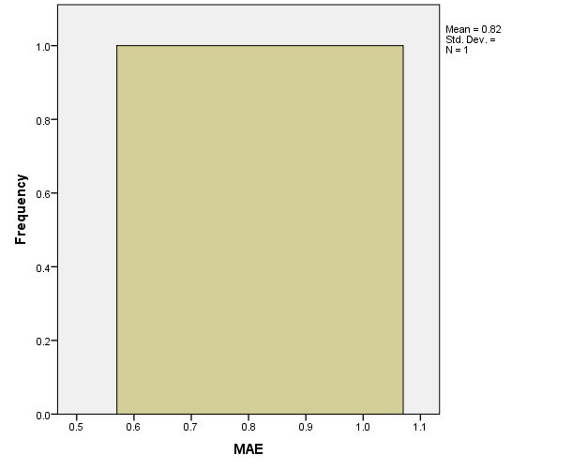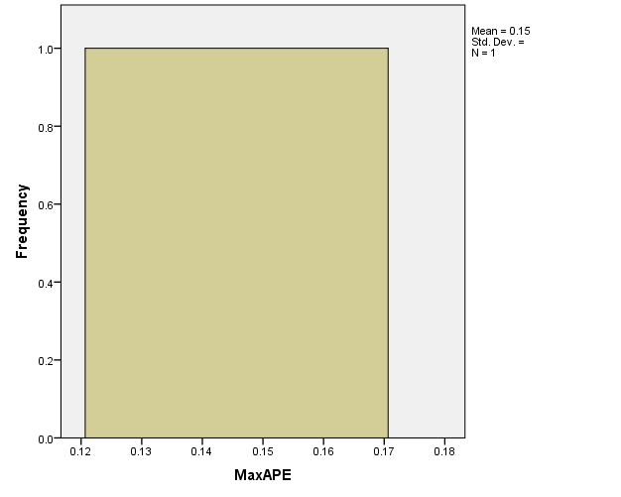
Fig 9: MAE Model Summary Chart Fig 10: MaxAPE Model Summary Chart

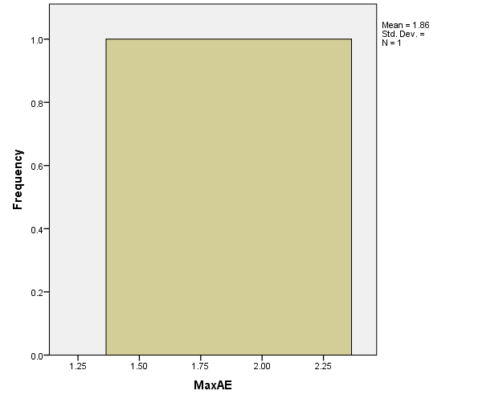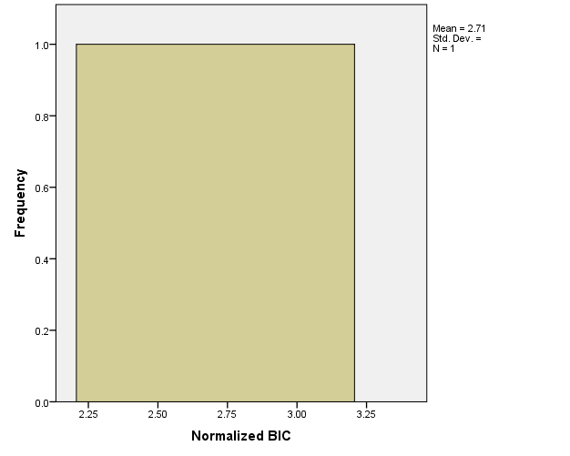
Fig 11: MaxAE Model Summary Chart Fig 12: Normal BIC Model Summary Chart

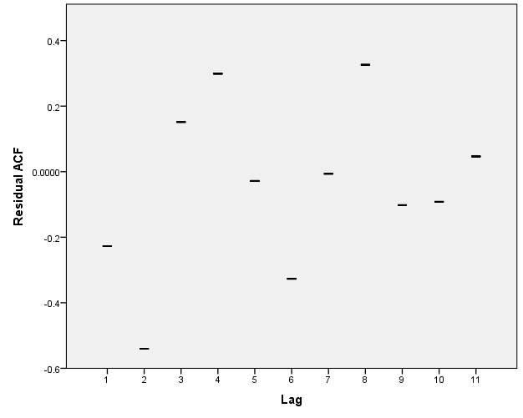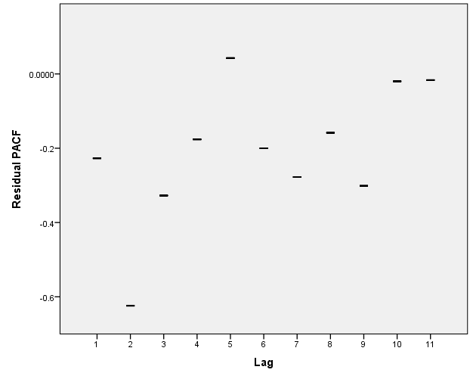
Fig 13: Residual ACF Model Summary Fig 14: Residual PACF Model Summary

5. ARIMA Model Summary

Table 6: Model Summary Fit
Fit Statistic | Mean | SE | Minimum | Maximum | Percentile
 |  |  |  |  | 5 | 10 | 25 | 50 | 75 | 90 | 95
Stationary R-squared | 1.000 | . | 1.000 | 1.000 | 1.000 | 1.000 | 1.000 | 1.000 | 1.000 | 1.000 | 1.000
R-squared | 1.000 | . | 1.000 | 1.000 | 1.000 | 1.000 | 1.000 | 1.000 | 1.000 | 1.000 | 1.000
RMSE | 1.691 | . | 1.691 | 1.691 | 1.691 | 1.691 | 1.691 | 1.691 | 1.691 | 1.691 | 1.691
MAPE | .023 | . | .023 | .023 | .023 | .023 | .023 | .023 | .023 | .023 | .023
MaxAPE | .146 | . | .146 | .146 | .146 | .146 | .146 | .146 | .146 | .146 | .146
MAE | .820 | . | .820 | .820 | .820 | .820 | .820 | .820 | .820 | .820 | .820
MaxAE | 1.864 | . | 1.864 | 1.864 | 1.864 | 1.864 | 1.864 | 1.864 | 1.864 | 1.864 | 1.864
Normalized BIC | 2.707 | . | 2.707 | 2.707 | 2.707 | 2.707 | 2.707 | 2.707 | 2.707 | 2.707 | 2.707

Table 7: Model Statistical Analysis
Model | Number of Predictors | Model Fit statistics |  |  |  |  |  |  |  | Ljung-Box Q(18) |  |  | Number of Outliers
Model | Number of Predictors | Stationary R-squared | R-squared | RMSE | MAPE | MAE | MaxAPE | MaxAE | Normalized BIC | Statistics | DF | Sig. | Number of Outliers
Output-Model | 7 | 1.000 | 1.000 | 1.691 | .023 | .820 | .146 | 1.864 | 2.707 | . | 0 | . | 0

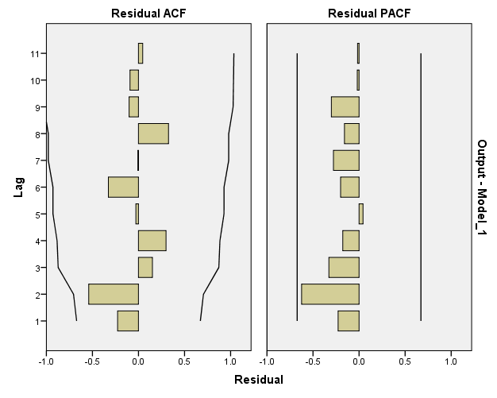
Fig 15: Residual Model Summary Chart

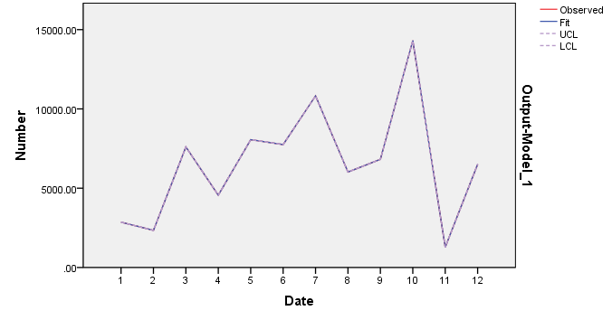
Fig 16: Output Model Summary Chart

Discussion
The results discuss are based on the charts, tables and the figures developed in this research. The literature review shows a concrete reason for embarking on the research. The methods applied are the application of both multiple input forecasting models and time series forecasting models. The time series forecasting models applied are time series decomposition analysis and winter’s forecasting methods. Time series decomposition analysis and winter’s forecasting methods used show that the appropriate quantity of the product that is necessary to be produced in January 2019 is 9416.11 and 10521.2units respectively.
Furthermore, the multiple inputs forecasting models applied are ARIMA and general multiple regression models to observe the effect of multiple input variables in forecasting the product. The models show that the input variables have one hundred percent coefficient of determination (that is the R-sq=100%) of the output variable. This shows that the input data is fit to predict the output variable. The multiple input forecasting methods also show that the models developed are not significance even though there is a good relationship of the determinant of the variables. It also revealed that the adjusted and the predicted coefficient of determination of the variables were not possible due to the fact that there is no significance value of the variables to the model. Therefore, time series are considered as an alternative model for the forecast.
However, the seasonal analysis expressed that the seasonal index is high at the month of January and July, while very low in the month of February and August. This shows a good comparative of results when compared with several models to understand the essence of model approximations and to always have a better solution of the result.

Conclusion
Having compared and analyze the application of forecasting techniques in plastic extrusion production variables, it was made clear the there is always a need to apply more than one methods in solving a problem for this will help to achieve a better result to a problem. The result will help the production manager in achieving preferable and more appropriate solutions to the production variables in the industry. The results showed that the industry should be conscious of their production variables and its seasonal effects in production.

References
  - Scott Armstrong, Fred Collopy, Andreas Graefe and Kesten C. Green. "Answers to Frequently Asked Questions". Retrieved May 15, 2013.
  - Nahmias, Steven (2009). Production and Operations Analysis.
  - Ellis, Kimberly (2008). Production Planning and Inventory Control Virginia Tech. McGraw Hill. ISBN 978-0-390-87106-0.
  - J. Scott Armstrong and Fred Collopy (1992). "Error Measures For Generalizing About Forecasting Methods: Empirical Comparisons". International Journal of Forecasting 8: 69–80.
  - J. Scott Armstrong, Kesten C. Green and Andreas Graefe (2010). "Answers to Frequently Asked Questions".
  - Kesten C. Greene and J. Scott Armstrong (2007). "The Ombudsman: Value of Expertise for Forecasting Decisions in Conflicts". Interfaces (INFORMS) 0: 1–12.
  - Kesten C. Green and J. Scott Armstrong (1975). "Role thinking: Standing in other people’s shoes to forecast decisions in conflicts". Role thinking: Standing in other people’s shoes to forecast decisions in conflicts 39: 111–116.
  - "FAQ". Forecastingprinciples.com. 1998-02-14. Retrieved 2012-08-28.
  - Kesten C. Greene and J. Scott Armstrong. [http://www.qbox.wharton.upenn.edu/documents/mktg/research/INTFOR3581%20-%20Publication% 2015.pdf "Structured analogies for forecasting"] (PDF). qbox.wharton.upenn.edu.
  - "FAQ". Forecastingprinciples.com. 1998-02-14. Retrieved 2012-08-28.
  - "Selection Tree". Forecastingprinciples.com. 1998-02-14. Retrieved 2012-08-28.
  - J. Scott Armstrong (1983). "Relative Accuracy of Judgmental and Extrapolative Methods in Forecasting Annual Earnings". Journal of Forecasting 2: 437–447.
  - Cox, John D. (2002). Storm Watchers. John Wiley & Sons, Inc. pp. 222–224. ISBN 0-471-38108-X.
  - Super intelligence. Answer to the 2009 EDGE QUESTION: "WHAT WILL CHANGE EVERYTHING?": http://www.nickbostrom.com/views/superintelligence.pdf
  - http://entranceguruji.in/read_matirial.php?maincourse=BBA-MBA%20(Matirials%20for%20business%20Management)&subject=Fundamentals%20of%20Economics&topic=Demand%20and%20supply&subsubject=Importance%20of%20Demand%20Forecasting.

