Title: Adaptive control for high speed on/off valve to preserve dynamic performance
Bin Zhang, Associate Researcher, Zhejiang University, China,
Qi Zhong, PhD, Zhejiang University, China
Hua-yong Yang, Professor, Zhejiang University, China

Abstract
High speed on/off valve (HSV) is an essential digital hydraulic component, and has been widely used for pressure and flow control in hydraulic systems, which require faster and more stable dynamic performance of HSVs to improve control preciseness. However, for some special kinds of HSVs, like ball structure and poppet structure valves which can reset by the hydraulic pressure instead of a traditional reset spring, their dynamic performance is greatly affected by the hydraulic pressure. Aiming at this problem, a self-correcting PWM control algorithm based on current feedback (SPWMCF) is proposed to improve and even maintain the HSVs’ original dynamic performance under changing pressures. Using current feedback analysis based on critical switching currents, the operational state of the HSV is estimated, and adaptive logic switching of different duty ratios of power source is also realized to preserve the dynamic performance of HSV under changing supply pressure to the maximum extent. Finally, a ball structure HSV is used as a research object, through numerical and experimental studies, it is demonstrated that the supply pressure has a great influence on the dynamic characteristics of the HSV, and the proposed control algorithm achieves the expected effect that the dynamic characteristics of the HSV is not only greatly improved but adapted to pressure changes, and the variation range of the dynamic performance can be controlled within 7.4% (0.3ms) under 4-20MPa operating conditions. The presented control algorithm is effective and can be applied in HSV-controlled systems to improve the robustness of the target actuator.

Image

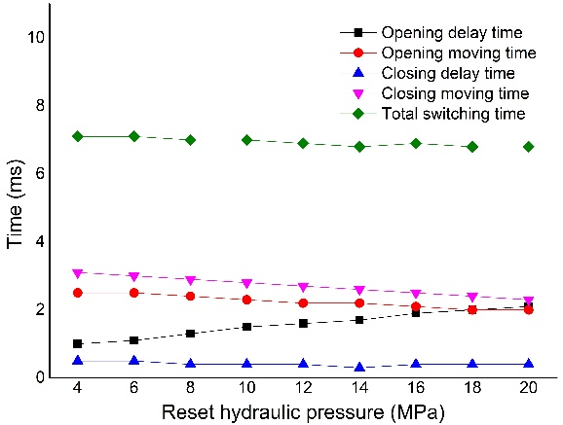
Switching performance of HSV under varying pressure with SPWMCF
Recent Publications (If Any)
- Zhong, Q., Zhang, B., Yang, H. Y., Ma, J. E., & Fung, R. F. (2017). Performance analysis of a high-speed on/off valve based on an intelligent pulse-width modulation control. Advances in Mechanical Engineering, 9(11), 1687814017733247.
- Zhong, Q., Zhang, B., Niu, M., Hong, H., & Yang, H. (2017, October). Research on Dynamic Performance of Independent Metering Control System. In ASME/BATH 2017 Symposium on Fluid Power and Motion Control (pp. V001T01A006-V001T01A006). American Society of Mechanical Engineers.

 Biography (150 word limit)
Bin Zhang, Ph.D. in Engineering, Associate Researcher. He received a doctorate in electromechanical and electrical engineering from Zhejiang University in 2009. He entered the post-doctoral workstation of Zhejiang University in February 2010 and was engaged in tissue engineering at the Institute of Biomedical Engineering at Oxford University in 2015 as a visiting scholar in 3D printing. He went to Kaohsiung No. 1 University of Science and Technology in Taiwan to conduct an interview cooperation on "axial piston pump pulse modelling and analysis". He mainly studied smart digital hydraulic pressure and applied in engineering machinery and agricultural machinery, field application, organize engineering biology 3D printing technology. He was in charge of 2 national natural science fund projects, 1 national support plan, 4 special projects and 1 project and more than 10 provincial and ministerial projects.
Name:Bin Zhang
Email: zbzju@163.com

Meetings Int. Pte Ltd

Company Registration No: 201524282R,28 MAXWELL ROAD, #03-05 RED DOT TRAFFIC, SINGAPORE
Web: https://www.meetingsint.com/conferences/mechatronics
E-mail: Mechatronics@annualmeetings.net
Contact: +6531080483

Copyright © 2016-2018 Meetings Int PTE Ltd, All Rights Reserved.

