Title: Determination of the critical growth rate and growth temperature for group-III elements segregation using two exchanges kinetic model
Vahid R Yazdanpanah, Mostafa Arjomandi, Pouria Hosseinzadeh, Shabnam Dadgostar, and Sattar Mirzakuchaki, School of Electrical Engineering, Iran University of Science & Technology(IUST), Tehran, Iran

Abstract
High-performance optoelectronic devices such as lasers, light emitting diodes (LED), solar cells, and detectors can be fabricated based on the complex quantum structures of III-V semiconductors. Quantum structures such as quantum wells (QW), quantum dots (QD), and superlattices can be grown with high quality using molecular beam epitaxy (MBE). However, the interface composition abruptness is a challenge due to the surface atom intermixing. The composition asymmetry in the quantum structures leads to the non-abrupt electronic band alignments that changes the optoelectronic device properties.
For the growth temperature below 600ºC, atomic arrangement in the crystal is determined by surface or near-surface processes and atoms cannot rearrange after burial. However, due to the surface mobility, atoms can displace on the growing surface. The increase of the surface mobility leads to the reduction of the growth defects; however, it may cause the so-called “surface segregation” that is the exchange between the sub-layer atoms with the impinging atoms on the growing surface. Surface segregation of atoms is driven by the differences in their binding and elastic energies. Several experimental and theoretical studies indicate that the group III atoms with weaker bond strength segregate to the surface, and therefore, it is expected to see more segregation for In atoms in comparison with Ga Atoms for similar growth conditions. Experimental results on the well known InGaAs/GaAs system show an Indium surface enrichment due to In segregation. A similar behavior has been observed for In atoms surface segregation in InGaAs QDs embedded in GaP matrix.
We studied the concentration profile of the group-III atoms for different growth parameters using the two exchanges kinetic model and determined the critical growth temperature and growth rate regions for the growth of structures with less than 10% segregation of group-III atoms. For instance, Figure 1 illustrates the growth rate and the growth temperature regions for InAs/GaAs and GaAs/AlAs heterostructures, in which the segregation rate is less than 10%. The kinetic model results also imply that the growth temperature threshold for segregation of Ga-atoms at the normal interface into the next AlAs layer occurs at higher temperature in comparison with the In-atoms segregation into the adjacent GaAs layer.

Image
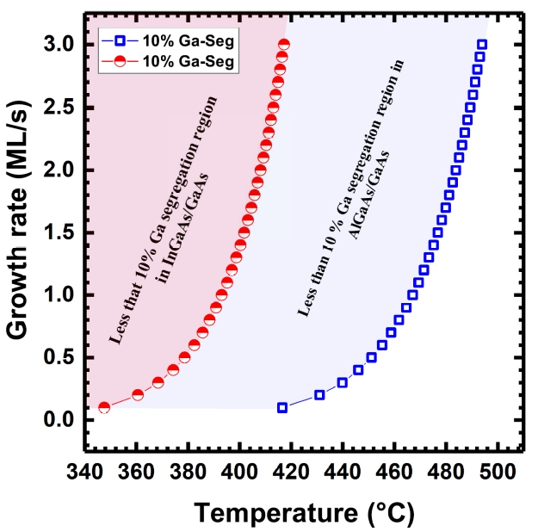
Figure 1. Critical growth rate and growth temperature regions for the In and Ga segregation rate <10% in InAs/GaAs (red region) and GaAs/AlAs (red+blue regions), respectively. To grow heterostructures with less than 10% segregation rate, it seems the growth rate need to be increases with increasing the growth temperature.

Biography
Vahid R. Yazdanpanah has more than 17 years industry and academic experience with III-V material growth and fabrication. His Ph.D. is in MicroElectronics-Photonics from UARK, USA. Then for few years he was working on optoelectronic devices in Center for Quantum Devices in Northwestern University, USA. Then, for about 10 year, he was working in Agilent Technologies, focusing on developing many novel manufacturing semiconductor devices such as GaAs and InP HBT and HEMT. He received the Agilent Tech High Frequency Tech Center award in 2010 for the best innovation.

Name: Vahid R. Yazdanpanah
Email: yazdanv@iust.ac.ir
Phone Number: +989013179273

Meetings Int. Pte Ltd

Company Registration No: 201524282R,28 MAXWELL ROAD, #03-05 RED DOT TRAFFIC, SINGAPORE
Web: https://www.meetingsint.com/conferences/mechatronics
E-mail: Mechatronics@annualmeetings.net
Contact: +6531080483
Copyright © 2016-2018 Meetings Int PTE Ltd, All Rights Reserved.

