Abstract Template

Title: How to Design a Robot from Scratch

Keywords: Robot, Robotics Design, Robotics Hardware Design, Robotics Mechanical Design, Robotics software Design

- Abstract Body (up to 300 words)
The field of the robotics design from the most interesting fields in the world those days. and to design one robot you must have a knowledge in different branches of Engineering like mechanical engineering, electrical engineering, electronics and programming etc...
So we found a RoboticsWare Academy that is focused in learning how to design Robots from scratch. as you can learn how to design any robot you want. the Educational curriculum of RoboticsWare is mainly based on three main axes.
Robotics Hardware Design: in this part you will learn everything about the hardware parts in your robot like electronic circuits, motor drivers, sensors, and power circuit for your robot.
Robotics Mechanical Design: here you will learn how to design any mechanical part in your robot and how to simulate it on a software like solid Works program also you will lean a good knowledge about Robot Anatomy. and you will now all actuators that you will use in your robot and how to choose the best actuator for your robot.
Robotics Software Design: here you will learn how to write your robot code and how to interface all sensor and actuators in your robot.

Image: 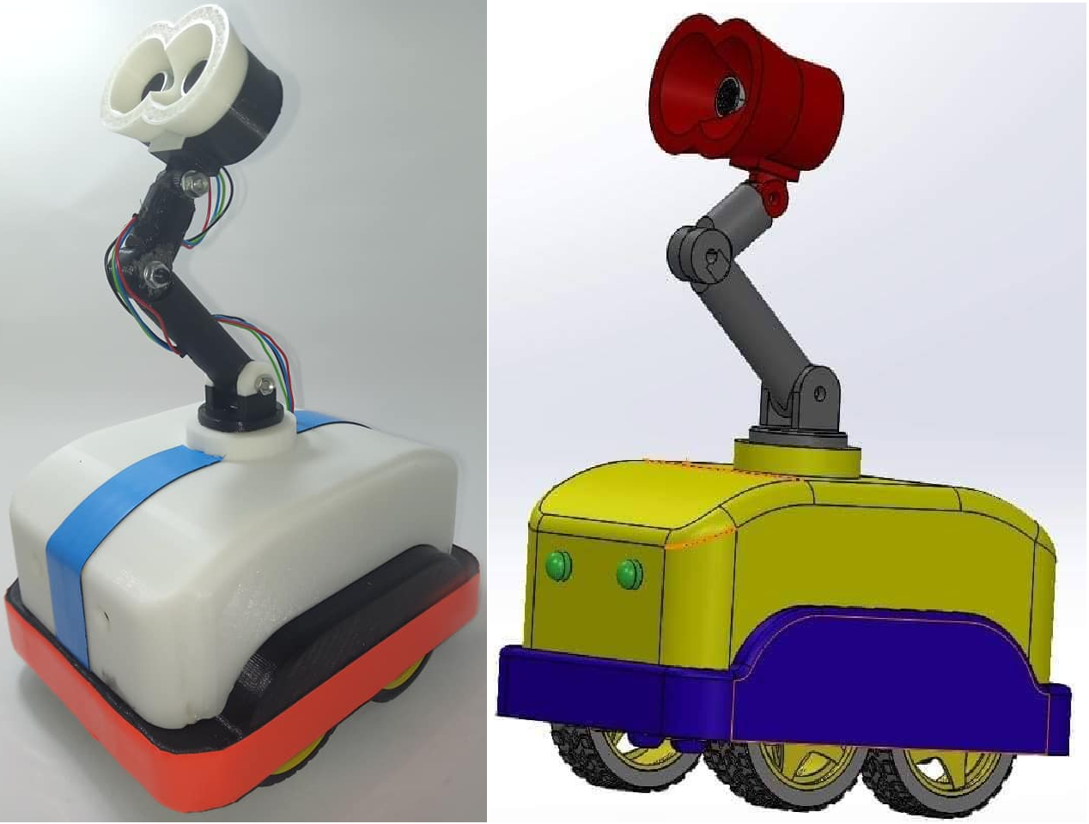
- Reference:

Biography:
Ahmed Shenhab Founder of RoboticsWare academy.
RoboticsWare is an Academy that is focused in learning how to design Robots from scratch to professionalism. With a new vision in robotics design and more than (150 hours) of teaching and training in the field of robotics design.
•Research Assistant at Egyptian Japan University of Science and Technology (E-JUST) from July 2018.
•B.Sc. degree in 2018 from Electronics and Communication Department, Alexandria University. with Grade Very good with honors

Presenting author details


Full Name: Ahmed Ragab Shenhab
Contact number: 01067455931
Twitter account: Linked In account: https://www.linkedin.com/in/ahmed-shenhab-648974b6
Session name/ number:
Category: (Oral presentation/ Poster presentation) Passport Number

