Surface structuring of optical tooling by laser remelting
Evgueni V Bordatchev, PhD DSc, NRC, Canada
Moritz Küpper, MSc, RWTH Aachen, Germany
Srdjan J. Cvijanovic, MSc candidate, Western University, Canada
Edgar Willenborg, PhD, Fraunhofer ILT, Germany
Nicolas Milliken, MSc, NRC, Canada
André Temmler, PhD-PhD, Tsinghua University, P.R. China
Remus O. Tutunea-Fatan, PhD, Western University, Canada
b)
c)
d)
a)

Statement of the Problem: Functional performance of optical lighting and illumination products and components critically depends on advanced technologies for cost-effective fabrication of tooling with strict surface quality and form geometry accuracy. Recent advancements in laser material processing have resulted in developing fundamentals of a novel unique no-material additive/removal technology known as a surface structuring by laser remelting (SSLRM) process [1-3]. During SSLRM, laser beam moves over a workpiece surface with a constant speed and synchronously controlled laser power while desired surface geometry is defined as a function of a laser power control algorithm. Consequently, new surface geometry is formed due to redistribution and relocation of molten workpiece material. It is a complex, highly non-linear thermo-dynamic process where material rapid melting, reallocation and rapid solidification is controlled by the parameters of the applied continuous wave laser irradiation. The purpose of this study is to advance preliminary developments of SSLRM towards optical tooling applications [4, 5]. Methodology: A wedged edge-lit light guide (WELLG) was chosen as a typical element of automotive rear lighting. Initially, sine-shape WELLG was optically designed where its geometry parameters (e.g. period of 500 µm, amplitude of 40 µm, wedge angle of 2°, made from PMMA plastic) were found to ensure a light delivery efficiency of >50% while covering >80% of the illuminated area. A metal insert from DIN 1.2343 (AISI H11) tooling steel was fabricated using SSLRM process (fig. a), replicated into PMMA plastic by hot embossing as a functional WELLG prototype (fig. c), and its optical performance was evaluated (fig. d). Findings: A period of 498.2±3.8 µm and amplitude of 40.0±2.0 µm were achieved for fabricated tooling insert. Plastic WELLG prototype has demonstrated highly efficient light delivery performance while fully covering the illuminated area. Conclusion & Significance: This study demonstrates high potentials in applicability of the SSLRM process for efficient fabrication of optical tooling for light guiding, distribution and illumination functions and products especially for automotive, solar energy and biomedical industry.

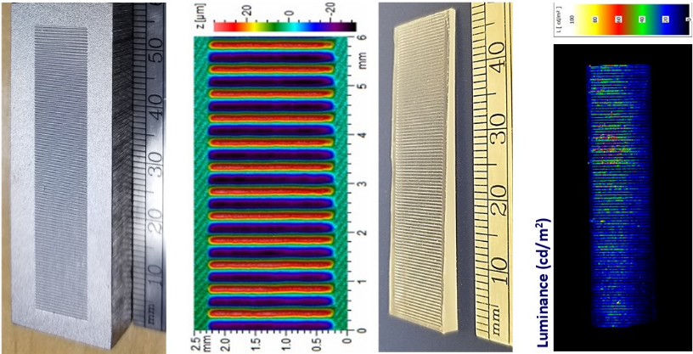

Fabricated optical insert (a), geometry (b), part (c), and performance (d).

- Temmler A, Walochnik MA, Willenborg E, Wissenbach K (2015) Surface structuring by remelting of titanium alloy Ti6Al4V. J of Laser Applications 27: paper S29103, 8 p.
- Temmler A, Comiotto M, Ross I, Küpper M, Liu DM, Poprawe R (2019) Surface structuring by laser remelting of 1.2379 (D2) for cold forging tools in automotive applications. J of Laser Applications 31: paper 022017, 12 p.
- Temmler A, Küpper M, Walochnik MA, Lanfermann A, Schmickler T, Bach A, Greifenberg T, Oreshkin O, Willenborg, E, Wissenbach K, Poprawe R (2017) Surface structuring by laser remelting of metals. J of Laser Applications 29(1): paper 12015, 12p.
- Bordatchev EV, Küpper M, Cvijanovic S, Willenborg E, Milliken N, Temmler A, Tutunea-Fatan OR (2019) Preliminary characterization of light guide tooling fabricated by surface structuring by laser remelting. Proceedings of The 2019 IEEE Photonics Society Conference, paper 314, 2 p.
- Bordatchev EV, Küpper M, Cvijanovic S, Willenborg E, Milliken N, Temmler A, Tutunea-Fatan OR (2019) Fabrication of edge-lit light guide tooling by surface structuring by laser remelting. Proceedings of 34th American Society of Precision Engineering 2019 Annual Meeting 71:84-89.


Evgueni Bordatchev is a Senior Research Officer and a Team Leader for Microfabrication and Surface Functionalization group at the National Research Council in London, Ontario, Canada. He received MSc, PhD, and DSc degrees in electro-mechanical engineering from Don State Technical University, Rostov-on-Don, Russia, in 1982, 1989 and 1996, respectively. Since 1998, he is with National Research Council demonstrating national and international recognition as an expert in laser- and cutting-based high-precision micromachining, surface functionalization, laser polishing, micro/nano-optics, and micro-opto-electro-mechanical systems/sensors. He has authored/co-authored 287 publications and holds 6 patents. Dr. Bordatchev is an Adjunct Professor at the Western University since year 2000, and he is also a member of Editorial Board for Springer’s Journal Lasers in Manufacturing and Materials Processing. Dr. Bordatchev is also a Sustaining Member of the American Society of Precision Engineering (ASPE) and a Senior Member of the Institute of Electrical and Electronics Engineering (IEEE).
email: evgueni.bordatchev@nrc-cnrc.gc.ca

Notes/Comments:

