Optimization of cold-sprayed Nickel Alloy 625 thick deposits using the KSS Software

Martha Flores^{a, b, *},

H. Assadi^{c,**}

ªResearch and Development Cummins Center, San Luis Potosí, México
^{b}CIATEQ, A.C., Centro de Tecnología Avanzada
^{c}Brunel University London, BCAST, Uxbridge, United Kingdom
∗Corresponding author. Email address: martha.k.flores@cummins.com
∗∗Corresponding co-author.

Abstract: Cummins R&D Center has been exploring and developing Thermal Spray Processes to repair damaged zones and remanufacture parts while ensuring full confidence on the final performance. For this purpose, Nickel Alloy 625 was selected for the High Pressure Cold Spray (HPCS) process as an attractive option due compatibility with cast iron materials and having strengthened alloyed matrix by elements such as molybdenum. The present paper reports on the steps developed for a HPCS application where Nickel Alloy 625 is sprayed over a gray cast iron flat substrate, in a series of experiments considering only the pressure gas and spray temperature as key variables. The coatings developed were tested using the bond strength according to ASTM C-633 and deposit efficiency was measured through metallography. The experimental results demonstrate that Nickel Alloy 625 can be successfully deposited on gray cast iron by cold spraying.

- Introduction

Nickel Alloy 625 has a high strength, excellent machinability and outstanding corrosion resistance. It is also a suitable material for joining processes. The main alloying elements of this alloy are molybdenum and niobium, which form precipitates and strengthen the nickel chromium matrix. Its ability to resist high stresses under a wide range of temperatures makes it particularly suitable for the current application, where cast iron is one of the main substrates to be repaired and be exposed to high temperatures.

The Cummins R&D Center has a technical interest in developing Nickel Alloy 625 coatings on gray iron substrates (ASTM A48) through High Pressure Cold Spray (HPCS). The aim is to establish specific precedents for applications of surface technology to repair damaged components of internal combustion engines. A particular objective is to use HPCS as a solid-state additive manufacturing process, thus, to obtain a clear understanding of the scope of this technology, in terms of its technical advantages and restrictions, as well as its economic feasibility.

- Principles of optimization
HPCS is a solid-state material deposition technique, where particles of a powder bond to a substrate as a
result of high-velocity impact and the associated severe plastic deformation. Acceleration of particles to high velocities is obtained via expansion of a pressurized (to a few tens of bars) and hot (up to a thousand Celsius) gas (typically nitrogen, in some cases helium or steam) through a diverging-converging (de Laval) nozzle [13,25]. Figure 1 shows a schematic of the process. Through a separate gas line, a fluidized powder feedstock is fed into the upstream of the nozzle. The gas stream accelerates the particles of the powder to impact the substrate at high velocities. Depending on the process gas and the spray parameters, impact velocities are between 200 and 1200 m/s.

HPCS is used for coating, repair and additive manufacturing (AM). The main advantage of HPCS is that it alleviates oxidation and unfavorable effects due to melting and re-solidification. It also offers relatively high deposition rates as compared to the conventional AM methods, i.e. those based on selective laser or electron beam melting.

The main technical objective in HPCS is to ensure that the particles of the feedstock powder impinge the substrate at or beyond a critical velocity. This condition is expressed conveniently through a dimensionless parameter (η) defined as the ratio of the impact velocity to the critical velocity (v_{p}/v_{cr}), thus successful deposition requires: η>1.

The parameter η depends on several factors, such as particle size, material density, and material strength, in addition to all process parameters, including gas temperature, gas pressure and nozzle dimensions. The value of this variable, on the other hand, scales with the quality of the deposition. It is therefore an important parameter used for optimization of HPDC and getting the best results on the deposition efficiency and bond strength.

This is so because the main properties of the coating have been shown to be a unique function of η in many cases [7]. In this way, the influence of all the relevant materials and process parameters on the coating quality can be investigated directly through calculating η for a given set of material and processing conditions.

It should be mentioned, however, that none of the suggested formulas for the critical velocity, and hence η, incorporate substrate properties.

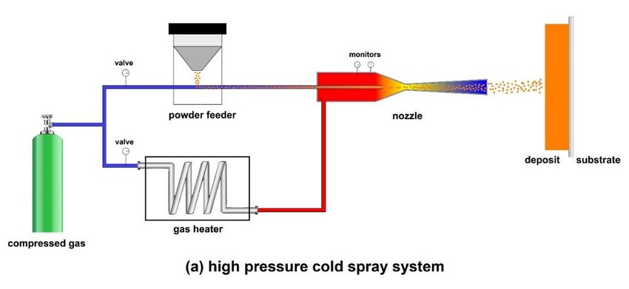
Fig. 1. High-pressure cold spray system: (a) schematics of the main components of the original system

- Methods

The aim of the present study is to optimize the cold spraying conditions for Nickel Alloy 625. For this purpose, simulations are performed to work out the value of η for different spraying conditions using the using the KSS software [www.kinetic-spray-solutions.com]. The experimental results were obtained from HPCS of the powder. The simulation and the experimental results were combined to determine the best operating conditions for the selected powder to give the performance of the coating.
For convenience, the design of experiments (DoE) is structured only with essential variables (temperature and pressure) while the non-essential variables (surface roughness, and substrate properties) were fixed.

3.1. Processing conditions

The gas pressure and temperature range used for this DoE is defined by capabilities of the equipment used in this study. Table 1 indicates the set of parameters used for each experiment.

Table 1. DoE defined for cold spraying of Nickel Alloy 625 on cast iron ASTMA48.
 |  | Pressure
Temperature |  | p_{min}  (35 bar) | p_{max}  (50 bar)
Temperature | T_{min}  (900 °C) | Set 1 | Set 2
Temperature | T_{max}  (1100 °C) | Set 3 | Set 4

The simulation of the spraying process was carried out using the KSS software. The 5 variables to be considered as input is listed below.

1. Particle size distribution (PSD) of the Nickel Alloy 625. The calculations were performed for a range of particle size between 20 μm and 50 μm.

2. Gas temperature. The temperature ranges are considered from 900 °C to 1100 °C.

3. Gas pressure. The working pressure ranges from 35 to 50 bar.

4. Nozzle type. Consistent with the equipment used, the nozzle is OUT 1 from Impact Innovations.

5. Gas type. The gas used in the simulation is nitrogen.

In addition to the above primary input parameters, the following conditions were applied to the HPCS experiments, and where applicable, considered in the corresponding calculations:

- Substrate: Pre-machined flat cast iron ASTM A48, surface roughness > 8 μm, then ground using alumina powder.

- Nitrogen purity: 99.999%

- Powder apparent density: 4.7 g/cm³

- Powder feed rate: 1.8 kg/h

- Area to be sprayed: 110×610 (mm²)

- Programmed thickness: 1 mm (0. 0393 in)

Moreover,
thickness evaluation was carried out through metallographic analysis.

3.2 Calculation of the Parameter Selection Map (PSM) and impact conditions

Calculation of cold spray parameters through the PSM module of the KSS software
.
The PSM provides a first approximation of the particle velocity, particle temperature, the critical
velocity for bonding, and the velocity ratio η = v_{p}/v_{cr}, which is used as a measure of quality of the cold-sprayed deposit. As rule of thumb, η = 1.5 is considered as a benchmark to secure a sufficiently high coating quality. Smaller values may be associated with higher levels of porosity,
lower deposition efficiency and lower cohesive strengths. Larger values may result in marginal
increase in the quality at the price of a higher gas consumption and hence higher costs. The input parameters used for PSM calculations are shown in Fig. 2.

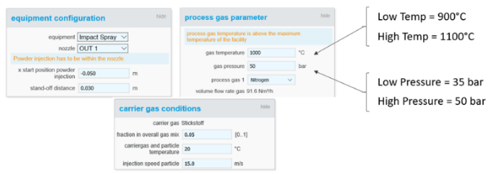

Fig. 2. A snapshot of the PSM input parameters in the KSS software.

- Results
4.1. PSM results
The results of the PSM calculations, including the impact velocity and temperature of particle, as well as the predicted deposition efficiencies are summarized in Table 2.

Table 2. PSM results considering inputs from DoE.
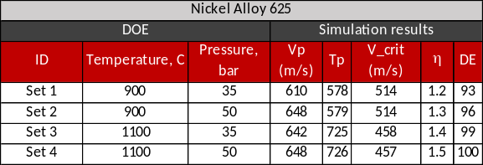

4.2. Experimental results

The HPCS experiments successfully produced high quality coatings of the Nickel Alloy 625 powder. Figure 3 shows two examples of the cross section of cold-sprayed coatings corresponding to the operational temperature. Both examples show a very low level of porosity, and a tight bonding to the gray cast iron substrate, although increasing the pressure to 50 bar appears to have reduced the porosity level even further. However, increasing the temperature to 1100 °C resulted in an increased level of porosity, and in the case of Set 4, a very low DE (Fig. 4). However, all samples exhibited the same value of bond strength, which was around 1 ksi (7 MPa), as shown in Fig. 5. It is not clear why increasing the process gas temperature, despite an expected higher η, resulted in higher levels of porosity and poorer DE. It is very likely however, that this is due to the technical limitation of the equipment to reach the prescribed processing condition.
The DE was not directly measured. However, the thickness of the coatings can be taken as an indirect measure of DE. Table 3 shows the results of thickness measurements on the 4 sets of operational HPCS process. The DE decreases noticeably by increasing the operating temperature, though this is presumably because of the technical limits of the equipment.

Table 3. The results of thickness measurement on the HPCS samples.
 | Thickness (mm)
Set 1 | 1.004
Set 2 | 1.126
Set 3 | 0.712
Set 4 | 0.111

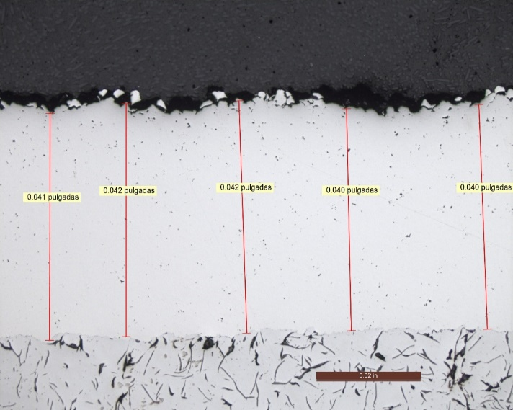
Fig 3 (a). Optical micrograph of cross section of Nickel Alloy 625 on cast iron substrate, corresponding to Set 1: 900 °C and 35 bar.
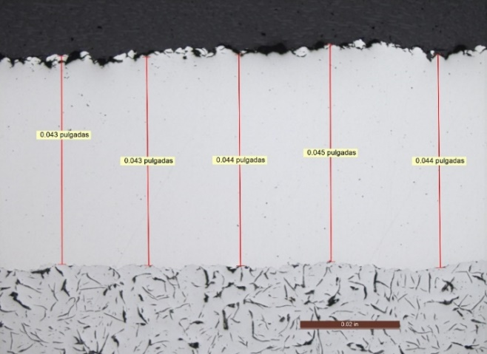
Fig 3 (a). Optical micrograph of cross section of Nickel Alloy 625 on cast iron substrate, corresponding to Set 2: 900 °C and 50 bar.
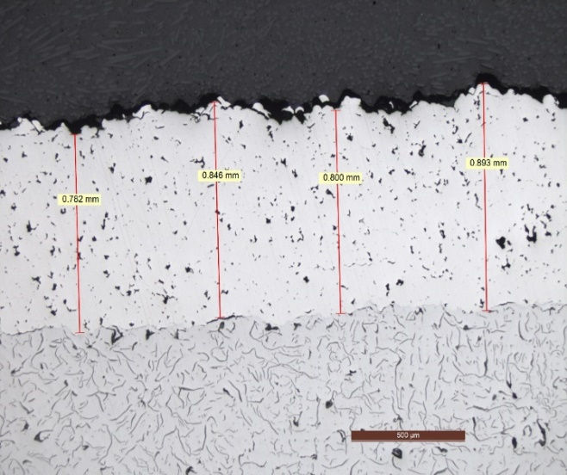
Fig 4 (a). Optical micrograph of cross section of Nickel Alloy 625 on cast iron substrate, corresponding to Set 3: 1100 °C and 35 bar.
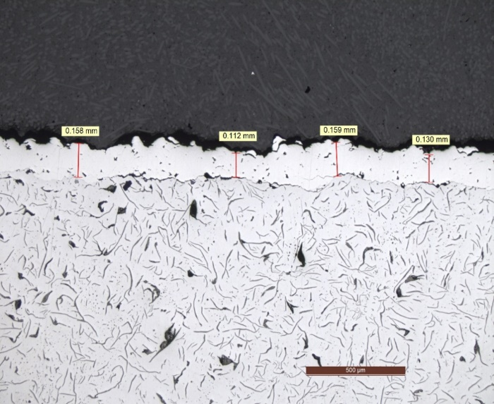
Fig 4 (b). Optical micrograph of cross section of Nickel Alloy 625 on cast iron substrate, corresponding to Set 4: 1100 °C and 50 bar.

Fig 5. Bond strength of the cold sprayed Nickel Alloy 525 coatings on cast iron substrates.

- Summary

Nickel alloy 625 has been considered as an excellent option for coating surfaces, because of its excellent strength and low oxidation. This study shows that cold spraying can be used successfully to deposit this material on gray cast iron. The experimental results presented here show good deposition efficiency for sets 1 & 2, where the operating temperature was 900 °C. However, the higher temperature of 1100 °C, sets 3 & 4, resulted in a lower deposition efficiency and a higher porosity level. The main reason for this discrepancy is attributed to the technical limits of the equipment. The power required to reach the prescribed processing conditions appears to surpass the maximum limits of the equipment. As for the bonding strength, a relatively good performance was observed, even with the samples showing poorer DE and higher porosity level. The associated simulations offered an essential guideline for finding the optimal spraying conditions, although the predicted higher quality at higher temperature could not be verified due to technical limitations.

References
[1] A. Papyrin, Cold Spray Technology, ﬁrst ed., Elsevier, Amsterdam, 2007.
[2] H. Assadi, F. Gärtner, T. Stoltenhoff, H. Kreye, Bonding mechanism in cold gas spraying, Acta Mater 51 (2003) 4379e4394.
[3] T. Hussain, D.G. McCartney, P.H. Shipway, Impact phenomena in cold-spraying of titanium onto various ferrous alloys, Surf. Coat. Technol. 205 (2011) 5021e5027.
[4] G. Bae, S. Kumar, S. Yoon, K. Kang, H. Na, H. Kim, C. Lee, Bonding features and associated mechanisms in kinetic sprayed titanium coatings, Acta Mater 57 (2009) 5654e5666.
[5] M. Grujicic, C.L. Zhao, W.S. DeRosset, D. Helfritch, Adiabatic shear instability-based mechanism for particles/substrate bonding in the cold-gas dynamic-spray process, Mater Des. 25 (2004) 681e688.
[6] T. Schmidt, F. Gärtner, H. Assadi, H. Kreye, Development of a generalized parameter window for cold spray deposition, Acta Mater 54 (2006) 729e742.
[7] H. Assadi, T. Schmidt, H. Richter, J.O. Kliemann, K. Binder, F. Gärtner, T. Klassen, H. Kreye, On Parameter selection in cold spraying, J. Therm. Spray. Technol. 20 (2011) 1161e1176.
[8] G. Bae, Y. Xiong, S. Kumar, K. Kang, C. Lee, General aspects of interface bonding in kinetic sprayed coatings, Acta Mater 56 (2008) 4858e4868.
[9] F.F. Wang, W.Y. Li, M. Yu, H.L. Liao, Prediction of critical velocity during cold spraying based on a coupled thermomechanical Eulerian model, J. Therm. Spray. Technol. 23 (2014) 60e67.
[10] H. Assadi, T. Schmidt, F. Gärtner, H. Kreye, Characteristics of particle bonding and material deposition in cold spraying, in: M. Jahazi, M. Elboujdaïni, P. Patnaik (Eds.), Proc. of Aerospace Materials and Manufacturing Processes: Emerging Materials, Processes, and Repair Techniques, Canada, Montreal, October 2006, pp. 49e59. COM 2006, 1e4.
[11] X.K. Suo, X.P. Guo, W.Y. Li, M.P. Planche, H.L. Liao, Investigation of deposition behavior of cold-sprayed magnesium coating, J. Therm. Spray. Technol. 21 (2012) 831e837.
[12] R. Ghelichi, S. Bagherifard, M. Guagliano, M. Verani, Numerical simulation of cold spray coating, Surf. Coat. Technol. 205 (2011) 5294e5301.
[13] F. Raletz, M. Vardelle, G. Ezo, Critical particle velocity under cold spray conditions, Surf. Coat. Technol. 201 (2006) 1942e1947.
[14] M. Grujicic, C.L. Zhao, C. Tong, W.S. DeRosset, D. Helfritch, Analysis of the impact velocity of powder particles in the cold-gas dynamic-spray process, Mater Sci. Eng. A 368 (2004) 222e230.
[15] D. Goldbaum, J.M. Shockley, R.R. Chromik, A. Rezaeian, S. Yue, J.-G. Legoux, E. Irissou, The effect of deposition conditions on adhesion strength of Ti and Ti6Al4V cold spray splats, J. Therm. Spray. Technol. 21 (2012) 288e303.
[16] R.C. Dykhuizen, M.F. Smith, Gas dynamic principles of cold spray, J. Therm. Spray. Technol. 7 (1998) 205e212.
[17] D.L. Gilmore, R.C. Dykhuizen, R.A. Neiser, T.J. Roemer, M.F. Smith, Particle velocity and deposition efﬁciency in the cold spray process, J. Therm. Spray. Technol. 8 (1999) 576e582.
[18] R.C. Dykhuizen, M.F. Smith, D.L. Gilmore, R.A. Neiser, X. Jiang, S. Sampath, Impact of high velocity cold spray particles, J. Therm. Spray. Technol. 8 (1999) 559e564.
[19] H. Kreye, T. Stoltenhoff, Cold spraying e a study of process and coating characteristics, in: proceedings of the International Thermal Spray Conference, 2000.
[20] T. Xiong, J. Wu, H.Z. Jin, M. Li, X. Liu, T.F. Li, Introduction to a new technology - cold gas dynamic spray, Corros. Sci. Prot. Technol. 13 (2001) 267e269.
[21] V.F. Kosarev, S.V. Klinkov, A.P. Alkhimov, A.N. Papyrin, On some aspects of gas dynamics of the cold spray process, J. Therm. Spray Technol. 12 (2003) 265e281.
[22] F. Gärtner, T. Schmidt, T. Stoltenhoff, H. Kreye, Recent developments and potential applications of cold spraying, Adv. Eng. Mater. 8 (2006) 611e618.
[23] V.K. Champagne, The Cold Spray Materials Deposition Process: Fundamentals and Applications, Elsevier, 2007
[24] Q. Wang, M. Zhang, Review on recent research and development of cold spray technologies, Key Eng. Mater. 533 (2013) 1e52.
[25] K. Lee, M. Lee, J. Yu, H. Kim, Effect of powder preheating temperature on the properties of titanium coating layers manufactured by kinetic spraying, Mater. Trans. 55 (2014) 622e628.

