Stereolithographic Additive Manufacturing of Ceramic Components with Functionally Modulated Geometry
Soshu Kirihara, Osaka University, Japan

In stereolithographic additive manufacturing (STL-AM) processes, 2-D cross sections were created minutely through photo polymerization by ultraviolet (UV) laser drawing on spread resin paste including ceramic nanoparticles, and 3-D models were sterically printed by layer lamination as shown in Fig. 1 [1-3]. In this investigation, solid electrolyte dendrites of yttria-stabilized zirconia (YSZ) with spatially ordered pores were processed for fuel cell miniaturization. Subsequently, ceramic sheets of lithium-lanthanum-titanate (LLT) with micro emboss patterns were developed for all-solid batteries. Designed models with intended 3-D structures were converted into the stereolithography (STL) file format through polyhedral approximations and sliced into a series of 2-D layers. The slicing pitches were defined as 50 μm for laser scanning stereo-lithography. The numerical data were transferred into each stereo-lithographic system to create raster patterns for laser scanning. The lithographic system has been developed to obtain bulky ceramic components with functional geometries. An automatic collimeter was newly equipped with the laser scanner to adjust beam diameter. Fine or coarse beams could realize high resolution or wide area drawings, respectively. As the row material of the 3-D printing, nanometer sized ceramic particles were dispersed in to acrylic liquid resins at 50 % in volume fraction. These materials were mixed and deformed to obtained thixotropic slurry for 15 min at 700 and 300 rpm of rotation and revolution speeds, respectively. The resin paste was spread on a glass substrate at 100 μm in layer thickness by a mechanically moved knife edge. An ultraviolet laser beam of 355 nm in wavelength was adjusted at 50 μm in variable diameter and scanned on the spread resin surface. Irradiation power was increased at 1 W for resin dewaxing and powder sintering through heating by ultraviolet ray propagations, resonations and absorptions in the paste materials. These YSZ and LLT micro components were shown in Figs. 2 and 3. Part accuracies of green bodies could be measured and observed by using a digital optical microscope (DOM). The micro-structures of the sintered components were observed using a scanning electron microscope (SEM). The relative densities of these ceramic components were measured by the Archimedean method.

References
- S. Kirihara, AM of Ceramic Components Using Laser Scanning STL, Welding in the World, 60 [4], 697-702 (2016).
- S. Kirihara, STL-AM of Ceramic Components by Using Nanoparticle Paste Feeding, Materials Science Forum, 879, 2485-2488 (2016).
- S. Kirihara, STL-AM of Ceramics Dendrites to Modulate Energy and Material Flows, Ceramic Transactions, 258, 11-17 (2016).

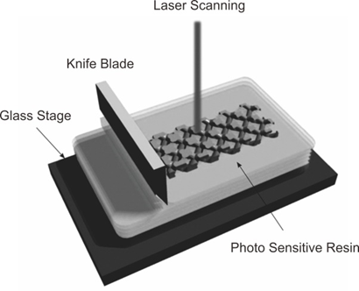 | 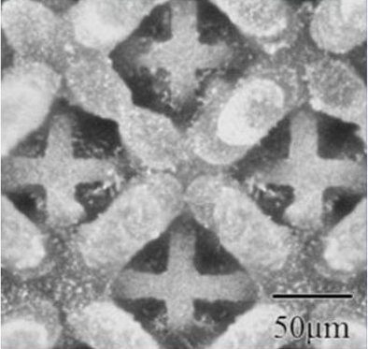 | 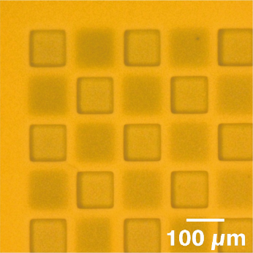
(a) | (b) | (c)
Fig. 1 A schematic illustration of sterelolithographic additive manufacturing using ceramic nanoparticles (a), and solid electrolytes components with micro geometric structures composed of yttria-stabilized zirconia (b) and lithium-lanthanum-titanate (c) for energy storage.


Soshu Kirihara is a doctor of engineering and a professor of Joining and Welding Research Institute (JWRI), Osaka University, Japan. In his main investigation “Materials Tectonics” for environmental improvements of “Geotechnology”, multi-dimensional structures were successfully fabricated to modulate energy and materials flows effectively. Ceramic and metal components were fabricated directly by smart additive manufacturing, design and evaluation (Smart MADE) using high power ultraviolet laser lithography. Original stereolithography systems were developed, and new start-up company “SK-Fine” was established through academic-industrial collaboration..
Email: kirihara@jwri.osaka-u.ac.jp

