Aggregate Mesoscience: There Is Plenty of Room in the Middle

Ben Zhong Tang, Department of Chemistry, The Hong Kong University of Science and Technology, Clear Water Bay, Kowloon, Hong Kong, China；School of Materials Science and Engineering, South China University of Technology, Guangzhou, China.

Abstract

Molecular science has been developed to disclose the material structures and properties at the molecular level. However, aggregates, which served as the particularly useful form of materials, sometimes behave differently from individual molecules and show annihilated or new properties. Some unique properties such as aggregation-induced emission (AIE), crystallization-induced emission (CIE), room temperature phosphorescence (RTP), aggregation-induced delayed fluorescence (AIDF), aggregation-induced anti-Kasha transition (AKT), clusterization-triggered emission (CTE), through-space interaction (TSI), mechanoluminescence (ML), aggregation-induced circularly polarized luminescence (CPL), aggregation-induced generation of reactive oxygen species (AIG-ROS), photothermal/photoacoustic (PT/PA), solid-state molecular motion (SSMM) are only identified in aggregates, indicating their exotic features. By virtue of the flourishing research on aggregation-induced emission, the concept of aggregate mesoscience is put forward to fill the gaps between molecules and aggregates. The established structure-property relationship of aggregates is expected to contribute to new materials and technological development. Ultimately, the aggregate mesoscience may become an interdisciplinary research and serves as a general platform for academic research.
Image
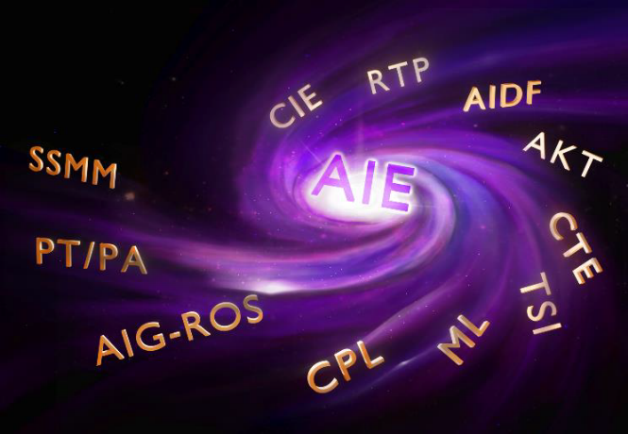
Recent Publications
- Zhao Z, Zhang H, Lam JWY, Tang BZ (2020) Aggregation-Induced Emission: New Vistas at Aggregate Level. Angew. Chem. Int. Ed. DOI: 10.1002/anie.201916729.
- Zhang H, Zhao Z, Tang BZ et al. (2019) Clusterization-triggered emission: Uncommon luminescence from common materials. Mater. Today 32, 275-292.
- Liu S, Li Y, Zhang H, Zhao Z, Lu X, Lam JWY, Tang BZ (2019) Molecular Motion in the Solid State. ACS Materials Lett. 1, 425-431.
- Li J, Wang J, Li H, Song N, Wang D, Tang BZ (2020) Supramolecular materials based on AIE luminogens (AIEgens): construction and applications. Chem. Soc. Rev. 49, 1144-1172.
- Mei J, Leung NLC, Kwok RTK, Lam JWY, Tang BZ (2015) Aggregation-Induced Emission: Together We Shine, United We Soar! Chem. Rev. 115, 11718-11940.

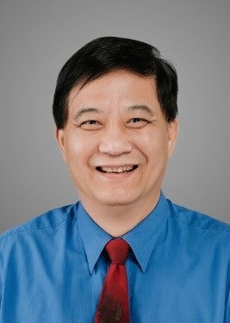 Ben Zhong Tang
Ben Zhong Tang is Stephen K. C. Cheong Professor of Science, Chair Professor at the Hong Kong University of Science & Technology (HKUST). His research interests include materials science, macromolecular chemistry, and biomedical theranostics. His lab is spearheading the research on aggregation-induced emission. Tang received BS and PhD degrees from South China University of Technology and Kyoto University, respectively. He was elected to Chinese Academy of Sciences (CAS), Asia Pacific Academy of Materials (APAM), and World Academy of Sciences for the Advancement of Science in Developing Countries (TWAS)..Tang has published >1,400 papers. His publications have been cited >90,000 times, with an h-index of 141. He has been listed by Clarivate Analytics as Highly Cited Researcher in both areas of Chemistry and Materials Science since 2014. He received State Natural Science Award (1st Class) from Chinese Government (2017), Scientific and Technological Progress Award from Ho Leung Ho Lee Foundation (2017). He is now serving as Editor-in-Chief of Materials Chemistry Frontiers.
Email: tangbenz@ust.hk

