Gate-all-around Si nanowire FET with low-thermal-budget process for monolithic three-dimensional integrated circuits
Tung-Ying Hsieh, Department of Electrical Engineering, National Tsing Hua University, Hsinchu, Taiwan;

Abstract (300 word limit)

For 3D monolithic integrated (3DMI) technology, the most important task is to fabricate high performance stackable device and prevent damage on underlying device and structure during processes. In this article, we propose a green nanosecond laser crystallization and laser spike anneal process to fabricate 3D stackable ultra-thin body transistors and realize a sequentially layered integrated circuit. As identified, the possible failure mechanism of underlying device using laser process is the directly penetrated laser light and the heat from the high temperature surface. By optimizing the process conditions and stacking layer thickness, we can reduce the thickness of interlayer dielectric to about 200-nm-thin which quite reducing the delay and power loss from interconnects for 3DIC.
Image
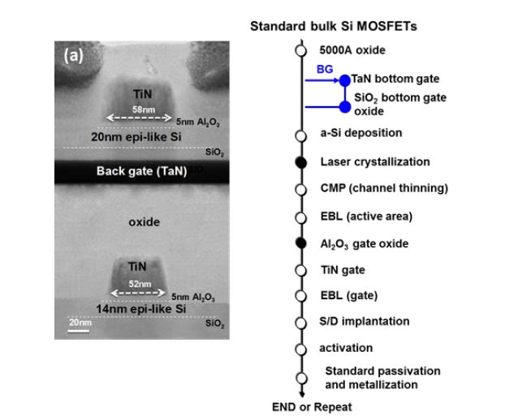
Recent Publications (minimum 5)
- Record-high 121/62 μA/μm on-currents 3D stacked epi-like Si FETs with and without metal back gate. CC Yang, SH Chen, JM Shieh, WH Huang, TY Hsieh, CH Shen, TT Wu, 2013 IEEE International Electron Devices Meeting, 29.6. 1-29.6.
- Low-cost and TSV-free monolithic 3D-IC with heterogeneous integration of logic, memory and sensor analogy circuitry for Internet of Things, TT Wu, CH Shen, JM Shieh, WH Huang, HH Wang, FK Hsueh, HC Chen, 2015 IEEE International Electron Devices Meeting (IEDM), 25.4. 1-25.4.
- Location-controlled-grain technique for Monolithic 3D BEOL FinFET circuits, CC Yang, TY Hsieh, PT Huang, KN Chen, WC Wu, SW Chen, CH Chang,2018 IEEE International Electron Devices Meeting (IEDM), 11.3. 1-11.3.
- Recent progress in low-temperature-process monolithic three dimension technology, CC Yang, TY Hsieh, WH Huang, CH Shen, JM Shieh, WK Yeh, MC Wu Japanese Journal of Applied Physics 57 (4S), 04FA06
A sandwiched buffer layer enabling pulsed ultraviolet-and visible-laser annealings for direct fabricating poly-Si field-effect transistors on the polyimide, MH Kao, WH Huang, JM Shieh, CH Shen, PK Lee, HH Wang, CC Yang, Applied Physics Letters 111 (2), 0241015. S

Biography (150 word limit)
TUNG-YING HSIEH has his expertise in monolithic 3DIC. He used to be an engineer in TSMC. And vising in Stanford University to conduct AI chips experiment. Now he is pursuing his PhD in Electronics engineering, NTHU, Hsinchu, Taiwan, Email:tyhsieh@narlabs.org.tw

