Dual Thermo-Super Elasticity and Nanoscale Aspects of Phase Transformations in Shape Memory Alloys

OSMAN ADIGUZEL

University of Firat, Department of Physics, 23169 Elazig, Turkey

Keywords: Shape memory effect, martensitic transformation, thermoelasticity, superelasticity, lattice twinning and detwinning.
I. Abstract
Shape memory effect is a peculiar property exhibited by a certain alloy systems in the β-phase fields, and result of thermal and mechanical processes. These alloys have dual characteristics called thermoelasticity and superelasticity, and take place in class of advanced smart materials. These phenomena are governed by successive thermal and stress induced martensitic transformations, and performed thermally and mechanically, respectively. Thermal induced transformation occurs along with lattice twinning on cooling and ordered parent phase structures turn into twinned martensite structures. Twinned martensite structures turn into detwinned martensite structures by means of stress induced transformation by deforming plastically in martensitic condition. Strain energy is stored in the material with deformation and released upon heating, by recovering the original shape in bulk level, and cycles between original and deformed shapes on heating and cooling, respectively. Superelasticity is also a result of stress induced martensitic transformation and performed in only mechanical manner in the parent austenite phase region. The materials are deformed just over Austenite finish temperature, and shape recovery is performed simultaneously upon releasing the applied stress. The ordered parent phase structures turn into the detwinned structures by means of stress induced martensitic transformation, like the deformation step in shape memory. Superelasticity is performed in non-linear way, unlike normal elastic materials, loading and unloading paths in stress-strain diagram are different, and hysteresis loop reveals energy dissipation. Shape memory effect is performed thermally in a temperature interval depending on the forward and reverse transformation, on cooling and heating, respectively, and this behaviour is called thermoelasticity. Deformation at different temperatures in intermediate region between Martensite start and Austenite finish temperatures exhibits different behaviour beyond shape memory effect and superelasticity, and the materials partially recover original shape. Thermal induced martensitic transformation occurs as martensite variants with the cooperative movement of atoms in <110>-type directions on {110}-type close packed planes of austenite matrix, by means of shear-like mechanism. The {110}- plane family represent 6 planes, and totally 24 martensite variants occur.
Copper based alloys exhibit this property in metastable β-phase region, which has bcc-based structures. Lattice invariant shears are not uniform in copper based shape memory alloys, and the ordered parent phase structures martensitically undergo the non-conventional complex layered structures on further cooling. The long-period layered structures can be described by different unit cells as 3R, 9R or 18R depending on the stacking sequences on the close-packed planes of the ordered lattice. The unit cell and periodicity is completed through 18 layers in direction z, in case of 18R martensite, and unit cells are not periodic in short range in direction z
In the present contribution, x-ray diffraction and transmission electron microscopy studies were carried out on two copper based CuZnAl and CuAlMn alloys. X-ray diffraction profiles and electron diffraction patterns exhibit super lattice reflections inherited from parent phase due to the diffusion less character of martensitic transformation. X-ray diffractograms taken in a long time interval show that diffraction angles and intensities of diffraction peaks change with the aging time at room temperature. This result refers to a new transformation in diffusive manner.

II. References
- Adiguzel O., Phase Transitions and Microstructural Processes in Shape Memory Alloys, Materials Science Forum 2013; 762, 483-486, Trans Tech Publications, Switzerland
- Li Z. Gang S, Wang M.P., Macroscopic Shape Change of Cu13Zn15Al Shape Memory Alloy on Successive Heating, Journal of Alloys and Compounds 2008, 452, 307-311.
- De Castro F., Sade M., Lovey F., Improvements in the Mechanical Properties of the 18R ↔ 6R High-hysteresis Martensitic Transformation by Nanoprecipitates in CuZnAl Alloys, Materials Science and Engineering A 2012, 543, 88-95.

III. Biography
Dr Adiguzel graduated from Department of Physics, Ankara University, Turkey in 1974 and received PhD- degree from Dicle University, Diyarbakir-Turkey. He has studied at Surrey University, Guildford, UK, as a post doctoral research scientist in 1986-1987, and studied on shape memory alloys. He worked as research assistant, 1975-80, at Dicle University and shifted to Firat University, Elazig, Turkey in 1980. He became professor in 1996, and he has already been working as professor. He published over 60 papers in international and national journals; He joined over 100 conferences and symposia in international and national level as participant, invited speaker or keynote speaker with contributions of oral or poster. He served the program chair or conference chair/co-chair in some of these activities. In particular, he joined in last six years (2014 - 2019) over 60 conferences as Keynote Speaker and Conference Co-Chair organized by different companies. He supervised 5 PhD- theses and 3 M.Sc- theses. Dr. Adiguzel served his directorate of Graduate School of Natural and Applied Sciences, Firat University, in 1999-2004. He received a certificate awarded to him and his experimental group in recognition of significant contribution of 2 patterns to the Powder Diffraction File – Release 2000. The ICDD (International Centre for Diffraction Data) also appreciates cooperation of his group and interest in Powder Diffraction File.
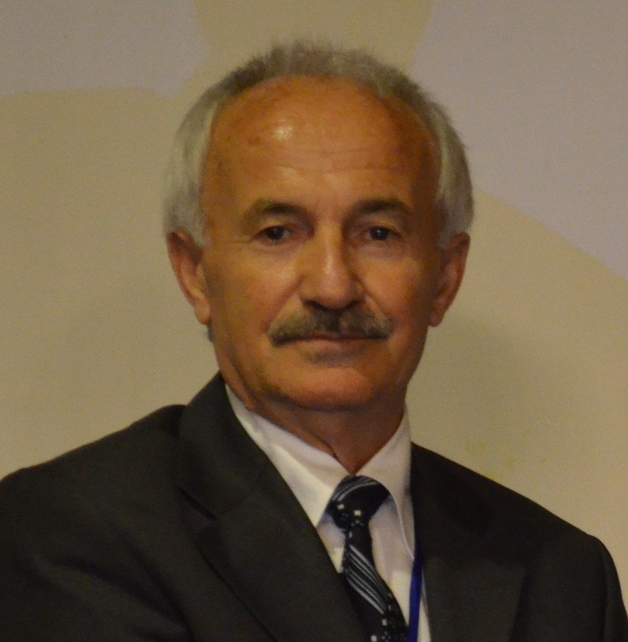
Full Name: Osman Adiguzel
Contact Number: +90 536 5638403
Twitter Account: -
Linked In Account: -
Session name/number: Advanced Materials
Category: Oral presentation
Passport Number: S02514240
Email: oadiguzel@hotmail.com
oadiguzel@firat.edu.tr

