A Study on Data Security Issues in Mobile Cloud Computing
Swati Oberoi, Assistant Professor, Rukmini Devi Institute of Advanced Studies, India
Dhriti Ghai, Student of BBA, Rukmini Devi Institute of Advanced Studies, India

Abstract
Cloud Computing is the delivery of on-demand computing services over the internet on a pay-as-you-go-basis. It is an emerging computing technology that uses the internet & central remote servers to maintain data & application. It helps in manipulating, configuring and accessing the applications online. With the development of cloud computing and mobility mobile cloud computing has emerged and become a focus of research. Users can access their data at any time, at any place, even with any device including mobile devices by using the cloud storage services. This study is undertaken to explore the data security issues in mobile cloud computing. However, data security is still a major concern and is the main obstacle preventing cloud computing from being more widely adopted. For analysis of the data and figures, a secondary data collection method was used. This paper gives an overview on the cloud computing concept followed by a description on mobile cloud computing and the different security issues & challenges pertinent to the mobile cloud computing environment. Mobile Cloud computing has a long way to go. After studying mobile cloud computing various findings were made such as the availability of mobile cloud computing services and applications are fully get accessed if and only if the device is having good internet connectivity, virtualization plays an important role in making mobile cloud computing economical, etc. Mobile cloud computing is a new model and architecture which still has an opportunity for future research expansion in many areas. Mobile cloud computing is the most emerging branch of cloud computing and a well-accepted technology with fast growth. So, this study foresees mobile cloud computing as next big thing in IT industry.

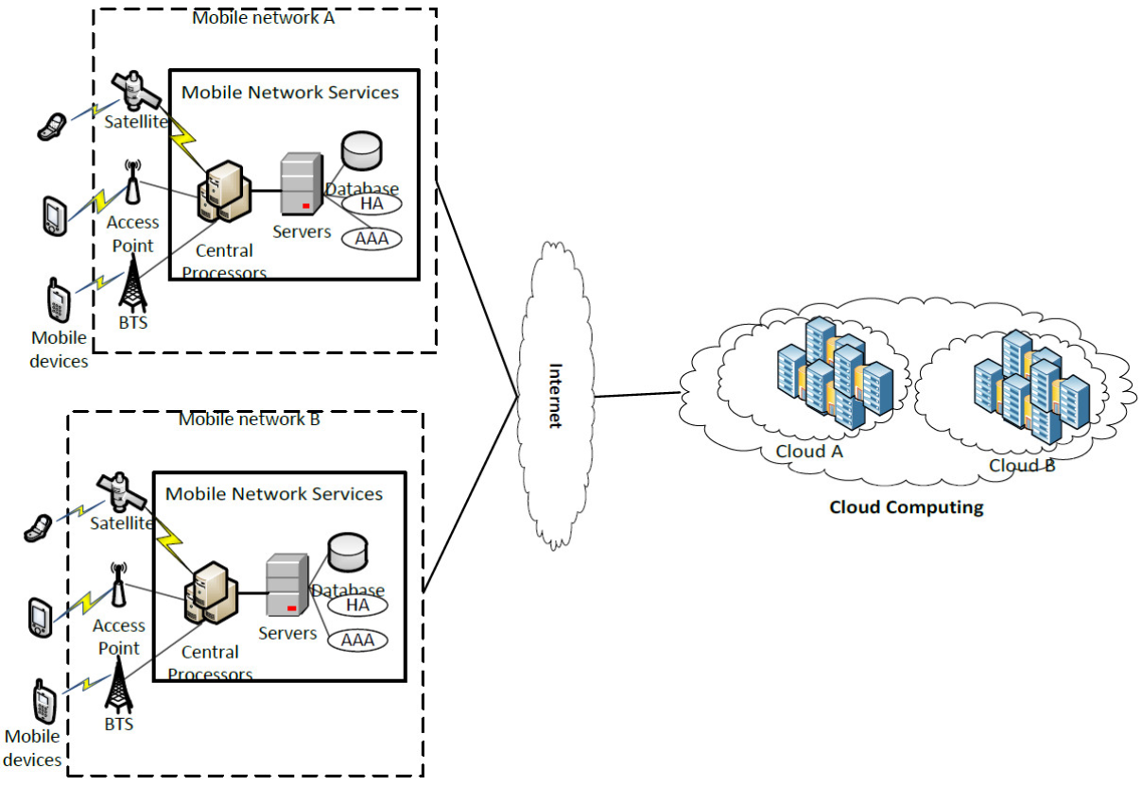

Architecture of MCC
Recent Publications
- Rahimi, M. R., Ren, J., Liu, C. H., Vasilakos, A. V., & Venkatasubramanian, N. (2014). Mobile cloud computing: A survey, state of art and future directions. Mobile Networks and Applications, 19(2), 133-143.
- Fernando, N., Loke, S. W., & Rahayu, W. (2013). Mobile cloud computing: A survey. Future generation computer systems, 29(1), 84-106.
- Suo, H., Liu, Z., Wan, J., & Zhou, K. (2013, July). Security and privacy in mobile cloud computing. In 2013 9th International Wireless Communications and Mobile Computing Conference (IWCMC) (pp. 655-659). IEEE.
- Shahzad, A., & Hussain, M. (2013). Security issues and challenges of mobile cloud computing. International Journal of Grid and Distributed Computing, 6(6), 37-50.
- JoSEP, A. D., KAtz, R., KonWinSKi, A., Gunho, L. E. E., PAttERSon, D., & RABKin, A. (2010). A view of cloud computing. Communications of the ACM, 53(4).

