Directed Self-Assembly of Hierarchical Block Copolymer Superstructures
Richard J Spontak, PhD, North Carolina State University, USA
Huibin Qiu, PhD, Shanghai Jiao Tong University, China
Ian Manners, PhD, University of Bristol, United Kingdom

Abstract
Spontaneous self-assembly of block copolymer (BCP) molecules in a block-selective solvent at low copolymer concentrations typically results in the formation of micelles possessing a spherical morphology.¹ Inclusion of a crystallizable block in the copolymer promotes crystallization-driven self-assembly (CDSA),²⁻⁴ yielding anisotropic cylindrical micelles that can, after additional processing, possess a remarkably narrow length polydispersity. Anisotropic nanoparticles prepared from BCPs are of growing importance as building blocks for the creation of a wide range of synthetic hierarchical materials. However, the assembly of such structural units is generally limited to the use of amphiphilic interactions. In addition to CDSA to generate single cylindrical micelles, reversible coordination-driven hierarchical self-assembly can be used to produce micron-scale fibers and macroscopic films based on the association of low-polydispersity cylindrical BCP micelles.⁵ In this case, coordination of Pd metal centers to phosphine ligands immobilized within the soluble coronas of BCP micelles is observed to induce intermicellar crosslinking, affording stable linear fibers comprised of micelle subunits in a staggered arrangement. The mean length of the fibers can be readily controlled by altering the micelle concentration, reaction stoichiometry or aspect ratio of the micelle building blocks. Furthermore, the nanofibers aggregate upon drying to form robust, self-supporting macroscopic micelle-based thin films with useful mechanical properties that are analogous to crosslinked polymer networks, but on a significantly longer length scale. A comparable hierarchical self-assembly strategy yields toroidal micelles that combine to form micron-scale superstructures. Addition of a crystallizable BCP to a solution of a toroid-forming BCP results in the formation of toroidal multimicelles, as well as single-layer hexagonal arrays of connected toroids. By controlling the ability of the BCPs to form hydrogen bonds through the introduction of hydroxyl groups on the crystallizable BCP and the accompanying level of solvophobic interactions, the BCPs can spontaneously self-assemble and form 3D periodic mesoporous superstructures.⁶

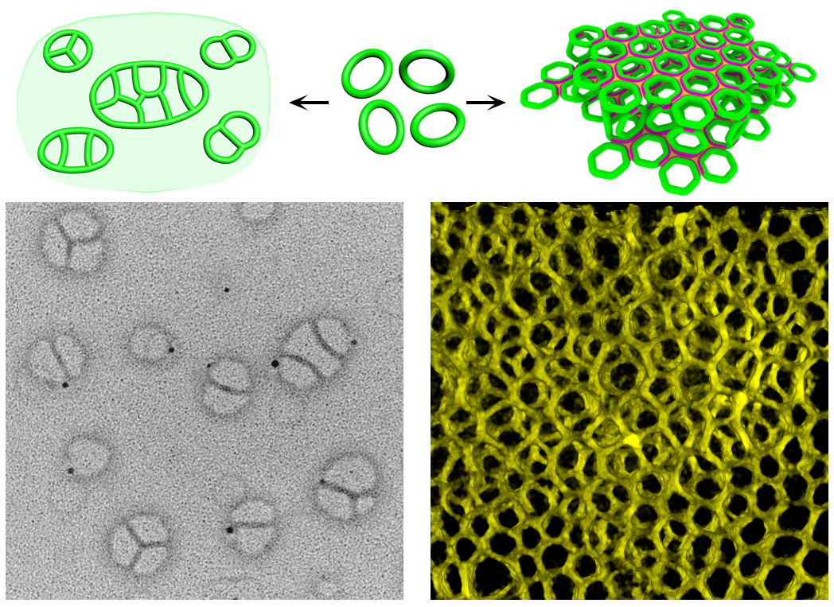

Figure 1: (Top) schematic illustration depicting the hierarchical assembly of toroidal micelles upon modulation of interparticle interactions. (Bottom left) toroids can aggregate into oligo-supermicelles or 2D hexagonal arrays, whereas (bottom right) addition of polyferrocenylsilane block copolymers promotes the formation of 3D nanoporous superstructures. Toroidal micelles can thus be manipulated as a type of building block.

References
- Woloszczuk S, Tuhin MO, Gade SR, Pasquinelli MA, Banaszak M, Spontak RJ (2017), ACS Appl. Mater. Interfaces 9:39940.
- Wang X, Guerin G, Wang H, Wang Y, Manners I, Winnik MA (2007) Science 317:644.
- Gilroy JB, Gädt T, Whittell GR, Chabanne L, Mitchels JM, Richardson RM, Winnik MA, Manners I (2010) Nat. Chem. 2:566.
- Hudson ZM, Lunn, DJ, Winnik MA, Manners I (2014) Nat. Commun. 5:5572.
- Lunn DJ, Gould OEC, Whittell GR, Armstrong DP, Mineart KP, Winnik MA, Spontak RJ, Pringle PG, Manners I (2016) Nat. Commun. 7:12371.
- Cai J, Mineart KP, Li X, Spontak RJ, Manners I, Qiu H (2018) ACS Macro Lett. 7:1040.

 Biography
Richard J. Spontak, Distinguished Professor and director of the Macromolecular Materials and Morphology Group at North Carolina State University, is a world-recognized expert in the field of nanostructured polymers and polymer nanocomposites. His research focuses primarily on the microphase separation, morphology and property development of block copolymers capable of intrinsic and directed self-assembly. He has published over 300 scholarly papers (with his work featured on the cover of 29 international journals and 1 book) and delivered over 300 invited presentations at universities, conferences and industries. He is the recipient of numerous awards for his research, and he is a fellow of several professional societies and a member of the Norwegian Academy of Technological Sciences.

Email: Rich_Spontak@ncsu.edu

Notes/Comments

