DFT investigation about magneto-electric coupling of ANiO3 (A = Ti, Ge, Zr, Sn, Hf and Pb) materials
De Lazaro, SR PhD, UEPG, Brazil, Ponta Grossa
Lacerda, LHS, UEPG, Brazil, Ponta Grossa
Ribeiro, APR, UEPG, Brazil, Ponta Grossa
Longo, E, UEPG, Brazil, Ponta Grossa

Abstract

Nowadays, the theoretical-computational methods based on quantum mechanics are important tools for the development of materials. The use of such methodologies oﬀers additional advantages to the experimental techniques since it shows a better relationship between results precision and study time, especially in the case of Density Functional Theory (DFT). The theoretical methods are also largely employed in materials development aiming for technological applications; nowadays, multiferroic (MF) materials represent an emergent technology and have attracted the interest of researchers around the world. Multiferroism consists in the coexistence and coupling between magnetic ordering and ferroelectricity or ferroelasticity in the same crystalline phase. In particular, the most common multiferroism is known as magnetoelectric (ME) coupling. The investigation of multiferroic materials aims its application at development of several devices such as actuators, magnetic readers, sensors, tunneling and data storage devices.

Multiferroism is found only in a very restrict group of crystalline structures such as perovskite, ilmenite (R3) and ordered corundum (LiNbO3 structure – R3c). It is important to note that the R3c structure is the most common structure observed in known multiferroic materials, such as BiFeO₃, PbNiO₃, YMnO₃, BiMnO₃ and TbMnO₃. The R3c has a general formula of ABO₃, lattice parameters a=b≠c and angles α=β=90° and γ=120°; the A and B cations are both surrounded by six O atoms forming two distorted octahedra.

Our work represents a theoretical eﬀort to provide molecular information about an already reported PbNiO₃ material (PNO) and new proposed materials (TiNiO₃, GeNiO₃, ZrNiO₃, SnNiO₃ and HfNiO₃). Therefore, theoretical-computational methods based on DFT/ B3LYP were employed to investigate multiferroic materials through chemical substitution of Pb atoms in PNO structure by Ti, Ge, Zr, Sn and Hf atoms.

Image
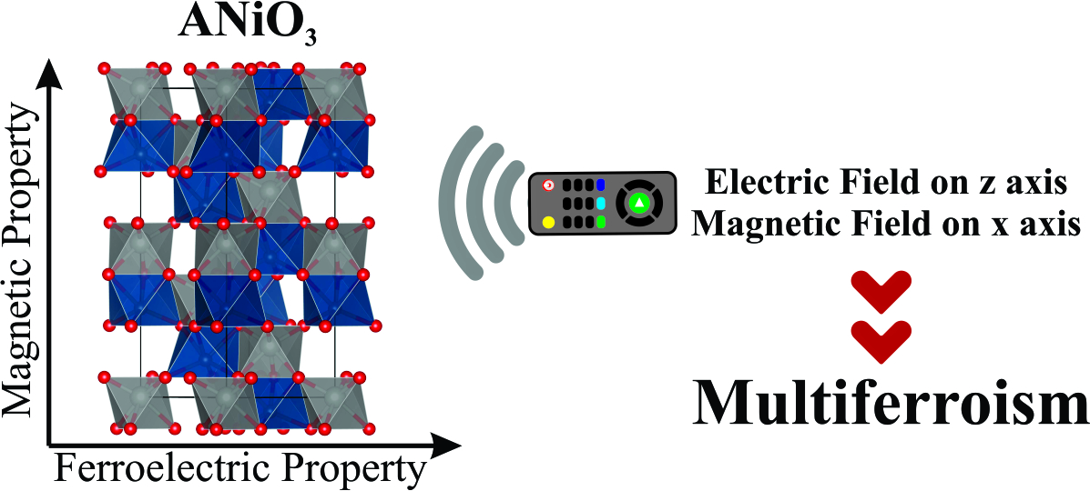
Recent Publications
- Rayapol S, Ribeiro APR, Singh K, Reddy VR, Kaushik SD, de Lazaro SR (2019) Experimental and theoretical interpretation of magnetic ground state of FeMnO₃. Journal of Alloys and Compounds 774:290-298.
- Lacerda LHS, de Lazaro, SR (2018) Improvement of multiferroic property and change of magnetic ordering in new ANiO₃ (A=Ti, Ge, Zr, Sn, Hf and Pb). Computational Material Science 153:228-234.
- Jurelo AR, Ribeiro APR, de Lazaro SR, Monteiro JFHL (2018) Structural, vibrational and electronic properties of the superconductor CuxTiSe2: theoretical and experimental insights. Physical Chemistry Chemical Physics 42:27011-27018.
- Ribeiro APR, Andrés J, Longo E, de Lazaro SR (2018) Magnetism and multiferroic properties at MnTiO3 surfaces: A DFT study. Applied Surface Science 452:463-472.
- Ribeiro APR, Longo E, Andrés J, de Lazaro SR A DFT investigation of the role of oxygen vacancies on the structural, electronic and magnetic properties of ATiO3 (A = Mn, Fe, Ni) multiferroic materials. Physical Chemistry Chemical Physics 45:28382-28392.

Biography
Sergio Ricardo de Lazaro has him expertise in molecular simulation using DFT to improve solid properties for devices and other applications. Him start the computational chemistry area in State University of Ponta Grossa; he is head of Quantum and Computational Chemistry coordinating a molecular simulation group in Department of Chemistry with aim to build theoretical methodology to investigate magnetic and ferroelectric properties in Ilmenites and R3c structures. Surface modeling has been applied together magnetic ordering in morphology. The multidisciplinary aspect of our group is essential to contribute in works with molecules and solid state interests. Since 2007 as Professor; lately is Associate Professor with publications using computational chemistry.
Email: srlazaro@uepg.br

Notes/Comments:

