A Triazol containing Uio-type metal-organic framework as highly efficient CO₂ capture and catalytic conversion
Pouria Zarshenas*, M.Sc student, Faculty of Chemistry & Petroleum sciences, Shahid Beheshti University, I.R.Iran Fataneh Norouzi, PHD student, Faculty of Chemistry & Petroleum sciences, Shahid Beheshti University, I.R.Iran
Hamid Reza Khavasi,Professor of Inorganic Chemistry,Faculty of Chemistry & Petroleum sciences, Shahid Beheshti University, I.R.Iran

Abstract
The rising levels of CO₂ have been the area of concern globally over several decades now, owing to its obvious detrimental effects in the biosphere. CO₂ as the primary dangerous gas has been cited as the leading culprit by temperature increase of the global surface as well as subsequent climate changes. The chemical conversion of CO₂ into five membered cyclic carbonates has been widely demonstrated as an industrially important transformation fulfilling typical green chemistry credentials. Metal-organic frameworks (MOFs) are an excited and rapidly growing class of porous crystalline materials that are constructed from multi dentate organic linkers and discrete inorganic nodes. Compared to other porous materials such as zeolites, mesoporous silica and carbon nanotubes, tunable pore size, high porosity and surface area of MOFs make them important candidates for heterogeneous catalysts, gas sorption/storage/separation, chemical sensing, biomedicines, drug delivery and other technologies. There are many known MOFs such as, zeolite imidazolat frameworks (ZIFs), MILs and Zr-based MOFs which exhibit both chemical and thermal stability for certain applications. One family of MOFs which are rapidly extended are Zr based MOFs including UiOs, PCNs, NU-1000 and MOF-808. The interest in these family of MOFs emerges from their thermal, chemical and mechanical stabilities which make them ideal candidates for many applications. In this seminar, a highly porous and stable UiO-66 -type metal-organic framework containing both metal sites (as Lewis acid) and nitrogen rich triazole group (as Lewis base) was successfully synthesized via solvothermal reaction. In comparison with non-functionalized UiO-66, triazole containing UiO-66 MOF exhibit superior catalytic activities in CO₂ cycloaddition with epoxides. It was demonstrated that the highly performance of triazole containing catalyst is due to the presence of nitrogen groups of triazole moiety which can act as Lewis base. In addition the catalyst showed excellent stability and easy recyclability in comparison with homogenous catalysts.

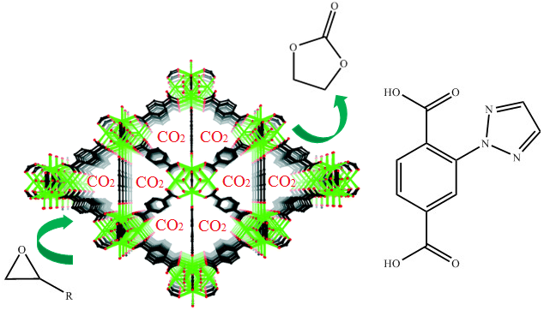
Recent Publications
- P.Zarshenas, R.Sedghi, B.Heidari,H.Shah Mohammadi(2018). Novel magnetically chitosan based N-heterocyclic carbene as recyclable nanocatalyst and highly efficient for crosscoupling reaction: DOI: 10.4172/2157-7439-C6-083
- H.Khavasi,F.Norouzi, A.Azhdari TehraniHalogen Bonding Synthon Modularity in Coordination Compounds Crystal Growth & Design 15(6):150428082818005 · April 2015
- Hamid Reza Khavasi and Narjes Rahimi, Fluorine-Substituted Ligands Induce Structural Diversity of Coordination Compounds, ChemistrySelect 2017, 2, 11314.
- Hamid Reza Khavasi and Narjes Rahimi, Are fluorine-based contacts predictable? A case study in three similar coordination compounds, CrystEngComm, 2017,19, 1361-1365
- Hamid Reza Khavasi and Narjes Rahimi, Coordination Polymers with Intramolecular Fluorine-Involved Contacts in Two-Dimensional Sheet Windows, Cryst. Growth Des. 2017, 17, 834−845

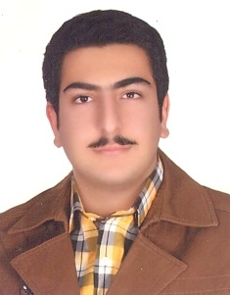Biography
Pouria Zarshenas was born in 1994, Tehran-Iran.
He started B.Sc in 2013 at Shahid Beheshti University. He finished B.Sc in 2017.
Immediately he Started M.Sc in 2018 at Shahid Beheshti University in Inorganic chemistry.
He wants continue his academic education in Inorganic chemistry, crystal engineering & Polymer Chemistry. Professional young chemist with more than 5 years experience in the laboratory and a strong working knowledge of the Research.
Excellent command of the English language, including oral and written comprehension skills. Critical thinker who is reliable, responsible & organized !
Outstanding critical thinker who can use logic and reasoning to identify weaknesses in laboratory research and modify the research plan to create a stronger proposal that yields more concise results.
A co-worker who has knowledge of teaching methods that helps new employees, interns, and others to learn how to properly conduct research in a laboratory environment.

Email: dr.pouryazarshenas@yahoo.com

Notes/Comments:

