Advances in Mixed Matrix Membranes for Water Sustainability
Amira Abdelrasoul, PhD, PEng

Department of Chemical and Biological Engineering, University of Saskatchewan, 57 Campus Drive, Saskatoon, Saskatchewan, S7N 5A9, Canada

Abstract (300 word limit)
Clean water is a basic human need, however it is not available to 1.4 -1.8 billion people around the world. It is essential that the current research trends are directed towards sustainable water and wastewater treatment technologies that can solve the existing industrial and environmental issues, especially when it comes to solutions that can be successfully commercialized on the global scale. Membrane technologies are currently the most effective and sustainable methods utilized in diversified water filtration, wastewater treatment, and industrial and sustainable energy applications. The major drawback of membrane technology is the fouling phenomenon, which causes a decline in permeation flux, selectivity change, separation efficiency, and increase in energy consumption, higher operating costs, and reduction in membrane lifetimes during active filtration operation. The way to enhance membrane performance and reduce the fouling phenomenon is to improve membrane hydrophilicity by inserting nanofillers, nano channels, and zeolites, or through effective surface modification and greater surface porosity. To meet the new demands and standards, mixed matrix membranes (MMM) have gained more attention in Microfiltration (MF), Ultrafiltration (UF), Nanofiltration (NF), Reverse Osmosis (RO), and Ion Exchange (IE) applications due to their ability to combine the features of the aforementioned membrane materials, offering better solutions in terms of performance, fouling, permeate quality, and longevity. Despite their advantageous features, MMMs have not yet reached sufficient maturity to challenge conventional membranes commercially. My talk will focus on how to optimize synthesis of MMM membranes designed with antifouling and how to develop selective permeation that will pave the way for the production of clean water.

Image

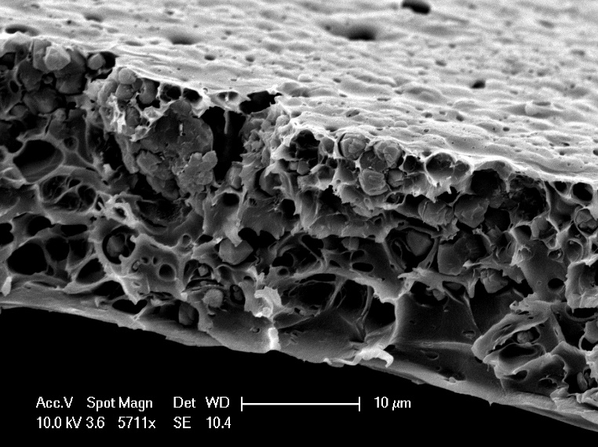
Recent Publications (minimum 5)

http://amiraabdelrasoul.ca

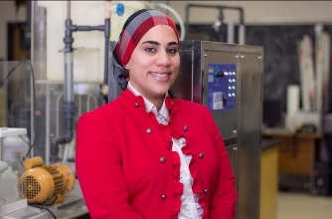Biography (150 word limit)
Amira Abdelrasoul: Dr. Abdelrasoul research interests focus on Membrane Science and Technology for Energy and Water Sustainability and Biomedical Applications; Process Modeling, Simulation and Optimization of Complex Systems; and Nanomaterials for Advanced Technologies. Her research projects focus on modeling; nanoscale molecular dynamics and computational fluid dynamics simulations; optimization; designing; developing; and synthesizing novel evolutional membranes with an advanced customized morphology that can pave the way for the sustainable engineering in the following areas: (i) Optimal membrane technologies for water and wastewater treatment, and the multiplicity of usage scenarios for various applications; (ii) Biomimetic and bioinspired membrane. Her academic excellence was recognized by numerous scholarships and academic awards from North American institutions.

Presenting author details
Full name: Amira Abdelrasoul, PhD, PEng
Contact number: 3069662946
Email id: amira.abdelrasoul@usask.ca
Category: (Oral presentation/ Poster presentation): Keynote

