Electrochemical analysis of lead by the modified carbon paste electrode: Application in real samples
LAGHLIMI Charaf, SMAINI Mouhamed Amine, ENNACHETE Madiha, SAADANE Hind, , ELMASTOUR Jihane and CHTAINI Abdelilah, Molecular Electrochemistry and Inorganic Materials Team, Beni Mellal Faculty of Science and Technology, Sultan Moulay Slimane University, Morocco

Abstract
The modification of graphite carbon is made by adding a quantity of 2-Benzimidazole Thiol (BIT), the 10% BIT electrode is able to detect with great sensitivity the lead in the electrolyte solution containing 0.1 mol / L NaCl with a detection limit (DL, 3s) equal to 2,77.10-9 mol/l and quantification limit (QL, 10s) worth 9,24.10-9 mol/l. The behavior of Pb2+ is studied by three electrochemical methods: Square Wave Voltammetry (SWV), Cyclic voltammetry (CV) and Electrochemical Impedance Spectroscopy (EIS). the extract of the plant studied to give a better complexation of Pb2 +. The extract of Capparis spinosa L has shown great efficiency for the complexation of lead.
Image
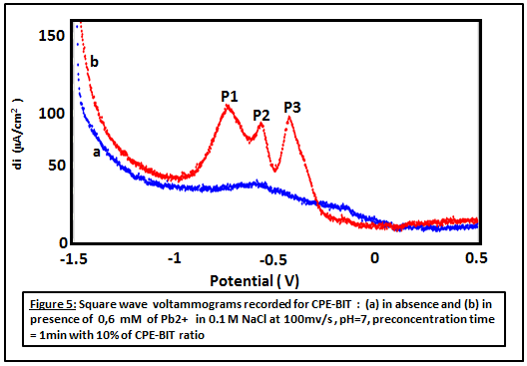
Recent Publications (minimum 5)
- Harper C (2009) The neuropathology of alcohol-related braindamage. Alcohol Alcohol 44:136-140.
- Laghlimi C, Smaini MA, Maallah R, Touzara S, El Qouatli S, and Chtaini A . Organic Sensor for the Detection of Ammonium. J Biosens Bioelectron 2017 ;8: 239.
- MA Smaini, R Maallah, S Touzara, C Laghlimi, S El Qouatli and A Chtaini. Electrochemical Detection and Removal of Mercury (II) at DNA Modified Carbon Paste Electrode. Biol Syst .2017 6: 173
- at DNA Modified Carbon Paste Electrode. Biol Syst .2017 6: 173
- M. El Mhammedi, M. Bakasse and A. chtaini, Electroanalysis, 19(2007), 1727-1733.
- EA. McGaw, GM. Swain, Anal Chim Acta 575(2006)180-9.

Biography
LAGHLIMI Charaf, student in 3rd year of doctorate, electrochemistry specialty. My doctoral work consists in studying the complexation insitu by electrochemical way. Until now, I managed to develop an EDTA-modified electrode that showed a great sensitivity for the detection of ammonium, my article is published on March 14, 2017 in Biosens Bioelectron¹. I also co-authored an article entitled "Electrochemical Detection and Removal of Mercury (II) at DNA Modified Carbon Paste Electrode" published on February 01, 2017. On November 4 and 5, 2016, I participated in the 5th National Days on Green Chemistry in Tetouan. I will be very happy if he is accepted for an oral communication. I chose to be in the category "Organic, Inorganic and Nanomaterials" option "Green chemistry"
1. Laghlimi C, Smaini MA, Maallah R, Touzara S, El Qouatli S, and Chtaini A. Organic Sensor for the Detection of Ammonium. J Biosens Bioelectron 2017; 8: 239.

Email: charaf.cac.fbs@gmail.com

Notes/Comments:

