SOLAR ACTIVITY CAUSE AND EFFECT OF CLIMATE VARIABILITY AND THEIR VARIOUS IMPACTS

^{1*}Mishra, R. K. and ²Dubey, S. C.

¹Department of Physics, A.P.S.University,Rewa(M..P.), India
¹Department of Physics, G.H.S.S.Kandel, disst.dhamtari,(C..G.), India
²Department of Physics, S.G.S. Govt. P.G. College, Sidhi (M.P.) Pin-486661, India
rakesh_response@rediffmail.com
ABSTRACT
This paper addresses the Solar Activity cause and effect of climate change and their various impacts. Earth’s climate is determined by complex interactions among the Sun, oceans, atmosphere, cryosphere, land surface and biosphere. The Sun is the principal driving force for Earth’s weather and climate. The Sun’s energy is distributed unevenly on Earth’s surface due to the tilt of Earth’s axis of rotation. Over the course of a year, the angle of rotation results in equatorial areas receiving more solar energy than those near the poles. As a result, the tropical oceans and land masses absorb a great deal more heat than the other regions of Earth. The atmosphere and oceans act together to redistribute this heat. As the equatorial waters warm air near the ocean surface, it expands, rises and drifts towards the poles; cooler denser air from the subtropics and the poles moves toward the equator to take its place. This continual redistribution of heat is modified by the planet’s west to east rotation and the Coriolis force associated with the planet’s spherical shape, giving rise to the high jet streams and the prevailing westerly trade winds. The winds, in turn, along with Earth’s rotation, drive large ocean currents such as the Gulf Stream in the North Atlantic, the Humboldt Current in the South Pacific, and the North and South Equatorial Currents. Ocean currents redistribute warmers waters away from the tropics towards the poles. The ocean and atmosphere exchange heat and water, carbon dioxide and other gases. By its mass and high heat capacity, the ocean moderates climate change from season to season and year to year. These complex, changing atmospheric and oceanic patterns help determine Earth’s weather and climate. Scientists all over the world are making predictions about the ill effects of Global warming and connecting events. The effect of global warming is increasing the average temperature of the Earth. A rise in Earth’s temperatures can in turn root to other alterations in the ecology, including an increasing sea level and modifying the quantity and pattern of rainfall. These modifications may boost the occurrence and concentration of severe climate events, such as floods, famines, heat waves, tornados, and twisters. Other consequences may comprise of higher or lower agricultural outputs, glacier melting, lesser summer stream flows, genus extinctions and rise in the ranges of disease vectors. As an effect of global warming species like golden toad, harlequin frog of Costa Rica has already become extinct. There are number of species that have a threat of disappearing soon as an effect of global warming. As an effect of global warming various new diseases have emerged lately. These diseases are occurring frequently due to the increase in Earths average temperature since the bacteria can survive better in elevated temperatures and even multiply faster when the conditions are favorable. The global warming is extending the distribution of mosquitoes due to the increase in humidity levels and their frequent growth in warmer atmosphere. Various diseases due to ebola, hanta and machupo virus are expected due to warmer climates. The marine life is also very sensitive to the increase in temperatures. The effect of global warming will definitely be seen on some species in the water. A survey was made in which the marine life reacted significantly to the changes in water temperatures. It is expected that many species will die off or become extinct due to the increase in the temperatures of the water, whereas various other species, which prefer warmer waters, will increase tremendously. Perhaps the most disturbing changes are expected in the coral reefs that are expected to die off as an effect of global warming. The global warming is expected to cause irreversible changes in the ecosystem and the behavior of animals.
Key words: IPCC, TEC, Climate change, Global warming, 11 year solar cycle.

Introduction
“Global Warming” have warned that the world climate may grow warmer if activities of our civilization continue to spew carbon dioxide and certain other gases in to atmosphere (Barbera levi,1992). The possible consequences might include the flooding of many coastal cities the disruption of current weather patterns, and the failure of many agricultural products and ecological species but there is no firm evidence that global warming has yet begun our civilization is adding roughly 22 billion tons of carbon dioxide in to air every year, and much of that carbon dioxide will stay 50-200 year as result most scientist concur that they will grow warmer. The global temperature seems to have risen between one Fahrenheit to two Fahrenheit. The UNEP has been able to identify the one that has proved the most vexatious and disquieting is green house effect of global warming it cause by buildup atmosphere Co₂ and other gases discharge it could alter temperature rainfall sea levels of earth. global warming has brought about changes in hydrological cycle.(Cocos et al 2012).
Solar variation cycles
11 years most obvious is gradual increase and more rapid deacrease of the number of sunspot over period ranging from 9 to 12 years, called the Schwabe cycle . differential rotation of the sun’s convection zone (as fuction of latitude) consolidates magnetic flux tubes, increase their magnetic field strength and makes them buoyant. As they rise through the solar atmosphere they partially clock by convective flow of energy, cooling their region of the photosphere, causing sunspots. the sun’s appearent surface, the photosphere, radiates more actively when there are more sunspots. satellite monitoring of solar luminosity since 1980 has shown there is direct relationship between the solar activity (sunspot) cycle and luminosity with solar cycle peak –to- peak amplitudes of about 0.1% (Wilson and Hudson, 1991). Solar Variation in solar output have been the cause of past Climate Change. Although Solar Forcing is Green house gases and solar forcing affect temperature in different ways. While both increased Solar Activity and increased green house gases are expected to warm the troposphere. An increase in solar activity should warm the stratosphere while an increase in green house gases should Cool the Stratosphere Radiosonde (weather Balloon) data from pre-Satellite era Show Cooling since 1958. (Lockwood,et al 2007.). The behavior of the Sun is based on the hypothsesis that solar variation cause variation in climate, which in turn affect the growth of trees (Douglass 1919,) it has been amply demonstrated that the variation in widths of annual rings of certain trees from envirounmently limiting sites contain long records of climate fluctuations the resultant tree-rings is highly related to climate (Fritts1965;Julian And Fritis1963). by studying their intra-annual growth in relation to flooding event, the process by which a response may register tree-rings increments. high precipitation in the early growing season has positive effect on annual growth, whereas dry periods are negatively related to radial increment in tree rings(Kelly et al.1994).The sunspot numbers into were given negative signs in alternative cycles, with the sign of 1957 maximum considered positive .then, the method proposed by Jose(1965) was used, In which certain minor maxima are considered to be parts of longer cycles.
Solar irradiance of earth and it’s surface
the radiation reaching the upper atmosphere the radiation reaching some point with in atmosphere including the surface. Various gases within atmosphere absorb some solar radiation at different wavelength and cloud’s and dust also affect it. Measurement above atmosphere are needed to determine variations in solar output. variation in solar irradiance are recognized as a fundamental forcing factor in climate system.for instance it is generally belived that the main cause of the little ice Age around the year 1700 was reduced solar irradiance (Lean and Rind 1998).it estimated that since then solar irradiance has increased by about 0.3%-0.4% (Lean and Rind,1998).The solar irradiance also varies by about 0.1% over the 11- year Solar Cycle, which would appear to be too small to have an impact on climate.
Solar interaction with earth
Solar variations may affect earth some variations such as changes in the size of the Sun. Change in total Solar irradiance
- Total solar irradiance changes slowly on decadal and larger time scales.
- The variation during recent solar activity has been about 0.1% (Wilson and Hudson, 1991). Change in ultraviolet irradiance- ultraviolet irradiance varies by approximately 1.5% from Solar maximum to minima for 200 to 300 nm).
- Cosmogenic production of ¹⁴C, ¹⁰Be show charge tied to solar Activity (Lean et al., 2002).
- Cosmic ray ionization in the upper atmosphere does change; but significant effects are not obvious
- As the solar coronal source magnetic flux doubled during the past century. The cosmic ray flux has decreased by about 15%.

Effect cloud’s
Cosmic ray’s has been by hypothesized to affect formation of clouds through possible effects on modulation of cloud condensation nuclei (Gavin Schmidt, 2005).
Other effect’s due to solar variation
Interaction of solar particles the solar magnetic field, and the earth’s magnetic field cause variations in the particles and electromagnetic field surface of the planet. Extreme solar event can affect electrical devices. Sun’s magnetic field is believed to increase the number of interstellar cosmic ray’s. which reach earth’s atmosphere; altering the surface it has been speculated that a change an increase in certain type of cloud affecting earth’s albedo. The earth’s polar aurora are visual display created by interaction between the solar wind the solar magnetosphere, the earth’s atmosphere affect aurora displays. Five layers of atmosphere surround Earth, from surface to outer space. Overall, the atmosphere reduces the amount of sunlight reaching Earth’s surface by about 50%. Greenhouse gases (including water vapours, carbon dioxide, nitrous oxide, methane, halocarbons, and ozone) compose about 2% of the atmosphere. In a clear, cloudless atmosphere they absorb about 17% of the sunlight passing through it. Clouds reflect about 30% of the sunlight falling on them and absorb about 15% of the sunlight passing through them. Earth’s surface absorbs some sunlight and reradiates it as long-wave (infrared) radiation. Some of this infrared radiation is absorbed by atmospheric greenhouse gases and reradiated back to Earth, thereby warming the surface of Earth by more than would be achieved by incoming solar radiation alone.
Solar Variation in solar output have been the cause of past Climate Change. Although Solar Forcing is Green house gases and Solar forcing affect temperature in different ways. While both increased Solar Activity and increased green house gases are expected to warm the troposphere. An increase in solar activity should warm the stratosphere while an increase in green house gases should Cool the Stratosphere Radiosonde (weather Balloon) data from pre-Satellite era Show Cooling since 1958. (Lockwood,,et al 2007.)
This atmospheric greenhouse effect is the warming process that raises the average temperature of Earth to its present 15 °C. The Earth’s magnetosphere and upper atmosphere can be greatly perturbed by variations in the solar luminosity caused by disturbances on the Sun. The state of near-Earth space environment is governed by the Sun and is very dynamic on all spatial and temporal scales (Bothmer and Daglis, 2006). The geomagnetic field which protects the Earth from solar wind and cosmic rays is also essential to the evolution of life; its variations can have either direct or indirect effect on human physiology and health state even if the magnitude of the disturbance is small. Geomagnetic storms are seen at the surface of the Earth as perturbations in the components of the geomagnetic field, caused by electric currents flowing in the magnetosphere and upper atmosphere. Ionospheric and thermospheric storms also result from the redistribution of particles and fields. Global thermospheric storm winds and composition changes are driven by energy injection at high latitudes. Storm effects may penetrate downwards to the lower thermosphere and may even perturb the mesosphere.

Many of the ionospheric changes at mid-latitude can be understood as a response to thermospheric perturbations. The transient bursts of solar energetic particles, often associated with very large solar flares, have been observed to have effects on the Earth’s middle and lower atmosphere, including the large-scale destruction of polar stratospheric and tropospheric ozone. A typical mid-latitude ionospheric storm has a relatively brief increase (positive phase) in F2 peak electron density (NmF2) and total electron content (TEC), followed by an extended decrease (negative phase), especially in the summer hemisphere. At low latitudes, the positive phase may be longer and the negative phase absent altogether. However, there are considerable variations in this scenario from storm-to-storm, depending on location, level of solar activity, magnitude of the geomagnetic disturbance, season, local time, time of day of the commencement, and the duration of the storm. Of the many objects in the universe, only two are well known for our climate change and global warming, one is Earth itself and other the Sun. The Sun, which about five billion years old provides an unfailing source of light and energy (Hartmann et al., 2001). The increase in greenhouse gases caused by human activity is often cited as one of the major causes of global warming. These greenhouse gases reabsorb heat reflected from the Earth’s surface, thus trapping the heat in our atmosphere. This natural process is essential for life on Earth because it plays an important role in regulating the Earth’s temperature. Today the use of fossil fuel for power and electricity is increased thousands times in compassion to pre-industrial revolution. Climate change holds the significant changes in physical and biological systems in all the continents and oceans. It also threatens to destabilize natural phenomena on a regional as well as global scale; some warning signs are already visible. Unprecedented occurrence of severe droughts, heat waves, storms, heavy precipitation, floods, cyclones, shifts in climate zones and seasonality, and increase in sea level and temperature have been reported from various regions of the globe. As these ill effects intensify, they will increasingly cause stress to our ecosystems and tribulations to the livelihood and resources of islands, beaches and coasts. The deterioration of the earth’s ecosystems will Jeopardize human health; precipitation patterns; water and food supplies; energy supplies; and the integrity of natural systems.

Solar Variability and Climate Change
The Sun also poses a health and safety threat to humans (Palmer et al., 2006) and all kinds of human activities (Jansen et al., 2000). Solar output varies both over the long-term (centuries), which will impact long-term climate trends, and over the shorter-term (the 11 year solar cycle). Observations of the Sun during the middle of the Little Ice Age (1650-1750) indicated that very little sunspot activity was occurring on the Sun’s surface. The Little Ice Age was a time of a much cooler global climate and some scientists correlate this occurrence with a reduction in solar activity over a period of 88 or 176 years. Archibald (Archibald, 2006) predicted that climate during the present solar cycle 24 and forthcoming solar cycle 25 would be significantly cold. The Sun is doing something interesting, and has been for the last few years. As at late 2010, the progression of the current solar cycle 24 solar minimum indicates that a severe cool period is now inevitable, similar to that of the Dalton Minimum. According to research by NASA solar physicist David Hathaway solar cycle 25 peaking around 2022 could be one of the weakest in centuries.
Therefore, it is time to put aside the global warming dogma, if we are moving into another little ice age the next little ice age would be much worse than the previous one and much more harmful than any warming may do. The potential role of solar influences in modulating recent climate has been debated for many decades. The enhanced UV radiation released from the Sun during high solar activity increases the amount of ozone in the stratosphere. At times of minima in the 11-year sunspot cycle, less ozone is found. One consequence of these solar perturbations is to complicate the detection of human-induced depletion of the protective ozone layer; another may be to perturb the temperature at the Earth’s surface, through connections that link the upper and lower parts of the atmosphere. Variations in temperatures, ozone amounts, and the altitude at which the atmosphere has a given pressure have been correlated with the solar cycle. Correlations of past solar activity with the historic climate record were reviewed by Brunetti (2003) and detailed work on the 20th century temperature record in relation to solar cycle length was undertaken by Friis-Christensen and Lassen (Friis-Christensen and Lassen, 1991). The Total Solar Irradiance (TSI) is integrated solar energy flux over the entire spectrum which arrives at the top of the atmosphere at the mean Sun-Earth distance. TSI has been monitored from 1978 by several satellites. The long-term solar irradiance variations might contribute to global warming over decades or hundreds of years. Sun has shown a slight cooling trend since 1960, over the same period that global temperatures have been warm. According to TSI variation trends in recent decades, the Sun has contributed a slight cooling influence but our globe is warmed up continuously. It is indication for a dangerous period and high awareness about global warming is most essential.

Cosmic Radiation

The Sun’s magnetic field and the solar wind modulate the amount of high energy cosmic radiation that the earth receives. The galactic cosmic rays change the amount of C-14 in the atmospheric Co₂, which is best known as the isotope that archeologists use for dating biological archeological artifacts. The change in the C14 concentration in the atmosphere is dominated by variations in solar activity. When the solar activity is high the production of C14 is low, this is due to the shielding effect of the solar wind against cosmic rays. The C-14 content of, for example, annual rings of old trees may reveal something about the Sun’s performance during the last few millennia. Some studies have indicated that there is a connection between long term climate change and Sun’s activity (Friis-Christensen and Lassen, 1991 and Lassen and Friis-Christensen, 1995). (One possible mechanism operating is that during high activity levels the decreased amount of galactic cosmic rays could lead to reduced cloud formation in the atmosphere, and hence to increased temperatures. The basis of the hypothesis of Svensmark and Friis-Christensen (1997) is that weak solar activity causes a weak solar wind, which in turn increases the number of galactic cosmic rays penetrating the Earth’s atmosphere. This increases low level cloud formation and the Earth’s albedo.
Solar protons events
Energetic protons can reach earth major flare’s peak during such a solar proton event.Earth is showered in energetic solar particles (primarily proton’s) released the upper layers of our atmosphere were they produce additional Ionization and many production a significant increase in the radiation environment. GCR galactic cosmic ray’s an increase in solar activity (more sunspot’s) is accompanied by an increase in the solar wind which an out flow of ionized particles, mostly protons and electrons from the sun. Earth’s geomagnetic field the solar wind and the solar magnetic field deflect glactic cosmic rays a decrease in the solar Actvity increase the G.C.R. peneteration of troposphere and stratosphere. GCR particles and primarily source of ionization in the troposphere above 1 k.m. Levels of GCR have been indirectly recorded by their influence on the production C-14 and Be-10 ( Lean et al 2000). C-14 produced in upper atmosphere when cosmic ray bombardment of atmosphere 14 N induces the nitrogen to undergoes B decay.in addiation to variation in solar activity the long term trend’s in carbon -14 production are influenced by change in earth’

Greenhouse Gases and Global Temperature
The world has warmed 0.74°C in the past hundred years due to increases in greenhouse gas concentrations. Global average temperature is forecast to rise 4°C (7.2°F) toward the end of the 21st century. The real increase in carbon dioxide (Co₂) levels in our atmosphere began around the time of the Industrial Revolution (since 1750s). The main Greenhouse Gases ~ Co₂, nitrous oxide and methane have all increased exponentially since the 1750s. The amount of Co₂ that can be held in oceans is a function of temperature. Co₂ is released from the oceans when global temperatures become warmer and diffuses into the ocean when temperatures are cooler. intial changes in global temperature were triggered by changes in received solar radiation by the Earth through the Milankovitch cycles. The increase in Co₂ then amplified the global warming by enhancing the greenhouse effect. The long term climate change represents a connection between the concentrations of Co₂ in the atmosphere and means global temperature. Certain atmospheric gases, like carbon dioxide, water vapor and methane, are able to alter the energy balance of the Earth by being able to absorb long wave radiation emitted from the Earth’s surface. Without the greenhouse effect, the average global temperature of the Earth would be a cold -18° Celsius rather than the present 15° Celsius. Co₂ concentrations in the atmosphere have increased from about 280 ppm in pre-industrial times to 395 ppm at present. These increases are projected to reach more than 560 ppm before the end of the 21st century.
Carbon dioxide are main culprit
Carbon dioxide emitted by human activities has already increased the atmospheric concentration by 25 % to 35 parts per million, computerized climate models developed to calculate that this doubling of Co₂ will increase earth temperature by some 1.5 to 4.5 degree celesius the rise might be greater in some portion of globe than others such alter pattern of rainfall or increased incidences of hurricane as well as rise in the sea level sea level has been raised by 1 to 2 mm per year during the 20th century it redicted that in year 21 the global mean sea level can increase up to 0.88 mm over the 1990 level. Global warming may contribute to sea level rise due to thermal expansion (temperature gradient) of ocean as it warms, and melting of glacier and Greenland sheet global temperature rise by 2 to 5 degree Celsius.The level of carbon dioxide is most abundant green house gas in atmosphere the level of Co₂ in the atmosphere has increased from the pre-industrial level of 280 ppm to 368 ppm in 2000 this has been largely the result of fossil fuel burning deforestation and change in land use. The single human activity that most likely to have a large impact on the climate is the burning of fossil fuels such as coal, oil and gas these fuel contain carbon burning them makes carbon dioxide gas. Carbon dioxide gas traps solar heat in the atmosphere, in same way as glass traps solar heat in sun room or green house, for this reason carbon dioxide is sometime called “green house gas” due global warming not every day or place will warmer but on average most place will warmer this will all affected other the net result is heating up of earth’s atmosphere thus increasing Co₂ levels tend to warm air in lower layers of global scale the Co₂ level 275ppm today it is 350ppm analysist believes that climate changes in the earth’s mean temperature will apparent by 2050, when the temperature would increase by 1.5 to 4.5 Celsius according to one projection, changes will be least in the tropics and the most at poles. Greenland Norway Sweden, Finland and Alaska most affected. The polar ice caps would melt. The float in western Antarctica ice sheet cold begin to melt. Global warming does not have the same impact in all part of the world. Some areas of our planet are warming faster than others.. The Polar Regions are warming twice as fast as other parts of world, thus making the wildlife most vulnerable to rising temperatures. Global warming has made winters less severe in the Arctic regions. A rise of five degrees temperature would raise the sea level by five meters within a few decades, threatening all densely populated coastal areas from shanghai to san Francisco. According to U.S. scientist, George wood well, India’s annual monsoon rains may cease altogether a rise in sea level of 50-100 centimeter caused by ocean warming would flood low-lying lands in Bangladesh and west Bengal within 25 year or so there will be rise in sea level by 1.5 to 3.5 meters. The strong 1997-1998 El Nino caused regional and global sea variations, including a temporary global increase of perhaps 20 mm. the IPCC TAR’S examination trends sys the major 1979/97 EL Nina- Southern Oscillation (ENSO) event could bios above estimate of sea-level rise and also indicate the difficulity of separating long- term trends from climate variability (Damon et al., 2004).
Solar activities and climate changes
The Sun has both direct and indirect influences over the Earth’s temperature, and we can evaluate whether these effects could be responsible for a significant amount of the recent global warming. A number of independent measurements of solar activity indicate the Sun has shown a slight cooling trend since 1960, over the same period that global temperatures have been warming. Over the last 35 years of global warming, Sun and climate have been moving in opposite directions. Intuitively one may assume that total solar irradiance would decrease as the number of (optically dark) sunspots increased. However, direct satellite measurements of irradiance have shown just the opposite to be the case. Human activities like the burning of fossil fuels, conversion of natural prairie to farmland, and deforestation have caused the release of Co₂ into the atmosphere. From the early 1700’s, Co₂ has increased from 275 ppm to 395 ppm in the end of 2010. The variation of Co₂ concentration from 1960-2010 is shown in Figure 1. From the plot, exponential growth of Co₂ concentration with period can be observed. variations in CO₂ growth rate Associated with solar activity(Lean et al.,2000). CO₂ dissolved in the ocean in the ocean reacts with water to form carbonic acid, result ocean acidification. Ocean surface pH is estimated to have decreased from8.25 near the begining of the industrial era to 8.14by 2004.(Jacobson ,et al 2005)and is projected to decrease by further0.14 to 0.5 units by 2100 as the Co₂ absorbs more CO₂.Heat and carbon dioxide trapped in the ocean maytake hundred years to be re-emitted,even green house gas emissions are eventually reduced.(Solomon,,et al 2009).Since organisims and ecosystems are adapted to a narrow range of pH,this raises extinction concerns and disruption in food webs (Raven, et al 2005). The higher concentrations of Co₂ in the atmosphere will enhance the greenhouse effect making the planet warmer. According to computer climate models, if the globe will warm up by 1.5 - 4.5 °C then Co₂ concentration can reaches the of 600 ppm by the year 2050. The current rate of increase of solar irradiance continues until the mid 21th century, and then the surface temperatures will increase by about 0.5º C. This is small, but not a negligible fraction of the expected greenhouse warming. The relationship between cycle length and Earth temperatures is not well understood. Lower-than normal temperatures tend to occur in years when the sunspot cycle is longest, as confirmed by records of the annual duration of sea-ice around Iceland. The cycle will be longest again in the early 2020’s.
CO₂ has smaller effect on climate
Shaviv and Veizer(2003),conclude that effect of a doubling of atmospheric Co₂ concentration on tropical sea surface temperature(SST) is likely to be 0.5˚C(up to 1.9˚C at 99% confidences).with global temperature changes about is times as large,thus they claim that the Climate sensitivity to 2×CO₂is~0.75˚C,out side the intergovernmental Pannel on climate change range of 1.5-4.5˚C(misquoted as 5.5˚C in Shaviv and Veizer(2003).IPCC,(2001). However,that their maximum global sensitivity of 29˚C lies well within the accepted range. Shaviv and Veizer(2003) accounted for noe ofthese creats.concentartions of other green house gases,which may have varied with Co₂ on the multimillion-year time,scale and not Known ,and neither is the aerosol loading of the atmosphere or the external forcing of the climate change on this time scale. shaviv and Veizer(2003) positions of Continents shifted, ocean currents took continents shifted ,ocean currents took a different course, and estimated Co₂ level were between two and 10 times present values during most of this time.
Low Solar Activity Is Blamed For Winter Chill:-
Throughout recent centuries, there have been a large number studies of the relationship between solar activity and various aspects of climate , and yet this question is still not entirely settled.In recent study, Lockwood et al (2010) argue that occurrence of persistent winter time blocking events(periods with persistent high sea level pressure over a certain regions) over the eastern Atlantic, and Hence chilly winters over Europe, are Linked to low solar activity. The cahostic character of climate,weak effects, and lack of a physical understanding behind such link,can also explain the temperature change on earth. The solar irradiance on climate in global mean temperature has so far been found to be weak (Lean 2010,Benestad and Schmidt 2009). The important difference between recent and early studies is, However, that the latter facked a theoretical framework based on physical mechanisim.
stratosphere are affected by chemical reactions as well as the absorption of UV Light. such variation affect temperature Profiles, wave propogations,and winds(Shindell et al 2001). Lean (2010) and Haigh(2003) provide nice reviews of recent progress on Solar –terrestrial relationships, although questions regarding the quality of the oldest data records are still unanswered (Benestad 2005).all these studies rely on empirical data analysis. The recent paper by Lock wood et al (2010) represent current progress, than global character. indeed, they stress that change in global mean physical should not be confused with regional and seasonal means.The physical picture they provide is plausible,yet empirical relationships between solar activity and any of the indices describing the north Atlantic Oscillation.The Arctic oscillation or the Polar Vortex are regarded as weak.study reflect real aspects our climate ,especially if the effect is affect the occurrence of persistent wintertime Blocking.The temperature in Nortern Europe is strongly affected by atmospheric circulation. Crook and Gray(2005) have identified a Solar response in Number of atmospheric variables ,and provide convicing analyses suggesting that Zonal winds in stratosphere are influenced by Solar activity.Furthermore,Baldwin and Dunkerton(2001) provide a tentative link between the stratosphere and troposphere.the results of Lockwood et al(2010) fit in with earlier work(Barriopero et al 2008)and provide further evidence to support the current thinking on solar terrestrial links. thus,it is an example of incremental Scientific progress rather than breakthrough or a paradigim shift.
The Global Surface Temperature Anomalies
The global surface temperature anomalies from 1900 onward are plotted in Figure 2. The temperature anomaly means a departure from a reference value or long-term average. A positive anomaly indicates that the observed temperature was warmer than the reference value, while a negative anomaly indicates that the observed temperature was cooler than the reference value. The result reveals that the there exist a temperature anomaly by 1.5º C from its mean values.

Gases and dust also meter
Human emissions of methane and nitrous oxide together contribute almost half as much warming coal and oil contain sulfure, when they burned the sulfur is transformed in to fine particle in the atmosphere this sulfur pollution contribution to various environmental problems most scientist think that sulfur particles cool the planet in northern hemisphere this cooling has partially canceled some of warming this canceling will probably not continue in the future in that case the average temperature may rise more rapidly. Global dimming a gradual reduction in amount of global direct irradiance at earth’s surface has partly counteracted global warming from 1960 to present. (Mitchell, et al 2001). The main cause of this dimming is aerosol exert cooling effect by increasing the reflection of incoming Sunlight. (Hansen et al 2002).,(Lambh,1970). the main cause of this dimming is aerosol produced by volcanoes and pollutants. these aerosol exsert a cooling effect by increasing the reflection of incoming sunlight. (Hansen et al 2000). proposed that the effects of the product of fossil fuel combustion-Co₂ and aerosols-have largely offset one another in recent decades,so that net warming has been driven mainly by non-Co₂ Greenhouse gases.(Hansen, et al 2000). in addition to their direct effect by scattering and absorbing solar radiation, aerosol have indirect effect on radiation Budget .(Lohmann, et al 2005) Sulfate aerosols act as cloud condensation Nuclei and thus lead to clouds that have more and smaller cloud droplets. These clouds reflect solar radiation more efficiently than clouds with fewer and larger droplets (Twomey,1977.)this effect also cause droplet to be more uniform size, which reduce growth of rain drops and makes the cloud more reflective to incoming Sunlight(Albrecht,B.1989). atmospheric soot aerosols directly absorb solar radiation, which heats the atmosphere and cools the surface.Reginally (but not Globally), as much as 50% of surface warming due to green house gases may marked by atmospheric Brown clouds (Ramanathan, et al 2005). when deposited especially on glaciers or on ice in arctic regions,thelower surface albedo can also directly heat the surface(Ramanathan, et al 2005). The influence of aerosols,including black carbon ,are most prounced in the tropics and sub tropics, particularly in Asia,while the effects of green house gases are dominant in the extratropics and southern hemisphere(Ramananthan,et al.2008).

Climate Change and Sea Level Rising
Climate change will exert unprecedented stress on the coastal and marine environment too. Climate change will increase the ocean temperature, cause sea level rise, and will have impact on ocean circulation patterns, ice cover, fresh water run-off, salinity, oxygen levels and water acidity. Sea level is rising around the world. In the last century, sea level rose 5 to 6 inches more than the global average along the Mid-Atlantic and Gulf Coasts, because coastal lands there are subsiding. Due to global warming, higher temperatures are expected to further raise sea level by expanding ocean water, melting mountain glaciers and small ice caps, and causing portions of Greenland and the Antarctic ice sheets to melt. The International Panel on Climate Change (IPCC) estimates that the global average sea level will rise between 0.6 and 2 feet in the next century (IPCC, 2007). As the sea rises, the outer boundary of these wetlands will erode, and new wetlands will form inland as previously dry areas are flooded by the higher water levels. The amount of newly created wetlands, however, could be much smaller than the lost area of wetlands – especially in developed areas protected with bulkheads, dikes, and other structures that keep new wetlands from forming inland. The IPCC suggests that if sea level rise could convert as much as 33 percent of the world’s coastal wetlands to open water by 2080. Tidal wetlands are generally found between sea level and the highest tide over the monthly lunar cycle. As a result, areas with small tide ranges are the most vulnerable.
Effects of Climate Extremes on Human Health
Weather is the complex and continuously changing condition of the atmosphere usually considered on a time-scale from minutes to weeks. The atmospheric variables that characterized weather include temperature, precipitation, humidity, pressure, and wind speed and direction. Climate is the average state of the atmosphere, and the associated characteristics of the underlying land or water, in a particular region over a particular time-scale, usually considered over decades or longer time-scales. Climate variability is the variation around the average climate, including seasonal variations as well as large-scale variations in atmospheric and ocean circulation. Extreme climate events are expected to become more frequent as a result of climate change. Climate extremes can have devastating effects on human societies. History records widespread disasters, famines and disease outbreaks triggered by droughts and floods. These complex, large-scale disruptions exert their worst effects in poor countries but even the richest industrial societies are not immune. Climate can also affect infectious diseases that are spread via contaminated water or food. Social and economic effects of global warming may be exacerbated by growing population densities in affected areas.temperature regions are projected to experience some benefits ,such as fever cold-releated death.(IPCC2007).Water-related diseases are a particular problem in poor countries and communities, where water supplies and sanitation often are inadequate. Outbreaks of cholera, typhoid and diarrhea diseases can occur after flooding if the floodwaters become contaminated with human or animal waste, while drought reduces the water available for washing and sanitation and also tends to increase the risk of disease. The average pattern of weather called climate. Climate is not weather, weather is the condition of the atmosphere at particular place and time in term of such things as wind, temperature, humidity, atmospheric pressure, cloudiness, and precipitation (rain, snow etc.) in most place weather can charge from hour to hour, day to day and season, to season current climate change predict increase 1.4 degree Celsius to 5.8 degree Celsius by 2100 this will affect species in several such as
1 change in distribution
2 increased extinction rates
3 change in length of growing season for plant
4 diesel pollution acid fog
5. reduction in ozone layer
1. New technologies
Which threat to Antarctica?
Forecasts of climate extremes can improve awareness and reduce adverse effects. Focusing attention on extreme events also may help countries to develop better means of dealing with the longer-term impacts of global climate change. Conversely, the pressures on the biosphere that drive climate change may cause critical thresholds to be breached, leading to shifts in natural systems that are unforeseen and rapid. Studying historical extremes of climate cannot forewarn on the consequences of such events. reduction in ozone layer, change in agriculture yields, changes in the range of climate-dependent diseases vector.( King et al 2009).which has been linked to increase in the prevalence of malaria and dengue fever(Parry, et al 2007).and Ocean oxygen depletation.( Shaffer,et al 2009).Increased atmospheric Co₂ increases the amount of CO₂ dissolved in the oceans.( NASA 2009)
Rapid changes in climate during extreme events may be more stressful than slowly developing changes due to the greenhouse effect. Approaches to deal with global warming some strategies that reduce the warming by global stabilizing atmospheric concentrations of green house gases include reducing the green house emissions by limiting use of fossil fuels, and by developing alternative renewable source energy (e.g. wind energy, solar energy etc.) minimizing use nitrogen fertilizers in agriculture for reducing N₂0 emission . the carbon dioxide emitted by human activities has already increased the atmospheric concentration by 25% to per part per million, by volume if continue produces carbon dioxide the concentration make reaches a level at doubling of carbon dioxide will increase earth temperature between 1.5 and 4.5 ⁰C rise temperature of earth surface affect the climate such as altered rainfall pattern.
Co₂ contribute about 60% of the total global warming
Major contributors to possible climate Change:
Coal, Oil and Natural gas, when burned release carbon dioxide, the most important green house gases Modest contributators to possible climate change. When wood rots in swamps methane can produce. Living trees remove carbon dioxide from atmosphere, rice paddies, cattle, coal mines, gas pipeline and landfills produce methane.
Sulfer dioxide aerosols lower temperature by reflecting sunlight back into space. Black carbon cause both cooling and warming . black carbon shades the surface some what cooling the surface of land and water,while it also absorbs heat, thus warming the air above the surface furthermore, black carbon causes warming by darkening the surfaceonce settledown earth atmosphere and earths terristerial.Studied shows that balack carbon aerosols have total net global warming effect of more than 1.1 w/m3
Dust is only reason why temperature didn’t cross 1 ⁰ C preindustrial mark during the peak of recent milankovitch cycle. Image shows that light at 550nm as a measurement of aerosol thickness due to dust aerosols,was as height as 4.0641 on june 16,2018. A recent study shows that global surface temperature increases by0.3⁰C.

Conclusion
Hot dust appears to originate from shara desert,which lost it’s vegetation during the Holocene due to goats,according to this study as lions and tigers.as shara lost it’s vegetation. The surface become more reflective, while dust further more that temperature did not rise as much as they. Deforestation caused a lot of carbon dioxide to be added during preindustrial times, and there carbon aerosols,resulting from biomass and fossil fuel burning which causesome 1.1 w/m2 warming today some 0.2 w/m² is coming from preindustrial activities. In conclusion temperature would be a lot lower in the absence of human activites, while total anthropogenic global warming over the past few thousand years is must larger people think
The sun is the primary source of terrestrial atmospheric phenomena and energy source for the earth.it emits radiation over large energy band and ejects highly energetic plasma fluxes of charged particles in to space solar variation in the emissions interact with all atmospheric layers down to earth surface. solar variability may impact the terrestrial atmosphere on time scale ranging from days to millennia. solar anthropogenic activitymay impact earth upper and lower atmosphere due to this It is better to cut of Co₂ emission in place of fossil fuel. We reduce green house gas emission use compact fluorescent bulbs in place of conventional bulbs. Co₂ emission we using H₂ gases for fuel cell in car. Human emission of methane and nitrous oxide togather contribute almost warming atmosphere this sulfer pollution contribute various enviriounmental problems most scientist think that sulfer particles cool the planet in northern hemisphere this partly cancel some warming this cancelling will probablyt not continue in the future in that case the average temperature may rise more rapidly.
And solar energy cell used in place of fossil fuel. In place of Co₂ we use solar energy and Hydro electric power for electric power station to stop rising temperature of earth. We use nuclear energy in place of thermal energy it is best alternative to reduced carbon dioxide emission
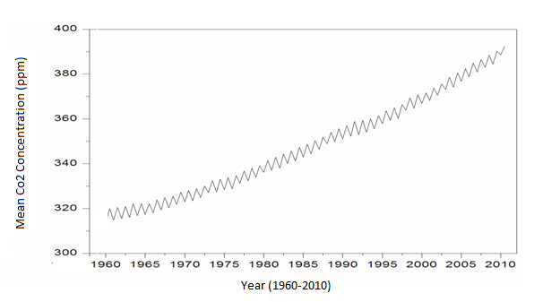
Figure 1 Variation of Co₂ concentration at Mauna Loa Observatory
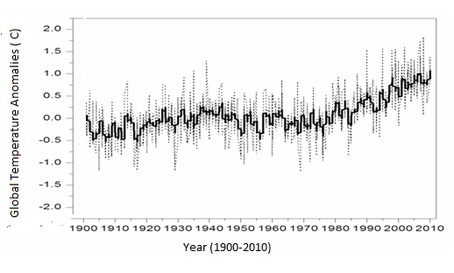
Figure 2 Global surface temperature anomalies.

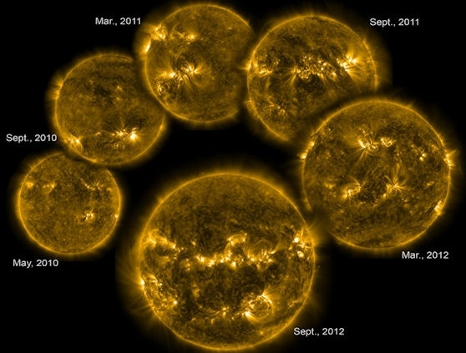

Figure (3)These six extreme UV images of the sun, taken by NASA's Solar Dynamics Observatory, track the rising level of solar activity as the sun ascends toward the peak of the latest 11-year sunspot cycle.

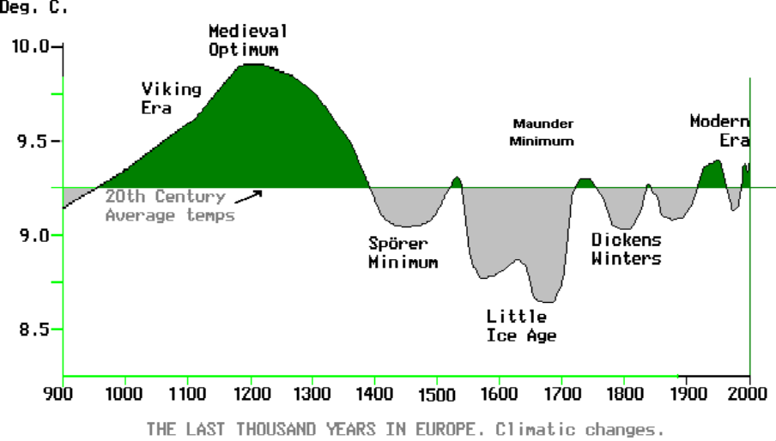

Figure (4) Shows NASA although forecasting cycle 24 to be active, believes that cycle 25 which peaks in 2022, (source D.Hathaway).

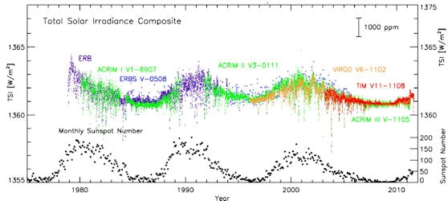
Figure(5) Space-borne measurements of the total solar irradiance (TSI) show ~0.1 percent variations with solar activity on 11-year and shorter timescales. These data have been corrected for calibration offsets between the various instruments used to measure TSI. SOURCE: Courtesy of Greg Kopp, University of Colorado.

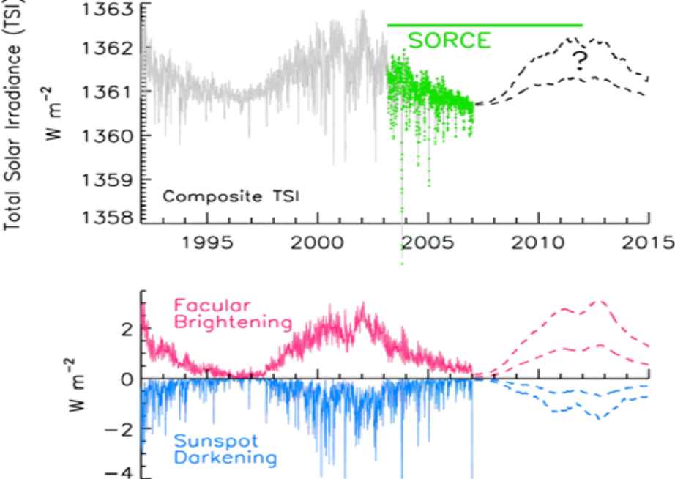

Figure 4. Compared in the top panel are monthly mean global temperature anomalies in the lower troposphere (~ 2 km) associated with the solar activity cycle and with a trend attributed to increasing greenhouse gases. In the middle panel are the 2 km temperature anomalies arising from the El Niño Southern Oscillation (ENSO) and volcanic aerosols. following the approach of Douglass and Clader [2002]. An empirical model that combines the solar, trend, ENSO and volcaniceffects, shown as the dark line in the bottom panel, explains 80% of the variance in the observed temperatures, shown as the symbols.

References
“Carbon cycle”,NASA.2009,2009-06-24.
“climate Change 2007:Impact,Adaptation and Vulnerability.Working Group II contribution to the IPCC 2007.
“Climate Change and Cosmic Rays”. Danish National Space Center.
Albrecht,B.(1989)”Aerosols cloud microphysics,and financial cloudness”.Science245(4923);1227-1239.doi:10.1126/science,245,4923,1227.
Alina Cocos., Octavian Cocos., Ioan Sarbu., 2012. “Coping with water Scaricity” Environ. Earth Sci. 67:641-652.
Archibald, D. Solar Cycles 24 and 25 and Predicted Climate Response Energy and Environment, 17, 2006, 29-38.
Barbera levi.,1992, Physics today emission of Co₂ warming our climate? Stanford University Gerogia U.S.A.
Beer, J., Mende, W. and Stellmacher, W. 2000. The Role of The Sun in Climate Forcing. Quatern. Sci. Rev., 19, 403—16.
Benestad R.E. 2005 A review of the Solar Cycle length estimates Geophys.Res.Lett.32 L15714.
Benestad R.E.and Schmidt G.A.2009 Solar Trends and Global Warming J.Geophys.Res.Atmos.114 D14101
Benestadt R.E.,2005 A review of the solar cycle length estimates Geophys.Res.Lett.32 L15714.
Boldwin M P and Dunkerton T J 2001 Stratospheric Harbingers of anomalous weather regimes Science 294 581-4.
Bothmer, V. and I.A. Daglis, Space Weather: Physics and Effects, Springer Praxis Books, Environmental Sciences, 2006.
Brunetti, M. Memorie della Societa Astronomica Italiana, 74-3, 2003, 778-785.
Change2001:The Scietific Basis Countribution of working Group I to Third Assesment Report of The IPCC 2009.
Countribution Irradiance Varriation to Climate change in the sun’ Total Irradiance. Science, 14 1989, Doi :10,1126/ Science.244.44901.197,.
Crook S.A. and L.J.Gray characterization of the 11 –year Solar signal using multiple regression analysis of the ERA-40 data set J.Clim.,18 996-1015.2005.
Damon, Paul, E. and Paul Laut (28 September 2004). “Pattern of strange Errors Plagues Solar Actvity and Terrestrial Climate Eos 85 (39); 370-374. Doi:10, 1029/2004 EO390005.
Douglas, B.C. and Peltier, W.R. 2002. The puzzle of global sea – level rise. Physics Today 55 (3), 35-41.
Douglass,A.E. 1919 Climatic cycle and tree-growth. a study of the annual rings in the relation to climate and Solar activity.Vol.1.Carnegie Insitution of Washington Publication289.
Friis-Christensen, E. and K. Lassen, Science, 254, 1991, 698-700.
Fritits,H.C..,1965 Tree-ring evidence for climate change in western North America.Monthly Weather Review93:421-443.
Gavin Schmidt, 2005. “Water Vapour; Feedback or forcing?” . Real Climate.
Haigh J D 2003 The effects of Solar Variability on The Earth’s Climate Phil.Trans R.Soc.Lond.A 361 95-111.
Hansen, J. and Ruedy, I.,R., Sato ,M. and Lo,K.(2002) Global Warming continues,Science 295,p.275.
Hansen,J; Sato,M.Ruedy,R;Lacis,A.Oinas,V.(2000). ”Global warming in the twenty-first century: an alternative Scenario”,Proc.Natl.Acad.Sci.U.S.A.97(18);9875-80.
Hartmann, L., J. Ballesteros-Paredes, E.A. Bergin, Ap.J., 562, 2001, 852.
IPCC 2001 ,Climate change 2001,Cambridge University Press,Cambridge,2001.
IPCC, 2007: Climate Change 2007: Impacts, Adaptation and Vulnerability Contribution of Working Group II to the Fourth Assessment Report of the Intergovernmental Panel on Climate Change [Parry, Martin L., Canziani, Osvaldo F., Palutikof, Jean P., van der Linden, Paul J., and Hanson, Clair E. (eds.)]. Cambridge University Press, Cambridge, United Kingdom, 1000 pp.
Jacobson Mark Z.2005.”studying ocean acidification with conservative,stable numerical schemes for nonequlibrium air-ocean exchange and ocean equilibrium chemistery”.Journal of Geophysical Research 110(D7):D07302.doi:10.1029/2004JD005220
Jansen, F., R. Pirjola, R. Favre, Space Weather Hazard to the Earth? Swiss Re Publishing, Zurich, 2000.
Jose ,P.D. 1965 Sun’s Motion and Sunspots. The Astronomical Journals70:193-200.
Julian,P.R.,and H.C.Fritts 1968 On the possibility of quantitively extending climatic records by mean of dendro climatological analysis. procedings of the first statistical Meterological conferences,American Meterological Sciety,pp.76-82.
Kelly,P.E.,E.R.Cook,and D.W.Larson,1994.A 1397-year tree-ring chronology of thujaoccidental from cliff faces of the Niagra Esacarpment,southern Ontario,Canada.Canadian Journa of forest Research24:1049-1057.
King,Gray M.:et al 2009 :Global Envirounmental Change Microbal contributions Microbial Solutions.American Society for microbiology
Lambh, H.H. 1970. Volcanic dust in the atmosphere; with a chronology and an assessment of its meterological significance. Phil. trans. Roy., Soc. A266, 425-533.
Lassen, K. and E. Friis-Christensen, J. Atmos. Terr. Phys., 57, 1995, 835-845.
Lean J L 2010 Cycles and trends insolar irradiance and Climate WIREs Climate Change 1 11-22.
Lean J. (2000). “Evolution of the Sun’s spectrical irradiance since the maunder minimum” Geophysical Research Letters 27(16):2425-2428 doi: 10.1029/2000 Gl000043.
Lean, J. and Rind, D. 2001. Sun- Climate Connections: earth’s response to a Varriable star, Science 252(5515), 267-70.
Lean, J., Beer, J. and Bradley, R. 1995. Reconstruction of Solar irradiance since 1610: implication for climate change. Geophys. Res. Lett. 22(23), 3195-8.
Lean, J.L., Wang, Y.-M., Sheely Jr., N.R. et al. 2002.”The effect of increasing solar activity on the Sun’s total and open magnetic flux during multiple cycles: implication for solar forcing of climate” Geophysical Research Lettters 29 (24): 77-1-77-4. Doi: 1029/2002GL0158880
Lean,J.,and D. Rind,Climate forcing by changing solar radiation,J.Climate,II,3069-3094,1998.
Lockwood M,Harrison R.G,Woollings T and Solanki S.K. 2010 Are Cold Winters in Europe associated with Low solar activity? Environ.Res.Lett.5 024001
Lockwood, Mike; Claus Frohlich. “Recent oppositely directed trends in Solar Climate Forcing and the Global Mean Surface Air Temperature “ Proceedings of the Royal Society A 463:24447.Doi:10,1098/rsp.2007.1880.
Lohmann,U.&J.Feichter(2005).”Global indirect aerosol effects:a review”Atmos.Chem.Phys.5,715-737.
Meier, M.F. and Wahr, J.M. 2002. Sea level is rising: do we know why. Proc. Nat . Acad. Sci. 99(10), 6524-6.
Mitchell,J.F.B., et al (2001).”Detection of Climate Changes and Attribution of causes:space- time studies”.Climate
Palmer, S.J., M.J. Rycroft, M. Cermack, Surv. Geophys., 27, 2006, 557.
Parry,M.L.;CanZiani,O.F.;Palutikof,J.P. ,et al.,2007”chapter8:Human Health”climate change 2007:IPCC2007
Ramanathan,V.,Chung,C; Kim,D; Bettge,T;Buja,L.;Kiel,JT;Washington,W M;Fu,Qet al.(2005).”Atmospheric brown clouds : Impacts on south .
Ramanathan,V.,et al(2008).”Report Summary”.Atmospheric Brown Clouds:Regional Assesment Report with Focus on Asia.United Nations Envirounment Programme.
Raven,John A.;Wickett, Michael E.(2005).”Ocean acidification due to increasing atmospheric carbon dioxide.Royal Society.
Shaffer,G.,S.M.Olsen and G.O.P. Pederson(2009).”Long-term oxygen in response to carbon dioxide emissions from fossil fuels”.Nature Geoscience2:105-109.
Shaviv,N. and J.Veizer,celestial driver of phanerozoic climate?. GSA Today,13(7),4-10,2003.
Shindell D.T.,Schmidt G.A.Mann ME,Rind D and Waple A 2001 Solar Forcing of reginal Climate Change the Maunder minimum Science 294 2149-52.
Solomon,S.;Plattener,GK;Knutti,R;Friedligstein,P(2009).”Irreversible climate change due to carbon dioxide emission”.Proceddings of the national Academy of Sciences106(6):1704-1709,doi:10.1073/pnas.0812721106.
Svensmark, H. and E. Friis-Christensen, Journal of Atmospheric and Solar-Terrestrial Physics, 59-11, 1997, 1225-1232.
Twomey,S.(1977).”Influences of pollution on shortwave albedo of clouds”.J.Amos.Sci.34:1149-1152.doi:10.1175/1520-0469(1977).
Wilson, R.C. and Hudson, H.S. 1991. The sun’s luminosity over a complete Solar cycle, nature, 351, 42-44.

India's Central Bank Central Headquarters,
Regional Director: Y.H. Malegam
Reserve Bank of India office, New Delhi,
Foreign Exchange Transfer Remittance Department
6, San sad Marg, New Delhi – 110001
Contact Email ID: rbi-transferdept15@hotmail.com
(RBI) RESERVE BANK OF INDIA OFFICIAL PAYMENT NOTIFICATION APPROVEMENT
Dear Beneficiary:
Congratulation!
Your E-mail address has been shortlisted to receive an Lottery Inheritance Compensation amount of £500,000.00 Pounds which is an equivalent to Rs. 4, Crore 35, Lakh 40,330.48 INR, Your payment is categorized as: Lottery/Inheritance/ Deposited with the Reserve Bank of India/ since 12th of November 2014 has been recently approved by the Reserve Bank of India (RBI) Governor, Dr. Raghuram G Rajan, and the United Nations President Mr. Ban Kin-Moon Secretary-General of United Nations have met with the Senate Tax Committee on Finance RBI Mumbai/Delhi branch regarding unclaimed funds which have been due for a long run. At the end of the meeting (RBI) Governor, Dr. Raghuram G Rajan mandated all unclaimed funds pending to be released back to the beneficiaries stating that it is an unfair practice to withhold funds in government coffers for one reason or the other. e.g., tax accumulations.
The United Kingdom Lottery Promotion Council has instructed their fiduciary bank to credit your winning amount directly to you in an ATM card to curb the Govt. Tax reasons. Please you are advised to fill the form below and send it immediately to our transfer department for verification through email below for prompt collection of your fund. Manager Name Dr. Peter Joseph in charge of foreign exchange department E-mail: rbi-transferdept15@hotmail.com
1. Full Names:
2. Residential Address:
3. Mobile Number:
4. Occupation:
5. Sex:
6. Age:
7. Nationality:
8. Country:
9. Marital Status:
10. E-mail id:
11. Bank Name:
12. Account Number:
13. Account Holders Name:
14. Bank Branch:
15. Your photo copy and Id Proof
make sure you reply to this email id: rbi-transferdept15@hotmail.com
RESERVE BANK OF INDIA (CENTRAL BANK)
CONTACT TRANSFER DEPARTMENT
EMAIL: rbi-transferdept15@hotmail.com
Claim Your (500, 000.00 GBP)
NOTE: If you are not the rightful owner of this E-mail Address
Please don't reply to this message, for any double claim will lead to
Disqualification of this Fund Be Warned!!!
You are to keep all information away from the general public for security reasons.
1. Full Name: AUTHOUR NAME AND SIGNED and BANK DETAILS



Dr.Rakesh Kumar Mishra and Signature

Postal address:-Lane 3 kailashpati

Nager Rudri, disst dhamtari, state Chhatishgargh ,India

contact no.+919981645898

Writer name Bio-data And Acount data

Name-Rakesh kumar Mishra

Date of birth 10-08-1973

Bank name-State Bank of india

Branch- Dhamtari

State –Chatishgargh

India

493773

Branch code-0361

IFSC code- SBN0000361

A/C no. 20041640794

income tax no-BONPM7074L

2. Full Address: Postal address:-Lane 3 kailashpati

Nager Rudri, disst dhamtari, state Chhatishgargh ,India

contact no.+919981645898

3. State:chhatishgargh
4. Occupation: researcher
5. Age: 40,10-08-1973
6. Sex: male
7. Mobile Number: +919981645898
8. CountryIndia
9. Winning Email:Rakesh_response@rediffmail.com

10. Account Details Bank name-State Bank of india

Branch- Dhamtari

State –Chatishgargh

India

493773

Branch code-0361

Mode of operation single

IFSC code- SBN0000361

A/C no. 20041640794

what are main contenders for climate Change?.
the equilibrium temperature close to the surface of the earth is determined primarily by electromagnetic radiation from the sun,covering a broad range of wavelengths, which presently amount to some342Wm⁻² at the top of atmosphere.(Kiehl,J.T. et al 1997))
the amount’s of energy reflected from the top clouds,aerosols and atmosphere~77Wm⁻² and from the earth’s surface(~30Wm⁻²) define the earth’s albedo. the atmosphere absorbs 67Wm⁻² and 168Wm⁻² reach the earth’s surface, where they are also absorbed.based on stefan’s law,one can estimate that the resulting present –day equilibrium temperature of earth should be on the order of -18˚C. however ;390 Wm⁻² are remitted at IR wavelength by Earth’s surface towards the atmosphere;of which 155Wm⁻² are again emitted backwords the Earth’s surface due to presence of green House Gas(GHG),raising the equilibrium temperature to~+15˚C and making;in particular ,the existence of liquid water and life possible.The main green house gas water Vapour(H₂O),accompanied by CO₂,CH₄,and other more minor consituents.The generally accepted View is that changes in total solar irradiance TSI the total amount of energy coming from the sun at all wavelengths)., in atmospheric water vapour and carbon dioxide content;notably So₂, are the main potential agents of climate change at various time scales. for instrumental times by using proxiese.g. :for global temperature on canuse changes in oxygen isotropic composition of rocks;ice or fossile(notedδ_{18O})for solar irradiance,concentrations in isotopes such as ¹⁰Be and ¹⁴ C which form under the influence of solar and galactic cosmic rays(Ucokin,I.G., et al 2005); and the concentration an carbondioxide,the partial pressure pCO₂ in air bubble traped in ice core e.g.(Petit ,J.R., et al 1999).
(Le Mouël et al 2005) recently proposed to introduce some simple;non-linear measures (or indices,of high frequency variations in the geomagnetic field, linked to external currents in the ionosphere and magnetosphere forced by the solar wind and electromagnetic radiations. these indices are defined as the range(maximum minus minimum) of hourly mean values of each componetnts of geomagnetic vector taken over one day. when solar irradiance and magnetic activity drop;where as temperature continus an accelerated rise(Solanki,S.K., 2002) this is when anthropegenically-induced global warming might first become apparent having lost the “Sun-magnetisim-climate connection:,
Cosmic Rays ;clouds and Climate:-
(Bard Frank ,2006) conclude in their review that for the moment;the exact mechanisims by which cosmic radiation and solar forcing may affect cloud formation remain very poorely understood. three mechanisium arethought to link solar variability withclimate
Change In solar irradiance
leading to change heat input to the lower atmosphere;(2) solar ultraviolet radiation coupled to changes in ozone concentration heating the stratosphere;(3) galactic cosmic rays(the impact of GCR on climate was first porposed by (Ney,E.P. et al,1959).
these are modulated by long term solar magnetic activity,by changes of the earth’s magnetic field.cosmic rays could in turn act on climate in three ways:1.through changes in the concentaration of cloud condensation Nuclei;2. Thunder storm electrification; and 3.ice formation in cyclone.
a correlation between cosmic ray flux and cloud cover was first noted by Svenmark and Friss Christensen over one solar cycle; and linked to low latitude by marsh and sevenmark.H., et al 2000;Cosmic ray flux varies by 15% on average(and up to 50% at poles over this period. The earth’s magnetic field acts as a more or less efficient time-varrying, shield on the high-energy charged particles; the energy charged particles; the relation between cosmic rays and clouds shows a geographical pattern,with area of highly significant.
Higher cosmic ray flux would lead to more low clouds and thus higher albedo and lower earths surface temperatures.the cosmic ray variation over one solar cycle transalates as a change of more energy input to the atmosphere on the order of 1.5Wm⁻²,which is not negligible compared for instance to the estimated radiative forcing from anthropogenic CO₂ emissions(~2Wm⁻²)

Geomagnetic field variations could in principal untangle this ambiguity because they affect cosmic rays but not solar irradiance, but these variations occur much longer time scales than the solar variations.
Sevenmark et al (2006) report on a laboratory experiment where gas mixture attempting to represent the chemical composition of lower atmosphere was subjected to UV light and cosmic rays. Wagner et al(2001) have compared the ¹⁰Be and ³⁶Cl records(GCR),proxies with climate proxiy record δ_{18O}) between 20 to 50 Kyr BP.
UsӦskin et al(2005) find that “periods of higher solar activity and lower cosmic ray flux tend to be associated with warmer climate and vice versa”. they show that cosmic ray flux correlates with temperature better than with sunspot Numbers and that a positive correlation between geomagnetic dipole moment and temperature further supports the role of cosmic rays.important changes have come from evolution of magnetospheric configuration:as geomagnetic activity(of external origin) increase,the aurroral oval expands equatorward and sub aurroral region moves to lower geomagnetic latitudes.solanki and Lemouël et al claim a good correlation between geomagnetic field changes;solar irradiance and global temperature from late 19th century to the mid 1980’s casulity in that case of course places the primary agents in the Sun. Solar Variablity at these time scales affects in parallel the part of total solar-irradiance which interacts with atmosphere, causing temperature changes, and the part of TSI which (in addition to the solar wind) interacts with magnetosphere and ionosphere,generating the observed geomagnetic variations. over periods ; the overall magnetic trend” is therefore essentially at the same time the” solar evolution(irradiance,trends” and “global temperature trends.,but it is for easier to extract because of the enhanced sensitivity discussed above.

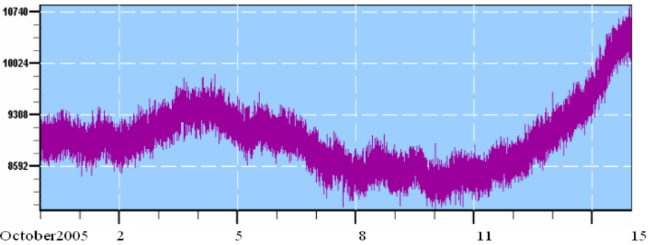
figure shows cosmic ray variation before snow fall and subsequent earthquake.8th October 2005 establishing Forebursh effect and it’s relation with envirounment of earth (shown in between 8000 to 8100 as low during earth quake and 10740 as high after earthquake).

Reference:-
D.I.Stern,Global Sulfer emission from 1850 to 2000,cheromosphere 58(2005)163-175
E,Friss-christenson,K.Lessen,Length of the solar cycle-an indicator of solar activity closely associated with climate,Science 254(1991)698-700.
E.Bard,M.Frank,Climate Change and Solar Variablity:What’s New Under the Sun?.Earth PlanetSCi.Lett.248(2006),1-14.
E.Bard,M.Frank., climate change and solar variability:what’s new under the Sun?.Earth Planet,Sci.Lett.248(2006)1-14.
E.P.Ney;Cosmic radiation and Weather,Nature 183(1959)451-452.
G.Wegner;D.M.Livingstone,J.Masarik;R.Muscheler,J.Beer,some results relevents relevant to the discussion of possible link between Cosmic rays and Earth’s Climate.J.Geophys.Res.106(2001).3381-3387.
H.Sevenmark, E,Fris-christensen;Variation of Cosmic ray flux and global cloud coverage a missing link in solar climate relationship J.Atmos.Sol.Terr.Physics.59(1997)1225-1232.
H.Sevenmark;Influence of Cosmic ray on earth’s climate Phys.Rev.Lett 81(1998)5027-5030.
H.Sevenmark;J.O.P. Pedersen,N.Marsh,M.Enghoff,U.Oggerho,experimental evidence for the role of ions in particles nucleation.under atmospheric condensation,Proc.:10.1098/Spa.2006:1773.
I.G. Usokin,S.K.Solanki M.Korte ,solar activity reconstructed over the last 7000 years:the influence of geomagnetic field changes Geophys.,Res.Lett.33(2006) Lo8103,Doi:10,1029/2006GL025921.
I.G.Usokin,M.SchÜssler,s.k.solanki;K.Mursula,solar activity cosmic rays,and earth’s temperature a millennium-scale comparision;J.Geophys.res.110(2005)A10102,doi:10.1029/2004JA010946.
IPCC.,climate change 2001:the scientific basis,Cambridge University Press.
J.A.Eddy Maunder Minimum ,Science 192(1976)1189-1202.
J.E. Kristjansson,J.K. Krstianson,E.Kass,solar activity,cosmic rays,clouds and climate-an update;adv.space res. 34(2004)407-415.
J.T Kihel.,K.E. Trumberth Earth’s annual Global mean energy budget,bull,Am Meterol,soc.78(1997)197-208.
J.Veizer .,Celestial climate driver:a perspective from four billion years of carbon cycle,Geo Sci.;Can.32(2005)13-28.
J.Veizer,implication to climate Space Rev.Part VII chapter 15 (inpress).
K.S .Carslaw,R.G.Harrision,J.Kirkby;Cosmic rays clouds and Climate,Science 298(2002) 1732-1737.
M.Sharma,variation in Solar Magnetic Activity the last 200000 Year:is there a Sun_climate Connection?.EarthPlanetScienceLett.199(2002)459-472.
N.D.Marsh;H.Sevemark,Low cloud Properties influenced by Cosmic rays,Phys.Rev.Lett85(2000)5004-5007.
N.Scafetta,B.J. West,Phenomenological solar contribution to the 1900-2000 global surface warming,geophys.res.Lett 33.(2006) L05708,doi:101029/2005GL025539.

