Condensed Matter Physics at the Threshold of the Extreme Environments of Temperature and Magnetic Fields.
Kevin Storr, Ph.D.
Associate Professor of Physics
Department of Physics and Chemistry, Prairie View A&M University, Prairie View Texas, USA

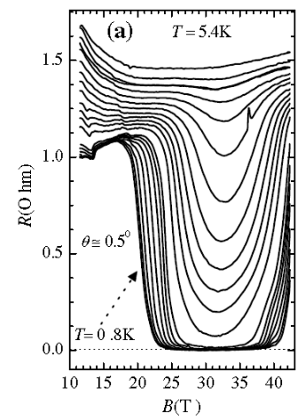
Abstract
In the area of Condensed Matter, we use extreme environmental conditions of temperature (down to 20 millikelvin) and magnetic field (≤ 45 Tesla) to elucidate and tune the electronic, magnetic and thermal properties of candidate materials using several techniques. Three of our most commonly employed techniques are: electrical transport, magnetic torque cantilever and specific heat. Here we present results from three classes of materials, each studied using similar methods: organic conductors, heavy fermion systems and hybridized graphene.
λ-(BETS)₂FeCl₄ is a quasi, two dimensional, layered, anisotropic organic conductor which has shown three states below liquid helium temperature: an antiferromagnetic-insulator state, metallic state, and a field induced superconducting (FISC) ground states with observed re-entrance.
Nd_{1−x}Ce_{x}CoIn₅ is 115 heavy fermion single crystal which exhibits unconventional superconductivity due to being an intermetallic compounds with large electron effective masses. This material can progress from having local moment magnetism to a heavy fermion with the gradual substitution of Nd with Ce. This leads to an adjustment of the availability of 4f electron coupling.
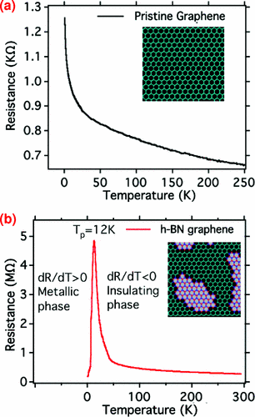
Hybridized graphene and hexagonal boron nitride (h-BNC) domains as a disordered 2D electronic system was studied using magnetoelectric transport measurements. It clearly showed show an insulating to a metallic anomalous transition during the cooling process which we modulated with electron and hole-doping. It was concluded that in comparison to other 2D systems, that in h-BNC the transition came about from percolation associated with the metallic graphene and hopping conduction along edge states.
- Figure 1. Hybridized-BNC graphene temperature dependence in zero field featuring metal to insulator transition at 12K. Inset shows its atomic model.

- Figure 2. Resistance R as a function of magnetic field along the c-axis of
- λ-(BETS)₂FeCl₄ for temperatures between 5.4 and 0.8 K.

References
- Li Song, Luis Balicas, Duncan J. Mowbray, Rodrigo B. Capaz, Kevin Storr, Lijie Ci, Deep Jariwala, Stefan Kurth, Steven G. Louie, Angel Rubio, and Pulickel M. Ajayan. Phys. Rev. B 86, 075429 (2012)
- Lijie Ci, Li Song, Chuanhong Jin, Deep Jariwala, Dangxin Wu, Yongjie Li, Anchal Srivastava, Kevin Storr, Luis Balicas, Feng Liu, Pulickel M. Ajayan, Atomic layers of hybridized boron nitride and graphene domains. Nature Materials, 2010; DOI: 10.1038/nmat2711.
- Balicas, L.; Brooks, J.S.; Storr, K.; Uji, S.; Tokumoto, M.; Tanaka, H.; Kobayashi, H.; Kobayashi, A.; Barzykin, V. and Gor'kov, L.P., Superconductivity in an organic insulator at very high magnetic fields, Phys. Rev. Lett., 87 (6), 067002 (2001)


Biography
Kevin Storr earned a Ph.D. in Low Temperature Condensed Matter Physics from the Florida State University at the National High Magnetic Field Laboratory in Tallahassee Florida. He is currently an Associate Professor of Physics at Prairie View A&M University where he mentors undergraduate students in Physics research along with directing the thesis of graduate students. He is a member of the Texas Physics Consortium and former faculty senator. Known as the Professor of Value, Dr. Storr conducts colloquia in areas of Value, Leadership, Science and Education, is the director of the newly formed, “Global Value Initiative.” He is the recipient of the International Golden Rule Award, The Girma Wolde-Giorgis, Human Conservation Solutionist Award and serves as Special Advisor to the Office of the Ambassador at Large for the Republic of Burundi.

Kevin Storr
936-261-3132
kastorr@pvamu.edu
Passport Number: 480671748

