ARTIFICIAL NEURAL NETWORK APPROACH FOR CASTING PROCESS PARAMETERS ON WEAR RATE OF Al-Cu-SiC_{P} METAL MATRIX COMPOSITES
Serajul Haque¹, Shashank Agrawal²

^{1, 2} Department of Mechanical Engineering, B.S Abdur Rahman Crescent Institute of Science & Technology, India
serajull@gmail.com

Abstract: In material selection the prime parameter is wear rate of material, mainly those engine and machine parts which are in dynamic condition. Stir casting is one of the cost efficient and common routes for fabrication of metal matrix composites (MMCs). The wear resistance properties of Al6061-Cu-SiC MMCs at variable levels of casting process parameters are investigated by Pin-on-disc test. The pouring temperatures are 675˚C, 700˚C, 725˚C, 750˚C and 775˚C , stirring speeds are 50 rpm, 200 rpm, 400 rpm, 600 rpm and 800 rpm and experiments were conducted on three MMCs with composition of Al6061,4% Cu and 5%SiC particles with three different particulate size as input parameters for experimentation purpose. The size of reinforced SiC particulate in MMCs are 63 µm, 53 µm and 45 µm respectively. It is found from ANOVA that the effect of material type is significant for wear rate. The pouring temperature and stirring speed effects are also highly significant for the wear rate of material. However the interaction effect of material type and pouring temperature and material type and stirring speed are insignificant factor for wear rate. The combine effect of material type, pouring temperature and stirring speed are not found significant for wear rate. The stirring speed and pouring temperature on wear rate is found significant (p=0.00 > > 0.005). The worn specimen were analyzed by Scanning Electron micrographs to recognize the features of MMCs at independent variables and an Artificial Neural Network (ANN) were modelling to establish the relationship and prediction of wear rate at different input variables.

Keywords: ANN, Wear rate of MMCs, SEM of Worn specimen of MMCs, Pin-disc method, Stirring speed and Pouring temperature Effect, Reinforcement size effect on wear.

1. Introduction
A report states that the cost of wear to industrial nations are up to four percent of gross national product and a considerable amount of all energy produced by man is exploited in numerous friction practices [1]. As per the previous studies for the applications of automobiles service properties such as wear resistance, hardness and strengths should be high as much as possible, which is customarily found in aluminium composite materials with respect to density [2].
Antaryami et.al, discovered that the MMCs of aluminum have wear resistance and strength equal to cast iron however the density is 67 % less than that of cast iron and likewise the thermal conductivity is considerably higher than cast iron and moreover Aluminum matrix composites reinforced with copper and SiC improves their strength and hardness [3]. The common reinforcement ceramics are boron carbide, alumina, zirconia and silicon carbide (SiC), but SiC is chemically well-matched with aluminum and forms suitable bond with the matrix without emerging intermetallic phase and has the additional benefits such as admirable thermal properties, good workability, low price, affluence of processing by conventional metalworking techniques such as rolling, extrusion, pressing and forging and also their isotropic properties that attract researchers [4-7]. The density declines with the fly ash content addition. Moreover, the wear ability of MMCs declines and slurry erosive wear rises with increasing fly ash content. Corrosion also upsurges with addition of fly ash content [8]. Mozammel et. al. forecasted the values of the surface roughness with respect to feed, speed, hardness for HPC and dry conditions by means of artificial neural network (ANN) in turning process of hardened EN 24T steel. In this paper Artificial Neural Network architectures were trained by using the Bayesian regularization (BR), Levenberg–Marquardt (LM) and scaled conjugate gradient (SCG) algorithms, and weighed based on the lowest root mean square error (RMSE) [9]. Girish K. et al., predicted the value of surface roughness using artificial approach (ANN) and optimized the value of depth of cut, cutting speed, feed and flank wear to minimize the value of surface roughness of AISI 1060 steel [10]. M. Hanief et al. predicted the value of surface roughness for running-in wear using guass newton algorithm and compared result with ANN network. The model was developed by considering the surface roughness as an explicit function of time during running and keeping other system parameters such as velocity, load, hardness, etc. held constant [11]. Marek V. et al., Predicted the surface roughness by using artificial intelligence approach (ANN) for nickel based super alloy UDIMET 720 by considering the effects of tool wear, cutting conditions, and monitoring parameters for the drilling process [12].

Hayajneh et al. established a feedforward backpropagation ANN to forecast the wear of Al–Cu-based metal matrix composite with SiC reinforcement and satisfactory relationship between the ANN results and experimental result was obtained using this approach [13]. Other researchers also used same ANN approach for prediction some properties like porosity, density and hardness of Al–Cu/SiC MMCs manufactured by compo casting route. Roberts et al. modelled the ANN for the destruction control during the forging of Al–SiC particle-reinforced brake discs. The outcomes exhibited that the ANNs can be used to make sensible predictions of damage positions in forged products. The ANN is able to make consistent predictions based on the threshold tensile strength, strain rate, least temperature, optimal strain and maximum hydrostatic pressure. [14]

The advantage of ANN demonstrating contrasted with other traditional methodologies is in its capacity to gain from cases. ANNs also well established with non-linear relationship and extraneous variables. The ANN approach of prediction for the mechanical, physical and tribological characteristics of MMCs was stated by above. However, the interaction effect of pouring temperature, stirring speed and particulate size of ceramic on wear rate and prediction ANN modelling is exceptional in literature. Hence in present research an ANN prediction modelling has been developed to explore the effect of stirring speed, pouring temperature and particulate reinforcement size on wear properties of Al6061-Cu-SiCp MMCs casting.

2. METHODOLOGY
2.1 Process parameters: The input process parameters are three types of materials, five levels of the pouring temperatures and the five levels of stirring speeds and the output are wear rate of MMCs. Full factorial with three replication is considered for data observation design. The null hypothesis for this experimentation is ‘pouring temperature, material type and stirring speeds have no influence on the wear rate of MMC’. The five level of pouring temperatures are 775˚C, 750˚C, 725˚C, 700˚C and 675˚C, stirring speeds are 800 rpm, 600 rpm, 400 rpm, 200 rpm and 50 rpm and three type of materials Al 6061-4% Cu- 45 µm SiCp MMCs, Al 6061-4% Cu- 53 µm SiC_{p} MMCs and Al 6061-4% Cu- 63 µm SiC_{p} MMCs are under consideration.

2.2 Production of MMC by Stir casting technique: A mechanical stirring system were fabricated with the motor, speed control regulator and a casted stirrer for appropriate mixing of ceramic particulates in metal matrix. To confirm the amalgamating of metal, all the heating process were carried out in a crucible of graphite material. A powder of copper and billet of aluminium were preheated for 40 minutes at 450⁰C before melting and preheating temperature of 1100⁰C for 2 hours are under consideration for the SiC particles to oxidize the surface. The temperature of furnace were first elevated beyond the melting point of metal matrix so that feed stock were in complete molten state and then cooled down below the liquidus to retain the slurry in a semi-solid state. Now, in preheated matrix alloy (Al6061-4%Cu) the preheated SiC particles were added and mixed manually. To avoid the difficulty in automatic mixing of semi solid mixture, manual mixing were done before mechanical (automatic) stirring. After sufficient manual stirring, the composite slurry was reheated to a fully liquid state and then mechanical stirring were done for about 10 minutes at five different stirring speeds. In the mixing procedure, the furnace temperature was within 800⁰C and the composite slurry were poured into a sand mold designed to get standard specimens as per full factorial design matrix.
2.3 Wear test: In this study, Pin-on-disc test device were used to examine the wear behaviour of the commercial aluminium Al 6061-4%Cu -5% SiC particulate MMC specimens. For wear tests, ASTM G99 standards were followed for preparation of wear test specimen as shown in Figure 2.1. The machining operation were followed after casting of samples and then polished by emery paper numbering in the sequence of 180,220, 320, 400, 600, 800 and 1200. The wear test of composites specimens were done at a constant normal load of 5kg (at a room temperature of 25ºC. The speed of the rotating disc was controlled at a constant speed of 620 rpm. The time for each sample was set for 10 minutes.
The microprocessor controlled wear testing machine was used, in which frictional force and height loss can be monitored at the same time by a PC-based data logging system. The weight losses were converted into volumetric loss by dividing density of test specimen. The wear rate was calculated by dividing volumetric loss with sliding distance and the counter load applied.
The wear rate for Al6061 and 4%Cu, reinforced 5% SiC particulate MMC were determined, this value is term as wear rate of fabricated MMCs.
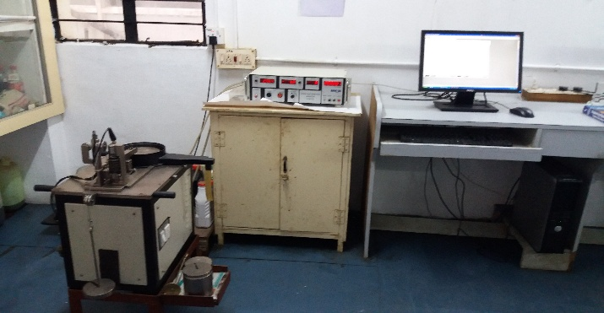
Figure 2.1. Wear Test Apparatus and Specimen

3 RESULTS
3.1 Scanning Electron Micrograph (SEM): The SEM analyses for worn specimen are shown in Figure 3.1 (a)-(h). Plastic deformation are observed on Figure 3.1 (a) for 50 rpm and 700˚C produced MMC sample .The shallow lines are observed on Figure 3.1 (b) for 200 rpm and 700˚C. Further increase in stirring speed from 200 to 400 rpm at 700˚C, patches are observed and grooves become wider and clearly visible on Figure 3.1 (c). Moreover further increment in stirring speed reveals patches of severely scratched regions and deep abrasion grooves due to intense plastic deformation as represented in Figure 3.1 (d).
Figure 3.1 (e) reveals deep grooves and heavy surface damage due to wear at 50 rpm and 725˚C pouring temperature. There is nominal effect of wear is observed on Figure 3.1 (f) states the least plastic deformation at 200 rpm and 725˚C. The continuous and thin grooves are present on surface of Figure 3.1 (g) at 400 rpm and 725˚C that is evidence of plastic deformation. The Figure3.1 (h) reveals the severe damage and deep cavity on the surface at 600 rpm and 725˚C, the reason of heavy damage may be the combine effect of high pouring temperature and higher stirring speed. Wear mechanism were abrasive type, meanwhile the size of ceramic is 63 µm and stirring speed and pouring temperatures are varied for production of specimen as per experimental design.

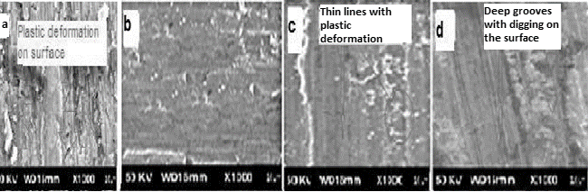
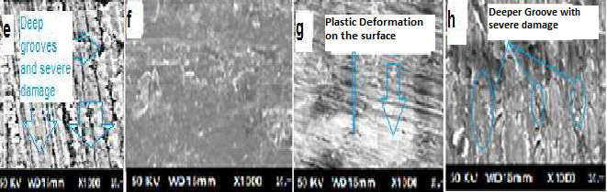
Figure 3.1 SEM of MMC at (a)50 rpm and 700˚C (b) 200 rpm and 700˚C (c) 400 rpm and 700˚C (d) 600 rpm and 700˚C(e) 50 rpm and 725˚C (f)200 rpm and 725˚C (g)400 rpm and 725˚C (h) 600 rpm and 725˚C.
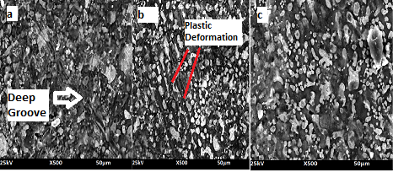
Figure 3.2 SEM of (a) 63 µm MMC (b) 53 µm MMC and (c) 45 µm MMC

Figure 3.2 (a) shows the severe damage of worn surface of MMC specimen for SiC particulate size of 63 µm. While with the reduction of SiC particles from 63 µm to 53 µm the grooves size becomes shallow as shown in Figure 3.2 (b). With further reduction in particulate size of SiC from 53 µm to 45 µm the wear affect is minimized as shown in Figure 3.2 (c). The reason of better wear resistance capacity of MMCs with ceramic particulate size reduction; may be postulated as the phenomenon of better precipitation hardening at lower particulate size. The SEM sample are prepared at 200 rpm and 700˚C and abrasive wear mechanism is observed.
3.2 Analysis of data: Statistical analysis was made by using Software. The result of Analysis of Variance (ANOVA) to observe the effect of input variables pouring temperature and stirring speed on output property material abrasive wear rate. It is found from ANOVA (Table 3.1), the effect of material type is significant for wear rate. The effect of stirring speed and pouring temperature are also significant for the material wear rate. Though the interaction effect of pouring temperature and material type and stirring speed and material type are insignificant factor for wear rate. The combined effect of material type, pouring temperature and stirring speed are not found significant for wear rate. The stirring speed and pouring temperature on wear rate is found significant (p=0.00 > > 0.005). The level of confidence for the above analysis were considered as 95%.
Table 3. 1 ANOVA Table
Dependent Variable: Wear Rate

Source | Type III Sum of Squares | Df | Mean Square | F | Sig.
Material Type | 473.495 | 2 | 236.748 | 202617.844 | .000
Stirring speed | 1.257 | 4 | .314 | 268.949 | .000
Pouring Temp | .508 | 4 | .127 | 108.792 | .000
Material Type * Stirring Speed | .001 | 8 | .000 | .120 | .998
Material Type * Pouring Temperature | .001 | 8 | 9.267E-5 | .079 | 1.000
Stirring speed * Pouring Temp | .105 | 16 | .007 | 5.605 | .000
Material Type * Stirring Speed * Pouring Temperature | .004 | 32 | .000 | .100 | 1.000

3.3 Characteristics Graphs: It is inferred from Figure 3.3 that at range of stirring speed 200 to 600 rpm the wear rate are more or less stable and the wear rate is high for 63 µm and least for 45 µm MMCs. Also these graphs revealed that the wear rate are more or less pursue stable trend ranging from the pouring temperature 700˚C to 750˚C after that it increases drastically.
The combined effect of two input variables on out wear rate is represented in Figure 3.4. It is clear from 3.4 (a) that the optimal value of wear rate is at stirring speed of 400rpm and pouring temperature of 700˚C. The value of wear rate is high at 775˚C for all stirring speed which is supported by the previous research in which it is concluded that at high pouring temperature the composite become porous [15]. The characteristic curve 3.4 (b) reveals that the minimum wear rate are observed at 45 µm at all levels of pouring temperatures. Similarly, it can be concluded from Figure 3.4 (c) that the least value of wear rates are at 45 µm material type for all stirring speeds. The maximum value of wear rate for all type of material are 50 rpm and 800 rpm. The reason behind high wear rate at 50 rpm may be improper mixing of ceramic in base matrix, and wear rate at 800 rpm is supported the previous work [16] in which it is concluded that with increase in stirring speed decline the wear resistance capacity radically. The wear rate is directly proportional to the size of abrasive particles which is supported by previous research [17, 18].
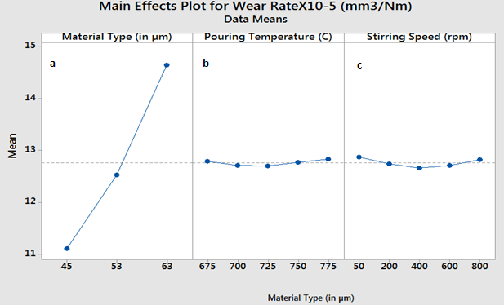
Figure 3.3 (a) Material Type Vs Wear Rate, (b) Pouring Temperature Vs Wear Rate and (c) Stirring Speed Vs Wear Rate of MMCs.

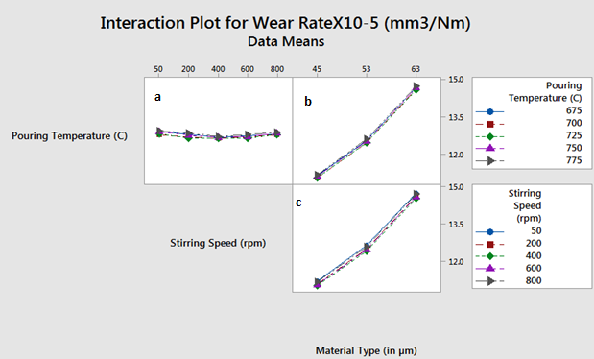
Figure 3. 4 The Interaction Effect of (a) Pouring Temperature, Stirring Speed on Wear Rate (b)Pouring Temperature and Material type on Wear Rate and (c) Stirring Speed and Material Type on Wear of MMCs.
3.4 Artificial Neutral Network (ANN) Modelling:
The notion behind ANN is probably evolved from the human brain functional style in non-manner. The common structure of ANN consists of three layers, which is colonized by one or more neurons. Some mathematical values are represented to the ANN model by using neurons of the input layer. Only one input value can be assigned to each input layer and value presented to each neuron is transferred to hidden layers. Numerical values of response is provided through output layer. ANN architecture training is achieved by adjusting the weights or strengths of the connection between the intermediate, output and input neurons. These neurons have the capability of storing information and memory. ANN produces the desired responses based on the given decision variables after attaining the learning ability. ANN network can be built without hidden layer or more than one hidden which completely rest on the decision variables, relationship among the outputs and inputs, input data and the number of process parameters. The numbers of neuron on a specific hidden layer could be diverse but selecting a proper number which evades over fitting because of large number of neurons along with under-fitting instigated by small number of neuron is rather a tough task and it is determined according to the input-output vector space and input vector size categorizations [19]. ANN performance rely on the training algorithm, network structure, data size used for training, transfer function, time of training, values of biases and weights, data representations, learning function and testing data size. ANN has the capability to find suitable solutions for the problems of similar nature by training.

3.4.1 Design of Artificial Neural Network (ANN)
The major step in designing artificial neural network is to develop the optimum number of neurons in the hidden layer in training of the neural network. The model has a feed-forward structure trained using the multilayer perceptron (MLP) and radial basis function (RBF) networks in this study. An ANN with 3 – [11]1 –– 1 setup was chosen for training. The full factorial experimental design data used for the construction of the ANN model. The experimental data is divided in three sets as a 15% testing, 15% validation and 70% training data for the ANN model. The ANN architecture used in this study is represented by Figure 3.5.

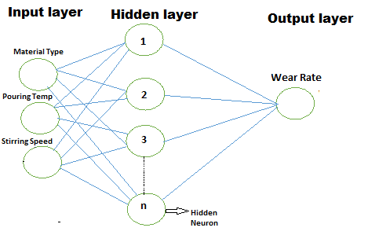
Figure 3.5 ANN Architecture

3.4.2 Training algorithms
R2015a version of MATLAB is used to train the ANN architecture. ‘nntool’ command is applied to build, test and train the ANN network. Training of Neural network is possible by using different algorithms such as Scaled Conjugate Gradient algorithm, Bayesian Regularization algorithms and Levenberg–Marquardt algorithm. These algorithm shows competitive benefits over one another, therefore it is desired to examine which one reveals the least error and good accuracy and so that one is recommended. These algorithm’s performance has been calculated in term of Root Mean Square Error of the experimental wear rate versus predicted wear rate values. The algorithm of Levenberg–Marquardt, represented by ‘trainlm’, works quicker when it trains a medium-size neural network of feed forward type. This algorithm can be used to hold up to numerous hundred weights [20] and helps in the training with test vectors and validation. Hence in this modelling Levenberg–Marquardt algorithm is adopted for training of data.

3.4.3 Performance and transfer function
During modeling, the pure linear function ‘purelin’ and hyperbolic tangent sigmoid function ‘tansig’ have been employed as the transfer function for output and hidden layer, respectively. ‘tansig’ has been chosen because of its symmetric nature[21]. Mean square error (MSE) is selected as a performance function that were used in comparing and evaluating errors with an aim of achieving the least error.
${MSE=\frac{1}{N}\sum{\{WR\left(Experimental\right)-WR\left(Forecasted\right)\}}}^{2}$
ANN Validation curve, ANN testing curve and ANN regression curves are shown in Figure 3.6, Figure 3.7 and Figure 3.8 respectively. These curves represents that ANN model well argued with experimental data.

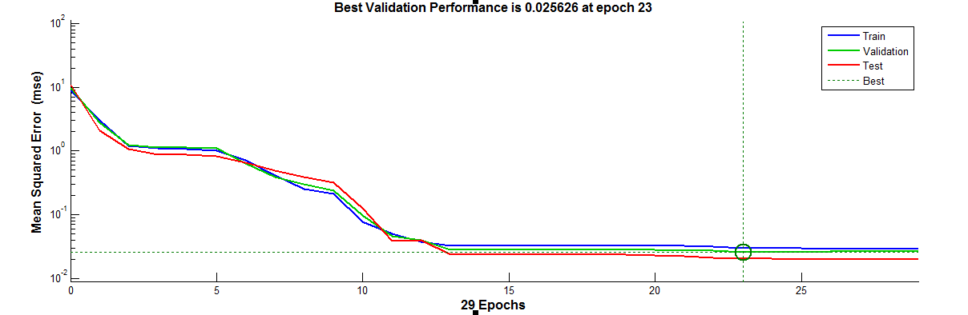
Figure 3.6 ANN Validation Curve.

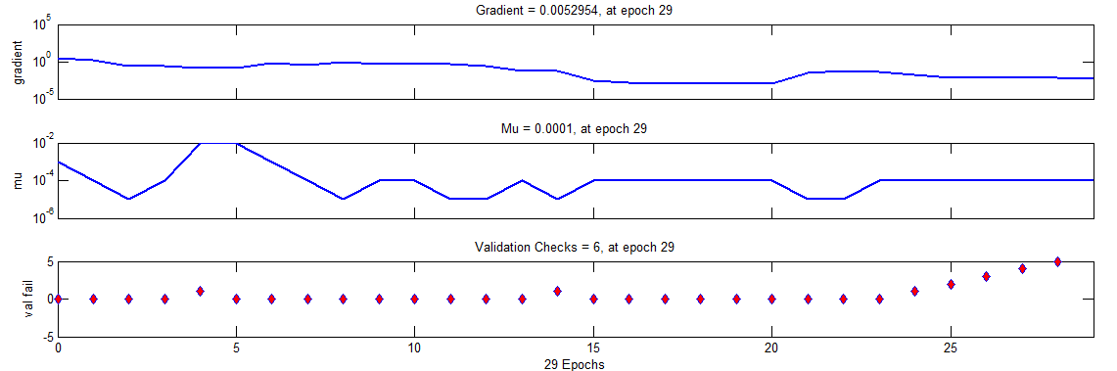

Figure 3.7 ANN Testing Curve
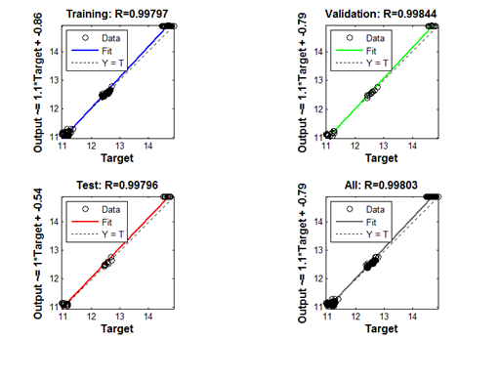
Figure 3.8 ANN Regression Curve.

5. CONCLUSSIONS
The following conclusions are made from the investigation of wear behavior of Al6061-Cu-SiC particulate MMC’s by Artificial Neural Network:

a) The wear loss is computed in terms of volumetric loss of MMCs at constant sliding distance and constant load, with reduction in particulate size from 63 µm to 43 µm of ceramic average 24% improvement in wear resistance were noticed.
b) The optimal wear are ranges from 200 rpm to 400 rpm Stirring speeds for Al6061-4%Cu- 5%SiC MMC.
c) Wear resistance properties are better at optimal range of 700˚C to 725˚C pouring temperature for Al6061-4%Cu- 5%SiC MMC.
d) A non-linear correlation was established using ANN between Material type, Pouring temperature, stirring speed and wear rate.
c) The ANN trained model results are found to be closely correlated with the experimental results.

REFERENCES

[1] D.A.Rigney. (1990). 1, ‘Fundamentals of Friction and wear of materials’, American Society for Metals, vol.21, pp.12-25.
[2] Yu. A. Kurganova, T.A Chernyshov, L.I Kobeleva and S.V Kurganov. ( 2011). Service Properties of Aluminum Matrix Precipitation Hardened Composite Materials and the Prospects of Their Use on the Modern Structural Material Market’, Material letter , pp.663-664.
[3] Antaryami Mishra and Sandip.Kumar Nayak, Mechanical Behaviour and Wear Characteristics of Al-Cu- SiCP Hybrid Composites, SSRG International Journal of Mechanical Engineering (SSRG-IJME) – vol.4(5), 2017, pp.39-46.
[4] S.V. Nair, J.K. Tien, R.C. Bates, SiC reinforced aluminium metal matrix composites, Int. Mater. Rev.vol. 30 (6) 1985, pp.275–290.
[5] Bhanuprasad VV, Bhat RBV, Kuruvilla AK, Prasad KS, Pandey AB, Mahajan YR. P/M processing of Al-SiC composites. Int. J. Powder Metall. 1991, vol.27, pp.227-235.
[6] Harrigan Jr. WC. Scaling up particulate reinforced aluminum composites for commercial production. J. Met. 1991; pp.32-35.
[7] J. K. M. Kwok, S.C. Lim, High-speed tribological properties of some Al/SiCp composites. I. Frictional and wear-rate characteristics, Compos. Sci. Technol. 59 (1999) 55–63.
[8] K.V. MAHENDRA, K. RADHAKRISHNA, Fabrication of Al–4.5% Cu alloy with fly ash metal matrix composites and its characterization, Materials Science-Poland, 2007, Vol. 25(1), pp. 57-68.
[9] Mozammel Mia, Nikhil Ranjan Dhar, Prediction of surface roughness in hard turning under high pressure coolant using Artificial Neural Network, Measurement 92 (2016) 464–474.
[10] Girish Kant ,Kuldip Singh Sangwan, Predictive Modelling and Optimization of Machining Parameters to Minimize Surface Roughness using Artificial Neural Network Coupled with Genetic Algorithm, Procedia CIRP 31 ( 2015 ) 453 – 458
[11] M. Hanief, M.F. Wani, Modeling and prediction of surface roughness for running-in wear using Gauss-Newton algorithm and ANN, Applied Surface Science 357 (2015) 1573–15776.
[12] Marek Vrabe, Ildiko Mankova, Jozef Beno, Jaroslav Tuharský, Surface roughness prediction using artificial neural networks when drilling Udimet 720, Procedia Engineering 48 ( 2012 ) 693 – 700.
[13] Hayajneh, M., Hassan, A. M., Alrashdan, A., and Mayyas, A. T. Prediction of tribological behavior of aluminum–copper based composite using artificial neural network. J. Alloys Comp., 2009, 470, 584–588.
[14] Roberts, S. M., Kusiak, J., Liu, Y. L., Forcellese, A., and Withers, P. J. Prediction of damage evolution in forged aluminium metal matrix composites using a neural network approach. J. Mater. Process. Technol., 1998, 80–81, 507–512.
[15] A.Jahangiri, S.P.H.Marashi, M.Mohammadaliha and V.Ashofte , The effect of pressure and pouring temperature on the porosity, microstructure, hardness and yield stress of AA2024 aluminum alloy during the squeeze casting process, Journal of Materials Processing Technology, Vol. 245, 2017, pp. 1-6.
[16] Waziz Wildan, S. (2015). Sadi , Viktor Malau, M Optimization of Stir Casting Process Parameters to Minimize the Specific Wear of Al-SiC Composites by Taguchi Method. International Journal of Engineering and Technology , pp.17-26.
[17] A.Jokinen and P.Anderson, “Tribological properties of PM aluminium alloy matrix composites”, Annu. Powder Metallurgy Con & Proc., Metal Powder Industries Federation, American Powder Metallurgy Institute, Princeton, NJ, 1990, pp. 517-530.
[18] Misra A. and Finnie I., Some observations on two body abrasive wear, Wear, vol. 68, 1981, pp. 41-56.
[19] D.J. MacKay, Bayesian interpolation, Neural Comput. 4 (1992) 415–447.
[20] M.T. Hagan, M.B. Menhaj, Training feedforward networks with the Marquardt algorithm, IEEE Trans. Neural Networks 5 (1994) 989–993.
[21] A.C. Basheer, U.A. Dabade, S.S. Joshi, V. Bhanuprasad, V. Gadre, Modeling of surface roughness in precision machining of metal matrix composites using ANN, J. Mater. Process. Technol. 197 (2008) 439–444.

