New Enzyme Mimic Hybrid Material
Nalan Özdemir¹, Cevahir Altinkaynak², Ebru Kocazorbaz³, Figen Zihnioglu³
¹Department of Chemistry, Faculty of Science, Erciyes University, Kayseri, 38039 Turkey
²Avanos Vocational School, Nevşehir Hacı Bektaş University, 5300, Nevşehir, Turkey.
³Department of Biochemistry, Faculty of Science, Ege University, 35100 Bornova, İzmir, Turkey.

Keywords: Organic-inorganic hybrid nanoflowers, Enzyme mimics, Egg white, Cu²⁺
Abstract
Enzymes are efficient and sophisticated biocatalysts. However, native enzymes have several drawbacks such as high cost, low operational stability, difficulties in purification, recovery, and storage, and so on. To overcome these limitations several approaches (genetic engineering, chemical modification and synthetic enzyme mimics (artificial enzymes)) have been established. In recent decades, many researchers have made highly intensive efforts to mimic the structural and functional properties of natural enzymes. Enzyme mimics have some advantages, such as having adjustable structures and catalytic activities, excellent tolerance to experimental conditions, low cost, as well as having catalytic activities similar to natural counterparts. As biomimetic catalyst, nanomaterials have been received much attention. Up to now, several metarials (carbon-, metal-, metal-oxide based nanoparticle besides metal complexes) have been reported. However, enzyme mimetic nanomaterials have some serious disadvantages, such as the relatively low catalytic activity, specificity and selectivity. For this reason, in recent years, organic-inorganic hybrid materials have attracted much attention and are being studied intensively. Hybrid materials can be defined as synergistic combination of organic and inorganic components in one material with new and improved properties. In 2012, Zare et al. reported production of flower-like hybrid nano structures with reaction of some enzymes (organic component) and Cu2+ ions (inorganic component). Using the same principle and facile method, many researchers synthesized different enzyme-inorganic hybrid nanoflowers (hNFs) using various metal ions and various enzymes.
In this study, for the first time, using crude egg white as the organic component and copper (II) ions as the inorganic component we synthesized flower-like organic–inorganic hybrid materials (egg white-inorganic hybrid nanoflowers (EW-hNFs)) having enzyme like activity. As known, egg white contains several functionally important main and minor proteins with different percentages and the protein molecules can form complexes with the some transitions metal ions (especially Cu²⁺) because of their strong affinity. Interaction between the proteins and metal ions allows the formation of hybrid structures with flower-like shapes under certain conditions. The synthesized EW-hNFs were characterized using SEM, EDX, XRD and FTIR analysis. Following characterization the biomimetic Polyphenoloxidase/Peroxidase activities of synthesized EW-hNFs were determined by using various substrates. The most noteworthy aspect of our study is that synthesized EW-hNFs which consist of only egg white proteins, showed phenol oxidase activity. The effect of pH and temperature, pH and thermal stabilities, and kinetic parameters of polyphenol oxidase like activity of EW-hNFs were studied. Furthermore, potential use of the EW-hNFs in the discoloration of the some synthetic dyes was also evaluated.
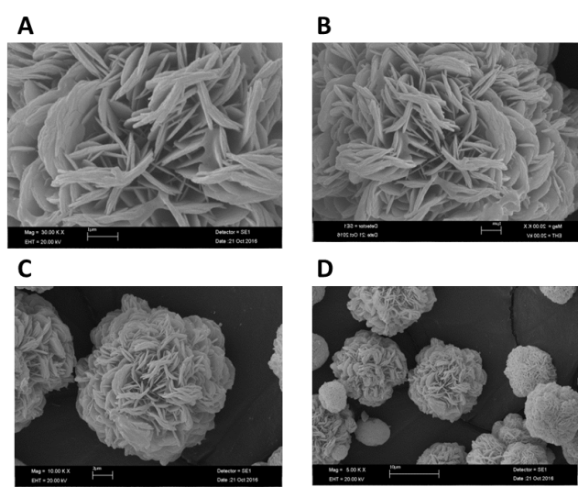
Fig. 1. SEM images of EW-hNFs A) with 30.00 k× magnification, B) 20.00 k× magnification, C) 10.00 k× magnification, and D) 5.00 k× magnification.
References
- Y. Lin, J. Ren, X. Qu, Acc. Chem. Res. 47 (2014) 1097–1105.
- W. He, W. Wamer, Q. Xia, J.J. Yin, P.P. Fu, J. Environ. Sci. Health. C 32 (2014) 186–211.
- J. Ge, J. Lei, R.N. Zare, Nat. Nanotech.(2012) 428–432.
- B. Somturk, M. Hancer, I. Ocsoy, N. Özdemir, Dalton. Trans. 44 (2015) 13845–13852.
- C. Altinkaynak, S. Tavlasoglu, R. Kalin, N. Sadeghian, H. Ozdemir, I. Ocsoy, N.Özdemir, Chemosphere 182 (2017) 122–128.

Biography

Nalan Özdemir has her expertise in biochemistry, especially separation and purification of enzymes, enzyme immobilization, preparation and characterization of enzyme-inorganic hybrid nanostructures. Dr. Özdemir is the founder of the Biochemistry Division at Chemistry Department, Faculty of Science- Erciyes University/TURKEY. She began her studies about synthesis and also characterization of organic-inorganic hybrid nanoflowers. Dr. Özdemir has done many projects and published several articles about organic-inorganic hybrid nanoflowers. Dr Özdemir's work still continues in this area.
Email: ozdemirn@erciyes.edu.tr

