Thousand years conception regarding time calculation theory is misleading the generations into wrong direction: “Need for a change”.
Author: Sahriar Ahamed, 44, GNB Khal Road, Khulna, Bangladesh.

Abstract
We all know the unit of TIME is known as Year, Month, Week, Day, Hour, Minute, Second. But take a look how we calculate year. Definition of the year shows that the earth’s one rotation around the sun is known as a year. A year can be divided in to 12 bigger parts. Every parts are known as months. There are more division in the year such as days. As we know, there are almost 365 days and some fractions of a day in one year. Now come to the definition of day. Day is a full rotation of the earth on its own axis. And day is divided in to smaller units known as hours. 24 hours make a day. Hours are also divided in to small units known as minute and seconds and many more. So, basically we are counting the earth’s rotation around the sun as a year and rotation of the earth on its own axis is known as day. So, what we are calling as the unit of time- is actually the unit of rotation of the earth. Actually, people needed to guess the sum/accumulated amount of spent period on the earth for any fact/reason etc. And the rotation of the earth has a very accurate and systematic movement characteristic. Thus, this system became a scale and from this scale people made the clock. We can understand a particular amount of spent period from clock time. But certainly it’s not the unit of time; it’s the rotational measurement of the earth only. So, from the discussion it’s clear that we are not measuring the unit of TIME with minute, second, hour, day and year. We are very familiar with the theory of TIME DILATION of Albert Einstein. Were he narrated that when a person goes with a faster rate of speed same as the speed of light; he can beat the time speed who is observing staying on the earth. But here you can notice that Albert Einstein assumed the clock time as the real “TIME- the 4h dimension”. But as we discussed earlier that clock time is not a time, it’s the measuring scale of the rotation of the earth on its own axis and around the sun. So, at any speed which is faster than the speed of earth’s rotation can help to beat the “Clock TIME”. So we need to change the text and reading accordingly.

Image:

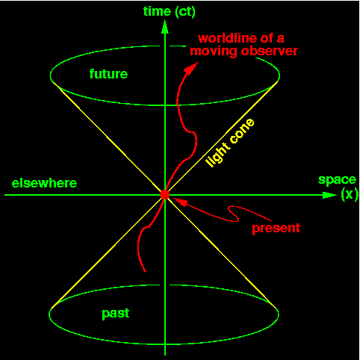

Recent Publications (minimum 5)
- https://www.tsijournals.com/articles/theory-of-time-dilation-twin-paradox-and-its-limitation-13895.html
- https://www.arcjournals.org/international-journal-of-advanced-research-in-physical-science/volume-7-issue-2/
- https://www.sryahwapublications.com/open-access-journal-of-physics/volume-2-issue-4/5.php
- https://www.tsijournals.com/articles/quantum-rotation-is-not-time-13943.html
- https://www.arcjournals.org/international-journal-of-advanced-research-in-physical-science/volume-6-issue-6/3
- https://www.sciencepubco.com/index.php/IJAA/article/view/20599
- https://www.morebooks.de/store/gb/book/theory-of-relativity-of-time-and-of-evaluation-of-human-civilization/isbn/978-3-659-75070-0
- https://www.morebooks.de/store/gb/book/theory-of-gate-way-in-case-of-traveling-time/isbn/978-613-9-44574-5


Sahriar Ahamed
Biography
Sahriar Ahamed, is an individual researcher. And doing research by personal fund without affiliation to any institute for more than 8 years, having 2 books and many theories published around the world in different international journal. Currently living in Khulna, Bangladesh with family and related with social service, research and education
Email: ahamedsahriar@gmail.com

Notes/Comments:

People should do which is their passion.

