Role of Zinc oxide nanoparticles in biomedical applications
Gulzar Ahmed Rather, Phd
Sathyabama, Institute of Science &
Technology, Chennai, 600-119,
Tamil Nadu India

Abstract

Over the past years the use metal oxide nanoparticles have gained greater interest due to their variety of applications in medicine, agriculture, environment, and electronics. Among the metal oxide nanoparticles Zinc oxide nanoparticles has been extensively studied, due to its unique antibacterial, wound healing, UV filtering, photochemical, catalytic and semiconducting properties. It has drawn much attention towards biomedical applications like in drug delivery, biological labeling, sensing and as nanomedicine.There are different methods for the synthesis of Zinc oxide nanoparticles like physical, chemical and biological. The physical and chemical methods are quite expensive required high temperatures and chemicals. To over these issues biological methods using plant extracts are preferred over physical and chemical methods. Biological methods using plant extracts are biocompatible. Non-toxic and one step approach. Plants are the greatest source for large production of nanoparticles. The photochemicals present in plant extracts like alkaloids, phenolics, terpenes and tannins acts as capping and reducing agents. In this paper we will discuss the role of plant mediated Zinc oxide nanoparticles and their biomedical applications in detail.


Image
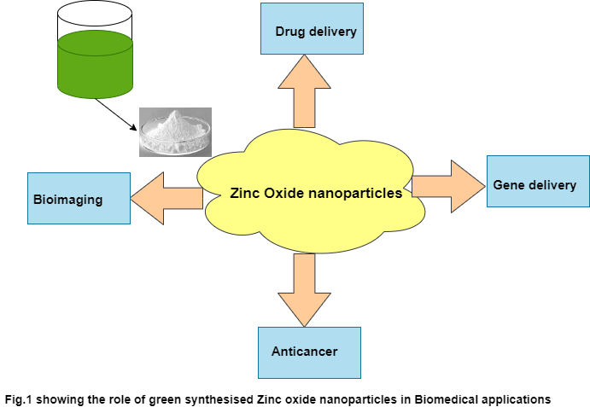
Recent Publications (minimum 5)
- Rather, G. A., Chakravorty, A., Bhat, B. A., Malik, I. M., Mir, F. H., Sana, S. S., & Choudhury, M. (2021). Routes of Synthesis and Characterizations of Nanoparticles. In Applications of Nanomaterials in Agriculture, Food Science, and Medicine (pp. 288-309). IGI Global.
- Mir, M. A., Bhat, B. A., Sheikh, B. A., Rather, G. A., Mehraj, S., & Mir, W. R. (2021). Nanomedicine in Human Health Therapeutics and Drug Delivery: Nanobiotechnology and Nanobiomedicine. In Applications of Nanomaterials in Agriculture, Food Science, and Medicine (pp. 229-251). IGI Global.
- Majeed, S., Danish, M., Ibrahim, M. N. M., Sekeri, S. H., Ansari, M. T., Nanda, A., & Ahmad, G. (2020). Bacteria Mediated Synthesis of Iron Oxide Nanoparticles and Their Antibacterial, Antioxidant, Cytocompatibility Properties. Journal of Cluster Science, 1-12..
- Rather, G. A., Bhat, M. Y., Sana, S. S., Ali, A., Gul, M. Z., Nanda, A., & Hassan, M. (2020). Quince. In Antioxidants in Fruits: Properties and Health Benefits (pp. 397-416). Springer, Singapore.
- Chakravorty, A., Rather, G. A., Ali, A., Bhat, B. A., Sana, S. S., Abhishek, N., & Nanda, A. (2020). Nano Approach: Indian Spices as Antimicrobial Agents. In Ethno pharmacological Investigation of Indian Spices (pp. 205-241). IGI Global.
- Ali, A., Bhat, B. A., Rather, G. A., Malla, B. A., & Ganie, S. A. (2020). Proteomic studies of micronutrient deficiency and toxicity. In Plant Micronutrients (pp. 257-284). Springer, Cham.

Biography
Mr.Gulzar Ahmed Rather is researcher in nanobiotechnology.He has done masters in biochemistry and currently PhD in nanobiotechnology.He has attended almost fifteen national and international conferences, and more than twenty webinars. He has been awarded several times in many conferences. In his PhD he has worked on biomedical applications of Zinc Oxide nanoparticles through biological synthesis. He is expertise in synthesizing and characterization of nanomaterials. He has published six books chapters and several review and research articles. He is working in collaboration with other scientist for review articles and book chapter from Jazan University Saudi Arabia, Hubei University, IT Chennai, North University of China and Kashmir University.
Email: rathergulzar5@gmail.com

Notes/Comments:

