Thermal cyclic life of glass-ceramic bonded thermal barrier coating system

Sumana Ghosh, PhD, CSIR-CGCRI, India

Abstract (300 word limit)

Statement of the Problem: Gas turbines produce energy at very high temperatures. Usually, creep, spallation and delamination occur in the metallic parts of gas turbines leading to deterioration of the turbine blades resulting in decrease in gas turbine efficiency. Thermal barrier coatings (TBCs) are provided to protect the metallic parts of gas turbines from the high inlet temperature. During thermal cycling at higher temperatures TBCs get damaged due to spallation on account of hot corrosion and oxidation of the metallic components of TBCs. In the present study, two types of TBCs were investigated for their thermal cyclic resistance at 1000℃ for 500 cycles: conventional TBC having NiCoCrAlY bond coat and 8-YSZ top coat and new TBC with glass-ceramic bond coat and 8-YSZ top coat. Methodology: Assessment of weight change, X-ray diffraction (XRD), scanning electron microscopy (SEM), energy dispersive X-ray (EDX) analysis were performed for both TBCs after thermal cyclic tests at 1000℃ for 500 cycles. Findings: Weight change measurement indicated that formation of thermally grown oxide (TGO) dominated over the coating spallation up to 300 cycles in case of both TBCs. On the contrary, coating spallation was much more than TGO formation beyond 300 cycles for both TBCs. Further, TGO was not appeared at the bond coat/top coat interface of glass-ceramic bond coated TBC system whereas it was clearly observed in the interfacial region of bond coat and top coat of conventional TBC system after completion of 500 cycles at 1000ºC. Conclusion & Significance: Glass ceramics as a bond coat in a TBC system can provide better heat resistance, oxidation resistance and good stability towards thermal cycling compared to conventional TBC system. Moreover, TGO formation could be avoided by using this new TBC system, which is the most significant controlling factor for the TBC degradation.
Image

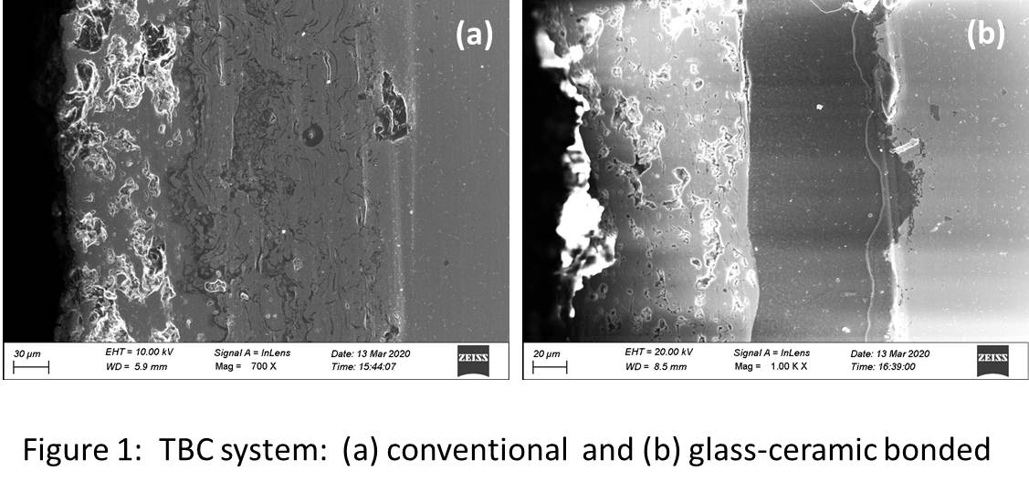
Recent Publications (minimum 5)

- Datta S, Das S (2005) A new high temperature resistant glass-ceramic coatingfor gas turbine engine components. Bulletin of Material Science 28: 689-696
- Das S, Datta S, Basu D, Das G C (2009) Glass-ceramics as oxidation resistant bond coat in thermal barrier coating system. Ceramics International 35: 1403-1406.
- Das S, Datta S, Basu D, Das G C (2009) Thermal cyclic behavior of glass-ceramic bonded thermal barrier coating on nimonic alloy substrate. Ceramics International 35: 2123-2129.
- Ebrahimzade V, Uchtmann H, Singheiser L, Küger M, Malzbender J (2019) Microstructure and cyclic oxidation behavior of APS TBC systems drilled with various laser methods. Surface and Coatings Technology 378: 1-11.

5. Li X, Peng X Y, Dong H, Zhao Y, Wang T, Ren K, Sun L (2019) The evaluation of durability of plasma-sprayed thermal barrier coatings with double-layer bond coat. Coatings 9: 241.


Biography (150 word limit)
Dr. Sumana Ghosh has completed B.E. from IIEST, Shibpur and M.Tech. from IIT, Kharagpur. She has got Ph.D. degree from Jadavpur University, Kolkata. Currently, she is the Principal Scientist of CSIR-Central Glass and Ceramic Research Institute (CSIR-CGCRI), a premier research organization in India. She is working in the field of coating, joining and microwave processing of materials. She has published 45 papers in reputed journals. She has published 55 papers in national and international conference proceedings/ book of abstracts. She has 5 Indian patents and 7 book chapters. She has presented 9 lectures as invited speaker. She is a reviewer of some SCI journals.
Email: sumana@cgcri.res.in

Notes/Comments:

