Title: Green Synthesis of Copper Oxide Nanoparticles Using Protein Fractions from an Aqueous Extract of Brown Algae Macrocystis pyrifera

Karla Araya-Castro1,2, Tzu-Chao Chiao3, Benjamín Durán-Vinet2, Carla Cisternas1, Gustavo Ciudad4, Olga Rubilar4*

1 Doctoral Program in Science of Natural Resources, Universidad de La Frontera, Temuco 54-D, Chile

2 Scientific and Technological Bioresource Nucleus, Universidad de La Frontera, Temuco 54-D, Chile

3 Institute of Environmental Change & Society, Department of Biology, University of Regina, Regina, SK S4S, Canada

4 Chemical Engineering Department, Universidad de La Frontera, Temuco 54-D, Chile

*Author to whom correspondence should be addressed.

Keywords: green synthesis; brown seaweed; proteins; size exclusion chromatography; copper oxide nanoparticles

- Abstract Body (up to 300 words)
Amongst different living organisms studied as potential candidates for the green synthesis of copper nanoparticles, algal biomass is presented as a novel and easy-to-handle method. However, the role of specific biomolecules and their contribution as reductant and capping agents has not yet been described. This contribution reports a green synthesis method to obtain copper oxide nanoparticles (CuO-NPs) using separated protein fractions from an aqueous extract of brown algae Macrocystis pyrifera through size exclusion chromatography (HPLC-SEC). Proteins were detected by a UV/VIS diode array, time-based fraction collection was carried out, and each collected fraction was used to evaluate the synthesis of CuO-NPs. The characterization of CuO-NPs was evaluated by Dynamic Light Scattering (DLS), Z-potential, Fourier Transform Infrared (FTIR), Transmission Electron Microscope (TEM) equipped with Energy Dispersive X-ray Spectroscopy (EDS) detector. Low Molecular Weight (LMW) and High Molecular Weight (HMW) protein fractions were able to synthesize spherical CuO-NPs. TEM images showed that the metallic core present in the observed samples ranged from 2 to 50 nm in diameter, with spherical nanostructures present in all containing protein samples. FTIR measurements showed functional groups from proteins having a pivotal role in the reduction and stabilization of the nanoparticles. The highly negative zeta potential average values from obtained nanoparticles suggest high stability, expanding the range of possible applications. This facile and novel protein-assisted method for the green synthesis of CuO-NPs may also provide a suitable tool to synthesize other nanoparticles that have different application areas.

Image:
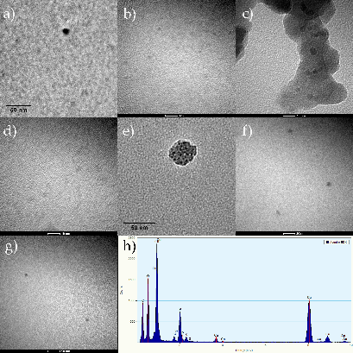

Biography:
Biotechnologist, Master and Ph.D. in Natural Resource Sciences. Extensive experience in project and enterprise management, climate change and sustainable initiatives, teaching, interdisciplinary teamwork and multicultural contexts problem solving. Person with physical disability, wheelchair user.

Presenting author details

Full Name: Karla Jesús Araya Castro
Contact number: +56 9 9943 2239
Twitter account: @KarlaArayaC
Linked In account: https://www.linkedin.com/in/karlaarayacastro/

Session name/ number: Green Synthesis of Copper Oxide Nanoparticles Using Protein Fractions from an Aqueous Extract of Brown Algae Macrocystis pyrifera

Category: Oral presentation

