Title: Green synthesis of copper oxide nanoparticles using Macrocystis pyrifera free-biomass extract

Benjamín Durán-Vinet¹, Karla Araya-Castro1,2, Tzu-Chao Chiao3, Carla Cisternas1, Gustavo Ciudad4, Olga Rubilar4*

1 Scientific and Technological Bioresource Nucleus, Universidad de La Frontera, Temuco 54-D, Chile

2 Doctoral Program in Science of Natural Resources, Universidad de La Frontera, Temuco 54-D, Chile

3 Institute of Environmental Change & Society, Department of Biology, University of Regina, Regina, SK S4S, Canada

4 Chemical Engineering Department, Universidad de La Frontera, Temuco 54-D, Chile

*Author to whom correspondence should be addressed.

Keywords: green synthesis; Macrocystis pyrifera; copper oxide nanoparticles.

- Abstract Body (up to 300 words)

The need to carry out research focused on novel ecological protocols has increased exponentially, motivated by the common aim to reduce toxic by-products drawback from chemical and physical methods. Amongst different living organisms studied as potential candidates for the synthesis of metallic nanoparticles, algae biomass is presented as a novel and easy-to-handle. We evaluate the influence of reaction parameters in the synthesis of copper nanoparticles (Cu-NPs) using Macrocystis pyrifera free-biomass non-boiled (FBNB) extract. Response surface methodology (RSM) based on a central composite design (CCD) was used to evaluate the following independent variables for nanoparticle formation in the extract: X1: CuSO4 concentration; X2: pH; and X3: temperature. Their effects were assessed on synthesized Cu-NP average size distribution, zeta potential, and polydispersity index (PDI) by dynamic light scattering (DLS). Shape, size, and elemental mapping at a microstructural level were measured by scanning electron microscopy (SEM) with energy dispersive X-ray spectrometry (EDS). Results from CCD showed that predicted optimal reaction conditions for Cu-NP formation using M. pyrifera extract were 2.2 mM CuSO4 concentration, pH 8, and incubation at 25,5°C, obtaining an average size distribution, Z potential and PDI of 121 nm, -23.5 mV and 0.3, respectively. This work demonstrated that M. pyrifera extract is a feasible biomass for the synthesis of Cu-NPs and that the control of the reaction parameters can determine the nanoparticle characteristics.

Image:

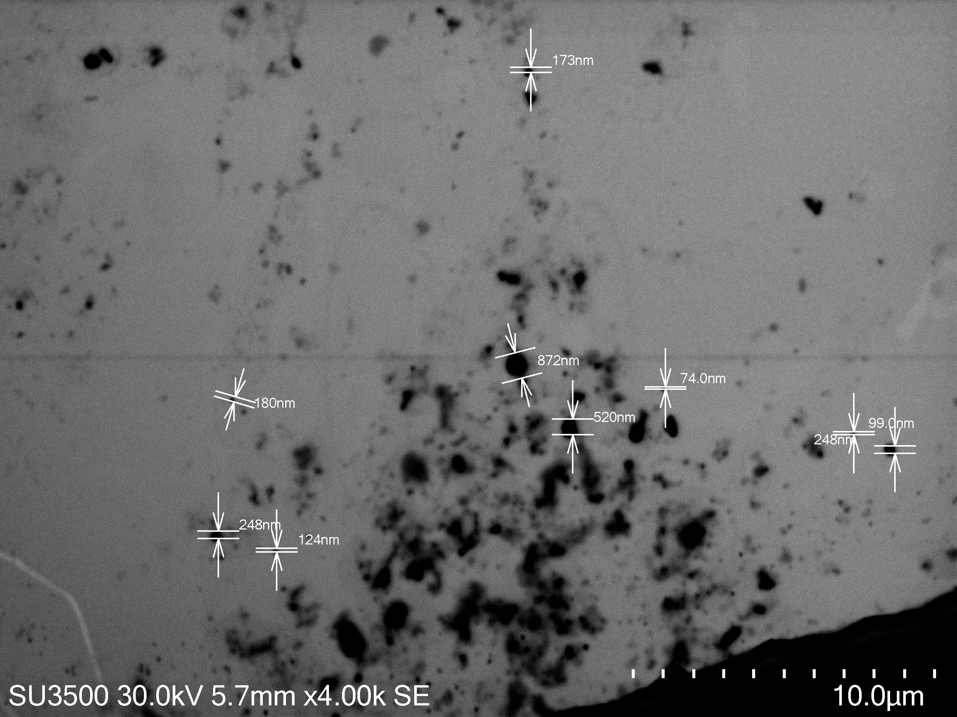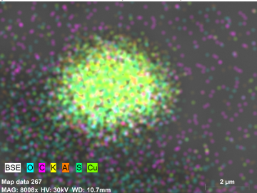

Biography:

I am a proactive Bachelor of Biotechnology (Honours), with relevant experience in biology, bionanotechnology, cell culture, microbiology, bioinformatics, molecular biology and genomics. Currently developing as an integral scientist to generate impact research, always willing to learn and improve. I am currently leading CRISPR/Cas-based biomonitoring project.

Presenting author details



Full Name: Benjamín Alexander Durán-Vinet
Contact number: +56 9 4060 6431
Twitter account: Not applicable
Linked In account: www.linkedin.com/in/benjaminduranv

Session name/ number: Green Synthesis of Copper Oxide Nanoparticles Using Macrocystis pyrifera free-biomass extract

Category: Oral presentation

