Abstract
Title: Effect of calcination temperature on the physical properties of Zn_{0.5}Co_{0.5}Pr_{x}Fe_{2-x}O₄ nanoparticles synthesized by co-precipitation method
ZOUHEIR BITAR
Department of physics, faculty of science, Beirut Arab University, Beirut, Lebanon
Keywords: co-precipitation, rare earth, FTIR, EPR, calcination temperature

- Abstract
The effect of calcination temperature, varying from 773 to 923 K, on the synthesis of Zn_{0.5}Co_{0.5}Pr_{x}Fe_{2-x}O₄ (0 ≤ x ≤ 0.2) by co-precipitation method was discussed in our present work. The X-ray powder diffraction XRD patterns for all the samples confirmed the formation of zinc cobalt nano ferrite with fcc spinel phase and Fd3 space group. The crystallite size calculated from XRD and the particle size measured from the Transmission Electron Microscope TEM increased with the increase of calcination temperature for all samples with different concentrations of Pr³⁺. The variation of calcination temperature didn’t show any change in the shape of the prepared nanoparticles. The impurity of all samples was investigated by the Fourier Transform Infrared FTIR spectra. UV-vis absorption spectra showed a red-shift with increasing the calcination temperature. The band gap energy E_{g}, determined from Tauc-plot, decreased with the increase of calcination temperature. This result is in good agreement with the decrease of particle size. ΔH_{pp} and g-value, obtained from the Electron Paramagnetic Resonance EPR spectra, increased with the rise of calcination temperature from 773 to 923 K. The variation of g-value can be an indicator for the rearrangement of cations between tetrahedral and octahedral sites due to the variation of calcination temperature.

- Image

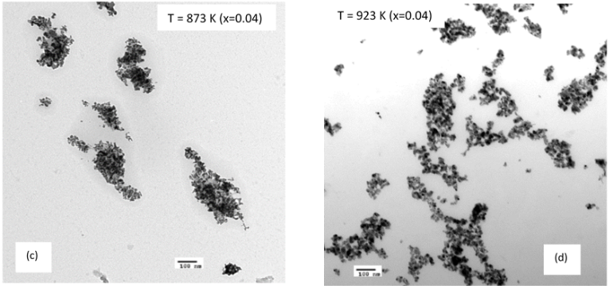

- Reference:
- Qu, Y., Yang, H., Yang, N., Fan, Y., Zhu, H., & Zou, G. (2006). The effect of reaction temperature on the particle size, structure and magnetic properties of coprecipitated CoFe₂O₄ nanoparticles. Materials Letters, 60:3548–3552.
- Hemeda, O. (2004). IR spectral studies of Co0.6Zn0.4MnxFe2−xO4 ferrites. Journal of Magnetism and Magnetic Materials, 28:36-41.

- Biography
Zouheir Bitar is a researcher in the physics department of Beirut Arab University, Lebanon. Currently, he is working on researches related to nanomaterials in the materials laboratory of Beirut Arab University. He received the Ph.D. in 2018 from Beirut Arab University. He has seven articles published in international journals. Recently, he is working on a new project. He believes in teamwork.

- Author Details

Full name: Zouheir Bitar
Linkedin: https://www.linkedin.com/in/dr-zouheir-bitar-90b6b985/
Phone/ whatsapp : +9613461249
Email : zouheirbitar@hotmail.com

