Proposition of new cold fusion reactor based on the mechanism with the flat wafer with nano structure and with the electrode to control the surface potential of metals
Noriyuki Kodama, Tokyo Japan Independent researcher

Abstract

I propose the new cold fusion reactor and heat element in fig.2 based on the cold fusion mechanism shown in fig.1.

I summarize this theory in fig1. D is absorbed in metal in D₂O and D enters in the surface T site after the sufficiently high D/Pd ratio, and the T site is expanded by the larger D⁻ and adjacent T site size is smaller due to the compress by the expanded T site, so it has D⁺. Under this condition, the coulomb attractive force moves D⁺ to D⁻. Here we must note that surface free electron can shield the coulomb attractive force and so, to control the fusion, it must be depleted from surface of metal otherwise higher temperature is needed to trigger fusion. Fig.2 shows the flat electrode above metal to control the surface potential of metal. W/o control of potential, it is very difficult to control the fusion due to its positive feed-back of fusion; I am afraid that the most cold fusion reactors and heat elements have this issue due to the lack of surface potential control(fig.3). The next step of fusion trigger is the compress of D2 in the expanded T site due to the larger size of D2 than original T site size. As is shown in fig.4, d has the deep electron orbit wave function (5) around d and also has the conventional 1S shell wavefunction around d and in case the distance between d-d is getting narrower, the overlap(c) of the two wavefunction becomes wider, and it will enhance the tunneling possibility from 1S to DEO. We call this smaller D₂ or femto-D₂. Due to the smaller size of femto-D₂ can shield the coulomb repulsive force between d-d completely and it can cause fusion. Now we have the solid evidence of this deep electron orbit in ref (4).
Recent Publications
- Masuhiro YAMAGUCH "Applied Physical Properties of Metal Hydrides" http://www.hess.jp/Search/data/11-02-030.pdf
- D.G. West1ake, J. Less-Common Met. 90(1983)251.
- A.C. Switendick.， Z. Phys. Chem. N. F.， 117(1979)89
- A. The role of π-blocking hydride ligands in a pressure-induced insulator-to-metal phase transition in SrVO2H, Nature Communications (2017), 8, https://repository.kulib.kyoto-u.ac.jp/dspace/bitstream/2433/227748/1/s41467-017-01301-0.pdf https://www.jst.go.jp/pr/announce/20171031/index.html
- J. Va’vra, A simple argument that small hydrogen may exist, Physics Letters B Volume 794, 10 July 2019, Pages 130-134 https://arxiv.org/ftp/arxiv/papers/1906/1906.08243.pdf

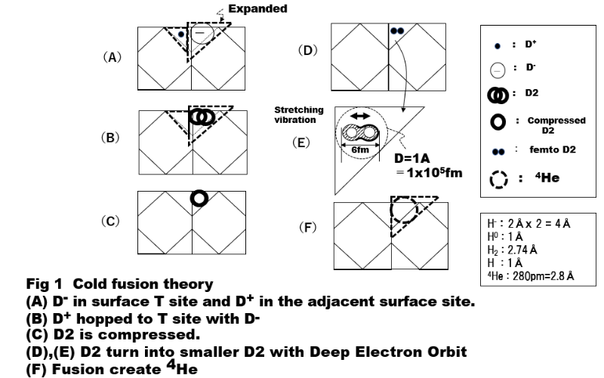

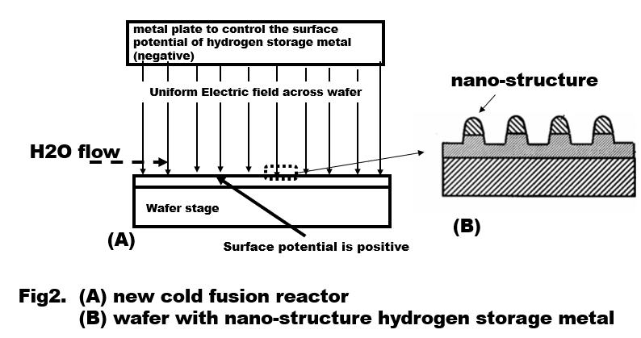

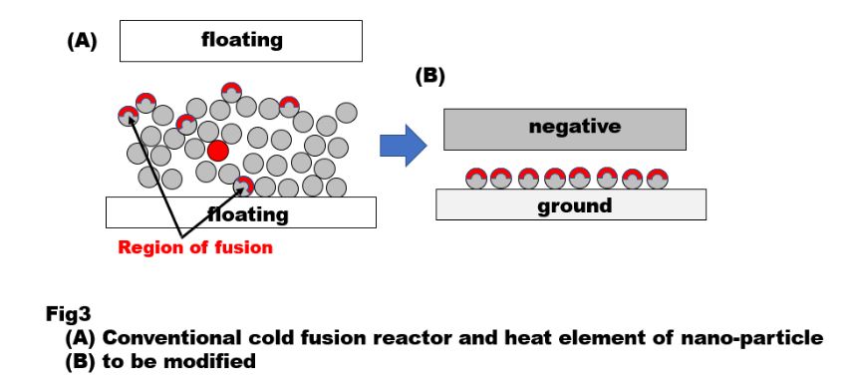

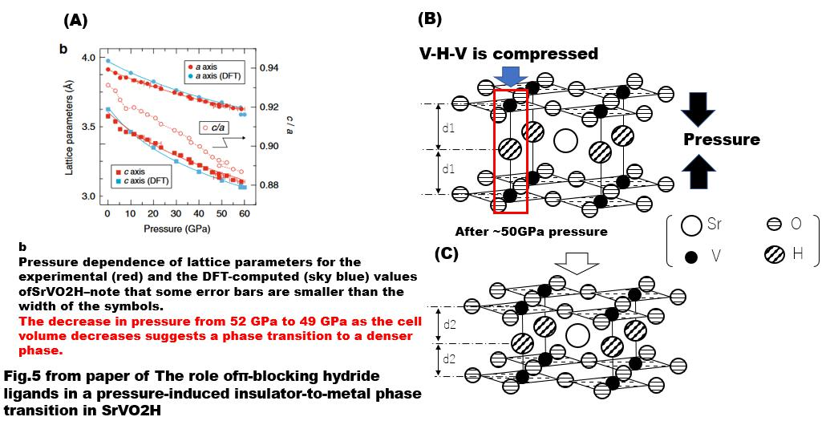
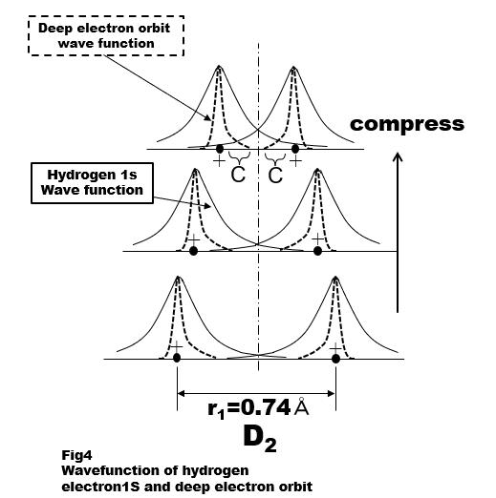

Recent Publications (minimum 5)
- Masuhiro YAMAGUCH Applied Physical Properties of Metal Hydrides; http://www.hess.jp/Search/data/11-02-030.pdf
- D.G. Westake， J. Less-Common Met.， 90(1983)251.
- A.C. Switendick.， Z. Phys. Chem. N. F.， 117(1979)89.
- YamamotoTakafumi et.al. The role of π-blocking hydride ligands in a pressure-induced insulator-to-metal phase transition in SrVO2H,NatureCommunications(2017), https://www.jst.go.jp/pr/announce/20171031/index.html

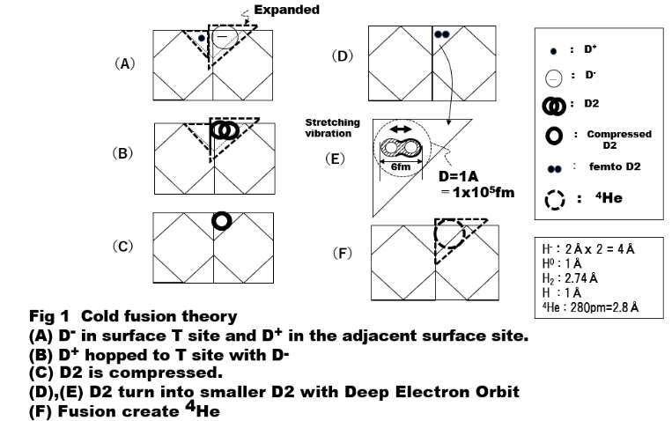

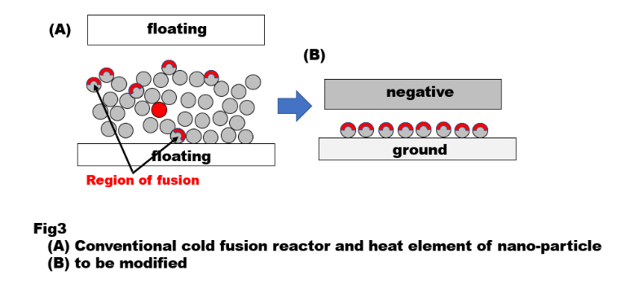
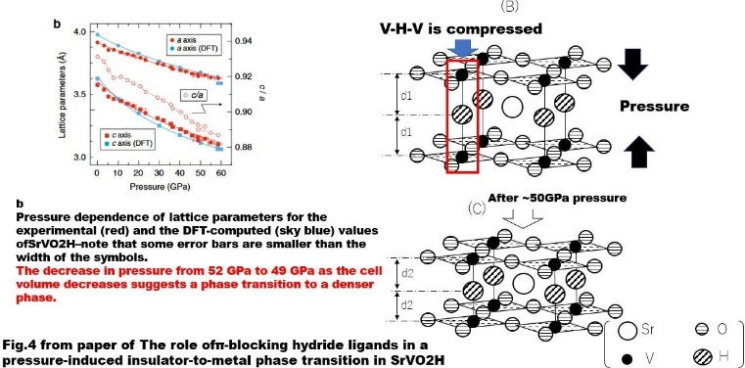

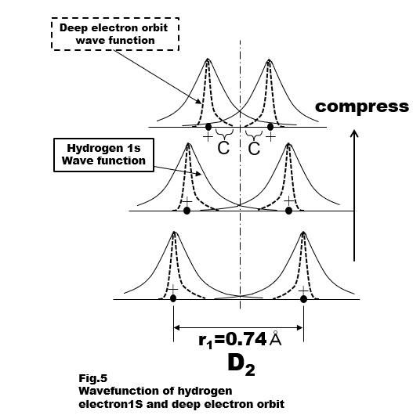

 Biography
Noriyuki Kodama has her expertise in nuclear physics at Tokyo Institute of Technology, has the vast experience of semiconductor process development.

Email: noriyuki.kodama.0820@gmail.com

Acknowledgments
I would like to thank Vavra, Jerry and Jean-Luc Paillet for useful discussions.

