Biomimetic structures and materials for energy absorption
Ngoc San Ha, School of Engineering, Swinburne University of Technology, Australia

Abstract (300 word limit)
Statement of the Problem: It is widely known that the availability of lightweight structures with excellent energy absorption capacity is essential for numerous engineering applications. Inspired by many biological structures in nature, bio-inspired structures have been proved to exhibit a significant improvement over conventional structures in energy absorption capacity. Therefore, use of the biomimetic approach for designing novel lightweight structures with excellent energy absorption capacity has been increasing in engineering fields in recent years. In this presentation, a comprehensive overview of recent advances in the development of bio-inspired structures for energy absorption applications at the Swinburne University Technology, Australia is presented. Firstly, I describe the unique features and remarkable mechanical properties of biological structures such as durian shell, pomelo peel, which can be mimicked to design efficient energy absorbers. I exposed the role of mesocarp layers and thorns in protecting the flesh of durians as well as the mesocarp layer in pomelo during their drop impact on the ground in terms of energy absorption. Next, I will discuss the structural designs as well as the energy absorption characteristics of current bio-inspired structures with different configurations and structures, including multi-cell tubes, frusta, sandwich panels, honeycombs. For instance, I proposed a novel tubular corrugated configuration mimicking the coconut tree profile in an attempt to enhance the energy absorption, minimize the initial peak crushing force, and stabilize the crushing process. I also proposed and fabricated bio-inspired multi-layer graded foam-filled structures mimicking the bone structures. Moreover, a novel bio-inspired honeycomb sandwich panel based on the microstructure of a woodpecker’s beak and a bio-inspired multi-cell tubes are presented. Besides, a theoretical model to predict the mean crushing force of the bio-inspired structures under axial dynamic impact loading based on the plastic deformation theory is developed. Finally, contemporary challenges and future directions for bio-inspired structures are discussed.
Image
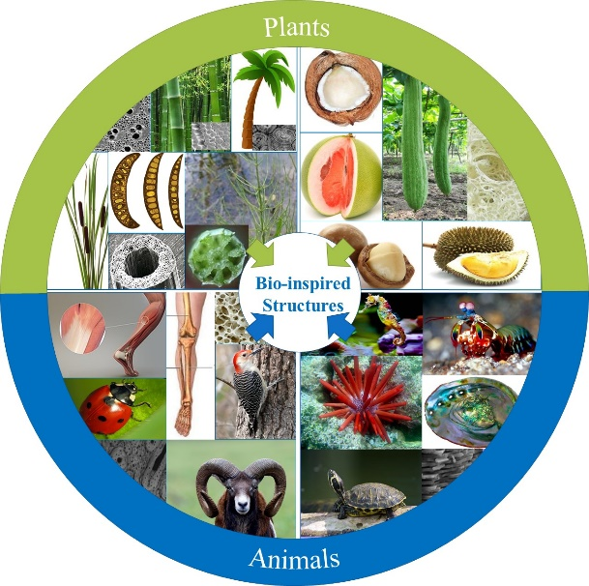
Recent Publications (minimum 5)
- Xiang X, Zou S, Ha N S, Lu G, Kong, I (2020) Energy absorption of bio-inspired multi-layered graded foam-filled structures under axial crushing. Compos Part B-Eng 198:108216.
- Ha N S, Lu G, Shu D, Yu TX (2020) Mechanical properties and energy absorption characteristics of tropical fruit durian (Durio zibethinus J Mech Behav Biomed Mater 104:103603
- Ha N S, Lu G, Xiang X (2019) Energy absorption of a bio-inspired honeycomb sandwich panel. J Mater Sci 54:6286-6300
- Ha N S, Lu G, Xiang X (2018) High energy absorption efficiency of thin-walled conical corrugation tubes mimicking coconut tree configuration, Int J Mech Sci 148:409-421
5. Ha N S, Lu G (2020) A review of bio-inspired structures and materials for energy absorption application Compos Part B-Eng 181:107496

Biography (150 word limit)
Dr Ha has acquired extensive research experience and expertise in biological materials, bio-inspired structures, structural design, energy absorption, impact mechanics and application of the digital image correlation technique. He developed several advanced experimental techniques as well as numerous numerical models to investigate the mechanical properties and behaviour of biological materials under static and dynamic condition. His past and on-going research works span across several subjects in protective biological materials such as protective beetle forewing, durian skin and in numerical modelling for a variety of bio-inspired structures to investigate their energy absorption characteristics, such as bio-inspired corrugated tube mimicking the coconut configuration, bio-inspired corrugated honeycomb core sandwich panel, bio-inspired multi-cell structures, bio-inspired multi-layer graded foam-filled structures. Through his research, Dr Ha aims to advance our understanding of underlying biological structural design that can create an effective guideline for the design of high-performance bio-inspired structures for many real-life engineering applications.

Email: nha@swin.edu.au

Notes/Comments:

