Materials Research 2022

Enhanced green luminescence dynamics of Cu doped ZnO nano-phosphors for white LEDs and their potential antibacterial activities against Enterococcus Faecalis and Pseudomonas Aeruginosa.

Hind Neelamkodan^{1,2}, U.Megha^{1,2}
¹Department of Physics, DGMMES Mampad College, P.O Mampad, Malappuram,Kerala,India
676542. ²Department of Physics, Govt.Arts and Science College, Meenchanda Kozhikode,Kerala,India

Keywords: Green Luminescence, Excitonic Peak, Defect Level Peak, Nanophosphors, Absorption Edge

Abstract Body

The straightforward co-precipitation approach was used to create pure and copper doped ZnO nanophosphors. The produced samples were evaluated for structural, optical, and microbial characteristics. By using X-ray diffraction analysis, it was determined that both the pure and copper-doped samples had hexagonal wurtzite nanocrystalline phases. The Tauc's plot was used to assess the band gap energies of all the prepared samples. All of the generated samples' room temperature photoluminescent spectra show two emission peaks: a broad defect level peak in the visible region and an excitonic peak in the UV region. The PL spectra's visible bands convey the clean as well as doped materials' yellow and green luminescence qualities, making them appropriate for optoelectronic applications. The antibacterial efficacy of the synthesised nanoparticles against the Gram-positive Enterococcus Faecalis (Gram positive) and Pseudomonas Aeruginosa (Gram Negative)bacterial strains was assessed. When compared to pure ZnO nanoparticles, the doped samples exhibit enhanced antibacterial activity. For samples with 5% copper doping, the greatest zone of inhibition against Pseudomonas Aeruginosa was noted to be 25mm. For samples that were 5 percent doped, the largest zone of inhibition against Enterococcus Faecalis was discovered to be 21mm. The findings indicate that the samples collected had more antibacterial potential against gram negative bacteria than gram positive bacteria. The generated chemically doped materials were therefore recommended by this investigation as excellent green nanophophors for the production of white LEDs and effective nanoantibiotics against gram-negative bacteria.

Image:
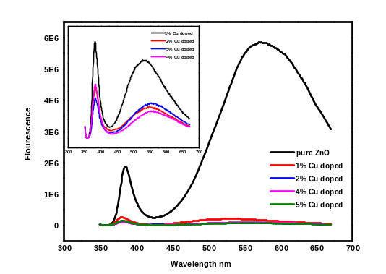

- Reference:

- M.J. Haque, M.M. Bellah, M.R. Hassan, S. Rahman, Synthesis of ZnO nanoparticles by two different methods & comparison of their structural, antibacterial, photocatalytic and optical properties, Nano Express. 1 (2020) 10007. https://doi.org/10.1088/2632-959X/ab7a43.
- U. Megha, G. Varghese, K. Shijina, Effect of Bi and Sr doping on morphological and magnetic properties of LaCo0.6Fe0.4O3 nanosized perovskites, Bull. Mater. Sci. 39 (2016) 125–131. https://doi.org/10.1007/s12034-015-1149-8.
- K. Shijina, G. Varghese, U. Megha, Surface passivation effect on structure, UV and visible emission of ZnNiPdO nanorods, Mater. Sci. Semicond. Process. 34 (2015) 21–26. https://doi.org/10.1016/j.mssp.2014.12.074.

Biography:

Since 2011, Mrs. Hind Neelamkodan has been as an
assistant professor of physics at MES Mampad College in
Kerala, India. She qualified the Graduate Aptitude Test for
Engineering in 2010 and the UGC/CSIR-NET for a
lectureship in 2009. Under the guidance of Dr. Megha U,
Research Guide, Govt. Arts and Science College
Meenchanda, Calicut, Kerala, India, she is pursuing a PhD
in nanoscience. Her co-authored book chapter has been
accepted for publication by Intech Open Access Book
Publishers in the United Kingdom.

Presenting author details

Full Name: Hind Neelamkodan
Contact number: 9633562847
Session name/ number: Presenter
Category: Poster presentation
Passport Number: M8303035



