Abstract

Title: Sterilization of Mushroom Soil by Using Non-Thermal Plasma.

Norizah Redzuan¹, Linda Agun¹, Muhammad Shakir Zulkifli¹, Raja Kamarulzaman Raja Ibrahim², Shazwin Mat Taib³ and Norhayati Ahmad¹

¹School of Mechanical Engineering, Universiti Teknologi Malaysia, Johor Bahru, Malaysia

²School of Science, Universiti Teknologi Malaysia, Johor Bahru, Malaysia

²School of Civil Engineering, Universiti Teknologi Malaysia, Johor Bahru, Malaysia

Keywords: Non-Thermal Plasma; Plasma Treatment; Microorganism; Sterilization; Bacteria Reduction
- Abstract Body (up to 250 words)
There are numerous methods for sterilizing process. In the mushroom cultivation process, mushroom entrepreneur involved steaming process to sterilize the mushroom soil. However, it required ~2-3 days to complete the process. Therefore, this project is to develop a cold plasma sterilization system for mushroom soil. Non-thermal plasma also refers as cold atmospheric plasma is a new technology that use electric field from voltage breakdown to discharge plasma radiation. The radiation is responsible for bacteria inactivation as it interacts directly to the microorganism without any side effect to the material to be treated. Current conventional sterilization method for the agricultural sector is not efficient, which is time consuming and dangerous if the sterilization used chemical substance. The aim of this project is to design and develop a non-thermal treatment system as shown in image for mushroom soil. The mushroom soil treated with non-thermal plasma using air and helium carrier gas respectively. The stainless steel rod, an inner electrode (cathode) used to discharge the plasma direct into the fertilizer. Copper sheet was wrapped as grounded electrode (anode), connecting to high voltage current. Treated samples are compared with the conventional sterilization system in terms of bacteria concentration (Cfu/ml), pH value and water content. Result obtains a higher reduction of bacteria in samples treated with cold plasma compare to conventional method. As conclusions, non-thermal plasma system can be a sterilization system for mushroom cultivation process.

- Image: Atmospheric Cold Plasma Pen
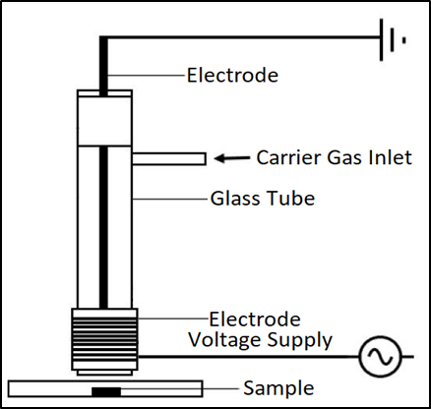

- Reference:
- Korachi, M., & Aslan, N., 2013. Low temperature atmospheric pressure plasma sources for microbial decontamination. Microbial Pathogens and Strategies for Combating Them: Science, Technology and Education, 453–459.
- Ito, M., Ohta, T., & Hori, M., 2012. Plasma agriculture. Journal of the Korean Physical Society, 60, 937–943.
- Stryczewska, H. D., Ebihara, K., Takayama, M., Gyoutoku, Y., & Tachibana, M., 2005. Non-thermal plasma-based technology for soil treatment. Plasma Processes and Polymers, 2, 238–245.
- Biography:
Norizah Redzuan has completed her PhD (majoring in Mechanical Engineering) in 2010 from Glasgow University, Scotland. She is the Senior Lecturer in Department of Materials, Manufacturing and Industrial Engineering, School of Mechanical Engineering, Faculty of Engineering, Universiti Teknologi Malaysia. Her research interests is in cold plasma application, machining and microdrilling.
- Presenting author details



Full Name: Norizah Redzuan
Contact number: +6012-5256787
Twitter account:
Linked In account: Norizah Redzuan
Session name/ number:
Category: Poster presentation
Passport Number:

