Room Temperature CO2 Gas Sensors of AuNPs/mesoPSi Hybrid Structures
Alwan M. Alwan¹
Amer B. Dheyab²
School of Applied Sciences, University of Technology, Baghdad, Iraq ¹
Ministry of Science and Technology, Baghdad, Iraq²

Abstract
Meso porous silicon (meso-PSi) layer prepared by laser-assisted etching process in HF acid was employed as CO₂ gas sensors. Embedded gold nanoparticles AuNPs could modify the surface morphology of meso-PSi and form meso-PSi/Au-NPs hybrid structures through simple and quick dipping process in different gold salts concentrations. The morphology of the hybrid structures was investigated using scanning electron microscopy (SEM) and x-ray diffraction (XRD). The electrical characteristics of the prepared gas sensor were measured at room temperature. Nanoparticles size, shape and specific surface area strongly influenced the current-voltage characteristics. Considerable improvements in sensitivity, response and recovery times of gas sensor were noticed when decreasing the incorporated AuNPs into the meso-PSi matrix.

Image

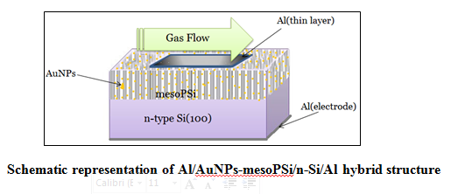
Recent Publications
- Gabouze N, Belhousse S, Cheraga H. Phys State Solidi (C) 2005;N9: 3449.
- He G, Narushima T, Iguchi Y, Goto T, Hirai T. 11th International conference on solid state ionics, Waikiki Beach, Honolulu, Hawaii, USA, 1997.
- Holzinger M, Maier J, Sitte W. Solid State Ionics 1997; 74:217.
- Liu J, Weppner W. Solid State Commun 1990;76(3):311.
- Lee D-D, Chooi S-D, Lee K-W. Sensors and Actuators 1995; B25–26: 607.
- Kale GM, Davidson AJ, Fray DJ. Solid State Ionics 1996; 86–88: 1107.
- [7] N. Gabouzea,_, S. Belhoussea, H. Cheragaa, N. Ghellaib, Y. Ouadaha,Y. Belkacema, A. Keffousa.CO2 and H2 detection with a CHx/porous silicon-based sensor. Vacuum 80 (2006) 986–989.
- S. Naama, T.Hadjersi, A.Keffous, G.Nezzal. CO2 gas sensor based on silicon nanowires modified with metal nanoparticles.Materials Science in Semiconductor Processing.1369-8001, 2015.
- J.Hayder Adawyia, M.Alwan Alwan, A.Jabbar Allaa"Optimizing of porous silicon morphology for synthesis of silver Nanoparticles"Microporous and Mesoporous Materials 227 (2016) 152e160.

Author(s) biography
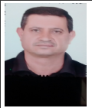

ASST.Proff Alwan M. Alwan, he received B.S degree in physical science from University of Technology, in 1991, M.S degree in Laser and optoelectronics university of Technology-Baghdad in 1996and he Ph.D degree in laser and optoelectronics Technology from Technology University /Iraq-Bagdad in 2006. He has published more than 50 articles, supervised on 13 Ph.D. and M.Sc. Students, and carried out research in thin films design system, optical design, laser electro optics and nano technology applications.

Amer B. Dheyab, he received B.S degree in physical science from University of Technology ,in 2011. He joined to the Laser and Optoelectronic center in Ministry of Science and Technology in 2013; he has published more than 5 articles, and carried out research in Thin films design system, optical design and the field of nanotechnology.


Email: amer.aljoburi@gmail.com

